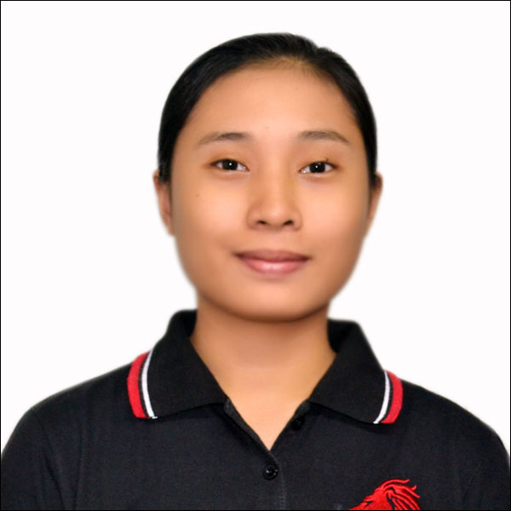
MARIBETH L. SITON
044 IBP Road Litex Corner
Commonwealth, Quezon City
+639565974523
maribeth_siton@dlsu.edu.ph

OBJECTIVE
To join an organization where I can use my skills in personnel administration and attain a high level of performance in personnel recruitment and training.

EDUCATION

2018-Present de la salle university
Bachelor of Science in Industrial Engineering

2012-2018 BATASAN HILLS NATIONAL HIGH SCHOOL
High School Diploma, April 2018. With Honor. Awards: Academic Excellence, 2014-2017.

CO-CURRICULAR ACTIVITIES
2016 SHS Science Camp
2013-2016 MTAP- DepEd Training Program

SEMINARS ATTENDED
2017 Science Department: Rabies and Teenage Pregnancy Awareness

2015 Orientation-Seminar on Geologic Hazards and the Radiation/ Nuclear Safety Program of the DOST, entitled “Science for Safer Community and Disaster Reduction: Iba na ang Panahon”

PERSONAL BACKGROUND

Fluent in English and Filipino. Knowledgeable in Microsoft programs and Adobe PageMaker. Interests: Cross-stitching, handicraft and desktop publishing. Adaptable, goal-oriented and quality oriented.

REFERENCES

MRS. MA. LOURDES V. INGRESO
Master Teacher II
Senior High School Coordinator
Adviser of Grade 12-STEM (Science Technology, Engineering and Mathematics)
Contact Number: (+63) 917-994-5731
Batasan Hills National High School
IBP Road Brgy. Batasan Hills, Quezon City

