Floods of the Maribyrnong
What 118 years of gauge data reveal about the river’s six great floods
Prepared from the Caravan-AUS-VIC dataset (ausvic, 10 gauges) · Lee Lanzafame · 10 June 2026

The dataset behind this report
Every figure here is computed from the Caravan-AUS-VIC extension: daily streamflow at ten gauges across the Maribyrnong catchment (north-west Melbourne), area-normalised with catchment polygons traced from the Melbourne Water Stream Network, and paired with ERA5-Land weather over each catchment. The dataset was built for Google Flood Hub’s open training corpus (Caravan), so every flood below is one the forecasting models will learn from. Flows are daily means in cubic metres per second (m3/s); instantaneous peaks ran higher.

A century of floods at Keilor
The Keilor gauge (230200) anchors the dataset with 118 years of record, 1908 to 2026. The dataset’s restored pre-1950 rows (streamflow without weather, per Caravan convention) turn out to matter: the September 1916 flood is the second-largest on record, and its three consecutive days above 395 m3/s have no parallel in the modern era — not even October 2022 sustained that. The record also spans the other extreme: during the Millennium Drought (1997–2009) most annual peaks failed to reach 16 m3/s, a 500-to-1 range in what a “bad year” means.
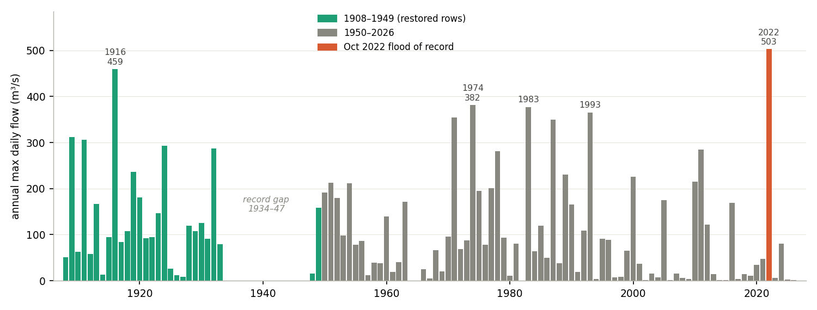
Figure 1. Annual maximum daily-mean flow, Maribyrnong River at Keilor. Teal bars are the restored 1908–1949 record; the 1934–47 gap is a genuine gauge interruption.
Rank | Date | Peak (m3/s) | Peak (mm/day) | Note
1 | 14 Oct 2022 | 503 | 33.3 | Flood of record; rain-driven, 57 mm day prior
2 | 24 Sep 1916 | 459 | 35.2 | Three consecutive days over 395 m3/s
3 | 16 May 1974 | 382 | 25.3 | Only May peak in 103 years; 4.20 m AHD at Maribyrnong
4 | 16 Oct 1983 | 377 | 25.0 | Spring event
5 | 16 Sep 1993 | 365 | 24.2 | Jacksons Creek flood of record; largest 7-day volume
6 | 8 Nov 1971 | 355 | 23.5 | Late-spring event
Table 1. The six largest floods at Keilor by daily-mean peak.

October 2022 — the flood of record
The 14 October 2022 flood tops every mainstem gauge: 503 m3/s daily mean at Keilor, after 57 mm of rain fell the day before on a catchment already saturated (topsoil moisture 0.44 m3/m3). The dataset resolves the event cleanly down the river — and exposes one instrument problem: Keilor North reads 313 m3/s, less than the 364 m3/s entering from upstream (Bulla 317 + Sunbury 47), while Keilor, only 27 km2 of catchment further down, reads 503. The Keilor figure is corroborated by the Jacobs post-event study; Keilor North’s high-stage rating is the likely culprit, and the dataset now carries a caveat note on that gauge. The tidal Chifley Drive gauge shows its designed behaviour: a certified flood reading (494 m3/s) rising out of an uncertified near-zero tidal baseline.
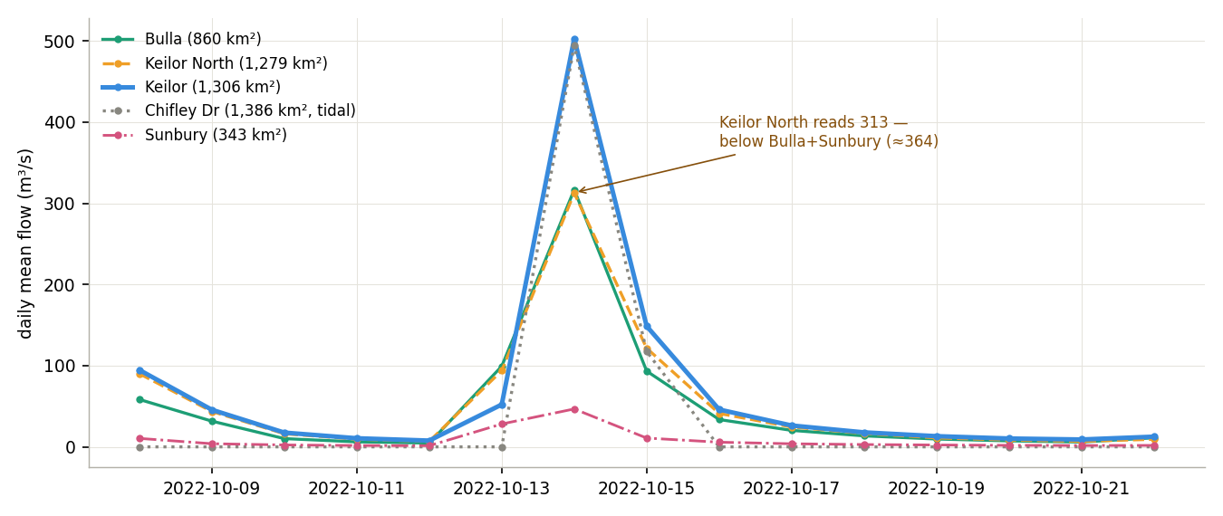
Figure 2. October 2022, daily mean flow. Keilor North (dashed) peaks below upstream Bulla — a rating-curve underestimate, now documented in the dataset.

May 1974, and the reservoir that ate a flood
The 16 May 1974 flood — the benchmark for a generation — peaked at 382 m3/s at Keilor, rank 3 in 118 years and the only May annual peak in the record. By volume it nearly matches 2022: 66 GL passed Keilor in seven days against 69 GL in 2022, because 1974 was front-loaded, running 241 m3/s the day before its peak and putting two consecutive days above 200 (2022 managed one).
The stranger discovery sits on Jacksons Creek. Gisborne, a 91 km2 gauge, recorded essentially zero flow through the entire event — 0.1 mm/day — despite its own catchment receiving 53 mm of rain, while Sunbury just downstream hit 17 mm/day. The explanation is Rosslynne Reservoir, the catchment’s only major storage, built 1971–74 immediately upstream: it was filling when the flood arrived and absorbed it whole. The same signature repeats in January 2011, when the drought-emptied reservoir was refilling and Gisborne again recorded ~0 while Sunbury reached its second-highest level on record. Two events, 37 years apart, same mechanism — now documented against the gauge in the dataset.
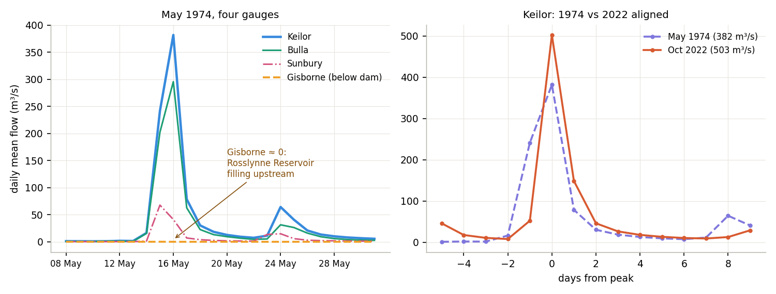
Figure 3. Left: May 1974 at the four gauges then operating — Gisborne flat at zero behind the filling dam. Right: 1974 vs 2022 at Keilor, aligned on peak day.

Three more floods, three personalities
July 1987 (350 m3/s, rank 7) is the catchment’s textbook winter flood: near-uniform intensity at every gauge, produced by modest rain (76 mm over a month) on winter-saturated soil. September 1993 (365 m3/s, rank 5) is the opposite — a bullseye on Jacksons Creek, where Gisborne (66 mm/day) and Sunbury (64 mm/day) both set their all-time records at roughly triple the mainstem’s intensity; it also moved more water past Keilor in a week (72 GL) than either 1974 or 2022. And January 2011 (284 m3/s, rank 12) is the summer outlier: the most rain of any event here (135 mm in seven days, La Niña) landed on summer-dry soil and still couldn’t crack the top ten — a clean demonstration that in this catchment antecedent wetness, not rainfall volume, decides the flood. Its upper tributaries flashed anyway: Lancefield set its record and Clarkefield and Sunbury their second-highest.
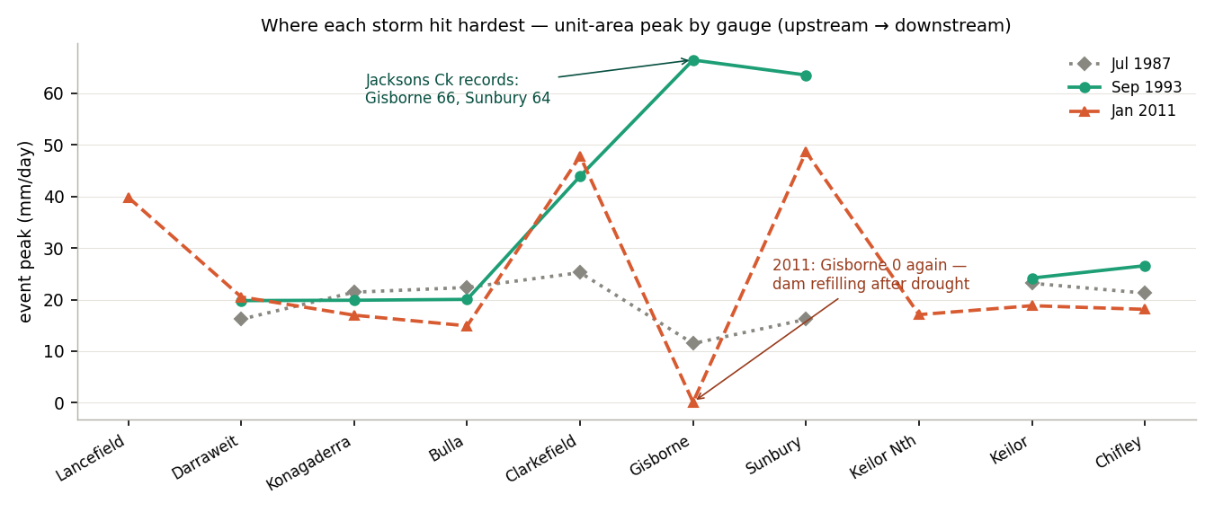
Figure 4. Where each storm hit hardest: peak unit-area runoff by gauge, upstream to downstream. Line breaks mark gauges not yet installed.

When the river floods
Across 103 years with data, four of every five annual peaks at Keilor arrive between June and November; September alone accounts for 26. January has produced just six — 2011 the largest — and May exactly one: 1974. The catchment’s flood season is late winter and spring, when soils are wet enough to convert rain to runoff; the 2022 disaster sits squarely in that window.
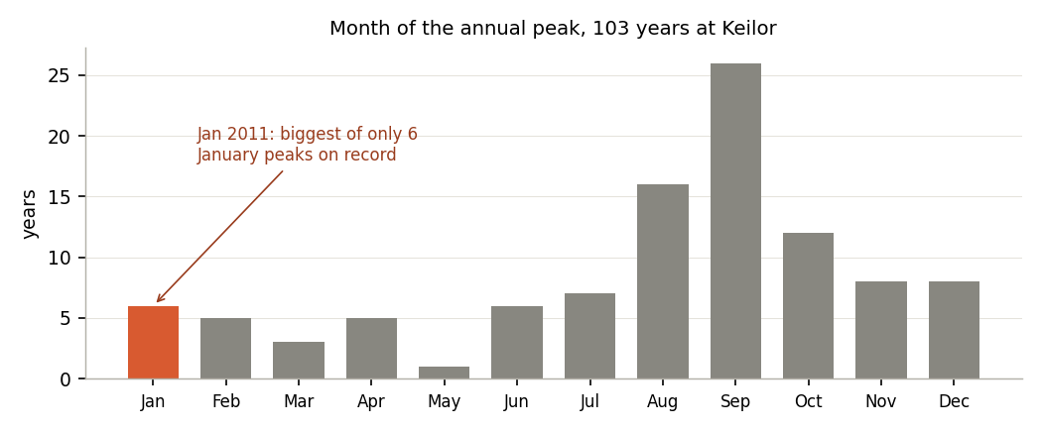
Figure 5. Month of the annual peak at Keilor, 1908–2026.

Why this matters for forecasting
Between them, these six floods give a forecasting model five distinct mechanisms to learn: a uniform winter soaking (1987), a front-loaded autumn event (1974), a tributary cloudburst (1993), a dry-soil summer deluge that mostly fizzled (2011), and a saturated spring catastrophe (2022) — plus a 1916 event that proves multi-day record flow is possible. The dataset also encodes the catchment’s two traps for any model: a reservoir that can erase floods at one gauge depending on how full it is, and a tidal gauge whose baseline is noise. Both are now documented per-gauge in the dataset’s attribute tables, which is exactly where a careful model — or reviewer — will look.

Data and references
Dataset: Lanzafame, L. (2026). Caravan-AUS-VIC: Maribyrnong River basin (10 gauges). Zenodo, doi 10.5281/zenodo.18736843 (all versions). Streamflow: BoM Water Data Online (7 Melbourne Water gauges) and Victorian Water Measurement Information System (Keilor, Sunbury, Gisborne). Weather: ERA5-Land (Copernicus C3S). Catchments: Melbourne Water Stream Network v1.3.1 (Walsh & Kunapo 2023). Corroborating studies: MMBW (1986) Maribyrnong River Flood Mitigation Study; Jacobs (2023) October 2022 Post Event Analysis; VICSES flood-history table (2018). Rosslynne Reservoir history: Southern Rural Water; Agriculture Victoria VRO. Daily means understate instantaneous peaks. CC-BY-4.0.

Appendix — how this dataset was built, in plain language
Adapted from the plain-language pipeline notes written while the dataset was being assembled (May 2026).
Flood Hub’s model needs four things for every gauge: where the basin is (a polygon on a map); what the basin is like (static facts that don’t change day to day — soil, vegetation, elevation, climate normals); what the weather has been doing there (daily rain, temperature, soil wetness — the inputs that cause floods); and what the gauge actually recorded, so the model can learn the relationship “given a basin like this and weather like this, the flow should be Y”. Caravan packages all four, for every contributed gauge on Earth, in one standard format.
The first item came from tracing each gauge’s upstream catchment through the Melbourne Water Stream Network — ten polygons, each ending exactly at its gauge. The clever part is that the next two items are not measured here at all: they are read off global datasets, using the polygons as cookie-cutters.
“The global dataset is a giant pizza. Your shapefile is a cookie-cutter shaped like your basin. The intersection is: press the cutter onto the pizza, and tell me everything that fell inside the shape.”
Static facts — HydroATLAS. The world has been pre-divided into hundreds of thousands of mini-basins, each carrying ~196 recorded facts (% forest, mean elevation, soil type, and so on). Google Earth Engine presses each of our ten cookie-cutters onto that layer and area-weights the facts inside it — Keilor’s polygon overlaps a couple of dozen mini-basins, and its “forest %” is the area-weighted average of theirs. The result is one row per gauge in attributes_hydroatlas_ausvic.csv.
Daily weather — ERA5-Land. The same trick against a global daily weather grid (~11 km cells, every day since 1950): for each basin, each day, area-weight the cells inside the polygon for 14 variables — rainfall, temperatures, wind, pressure, soil moisture at four depths, snow. For ten basins over 76 years that is a few million numbers, exported from Earth Engine in 75 batch tasks over about three hours.
Why not just use local rain gauges? Two reasons. Every country’s weather stations are sited, calibrated and averaged differently, and a model trained on that mishmash learns the differences instead of the hydrology — ERA5-Land is the same product computed the same way everywhere on Earth. And floods at Keilor are not driven by rain at Keilor; they are driven by the average rain over the entire 1,306 km2 upstream, which a grid can provide and a single rain gauge cannot.
The steps, end to end:
- Trace the ten catchment polygons from the Melbourne Water Stream Network — the cookie-cutters, one per gauge.
- Upload the polygons to Google Earth Engine.
- Intersect with HydroATLAS for the static basin facts.
- Intersect with ERA5-Land for daily weather, 1950 to present.
- Fetch the observed streamflow — BoM Water Data Online for the seven Melbourne Water gauges, the Victorian water measurement system for Keilor, Sunbury and Gisborne — and convert it to mm/day using each polygon’s area.
- Run Caravan’s Part-2 notebook to glue facts, weather and streamflow into one bundle, gauge by gauge.
- Validate the bundle against Caravan’s standards — file naming, attribute columns, polygon uniqueness, units — 36 automated checks.
- Publish to Zenodo and submit to the Caravan maintainers for inclusion in Flood Hub’s training data.
ERA5-Land tells the model what the weather did; the gauge record tells it what the river did in response. Everything else in the bundle exists so the model can compare this catchment, fairly, with 25,000 others.

