# Create a gmail account

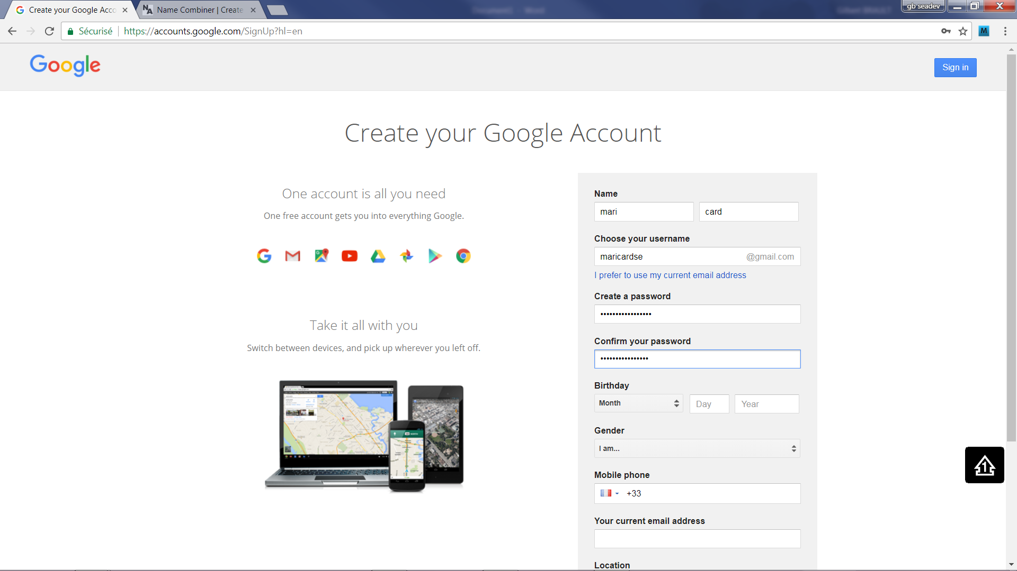

[maricardse@gmail.com](mailto:maricardse@gmail.com)

password maricardse.carros

# create a firebase project with this account

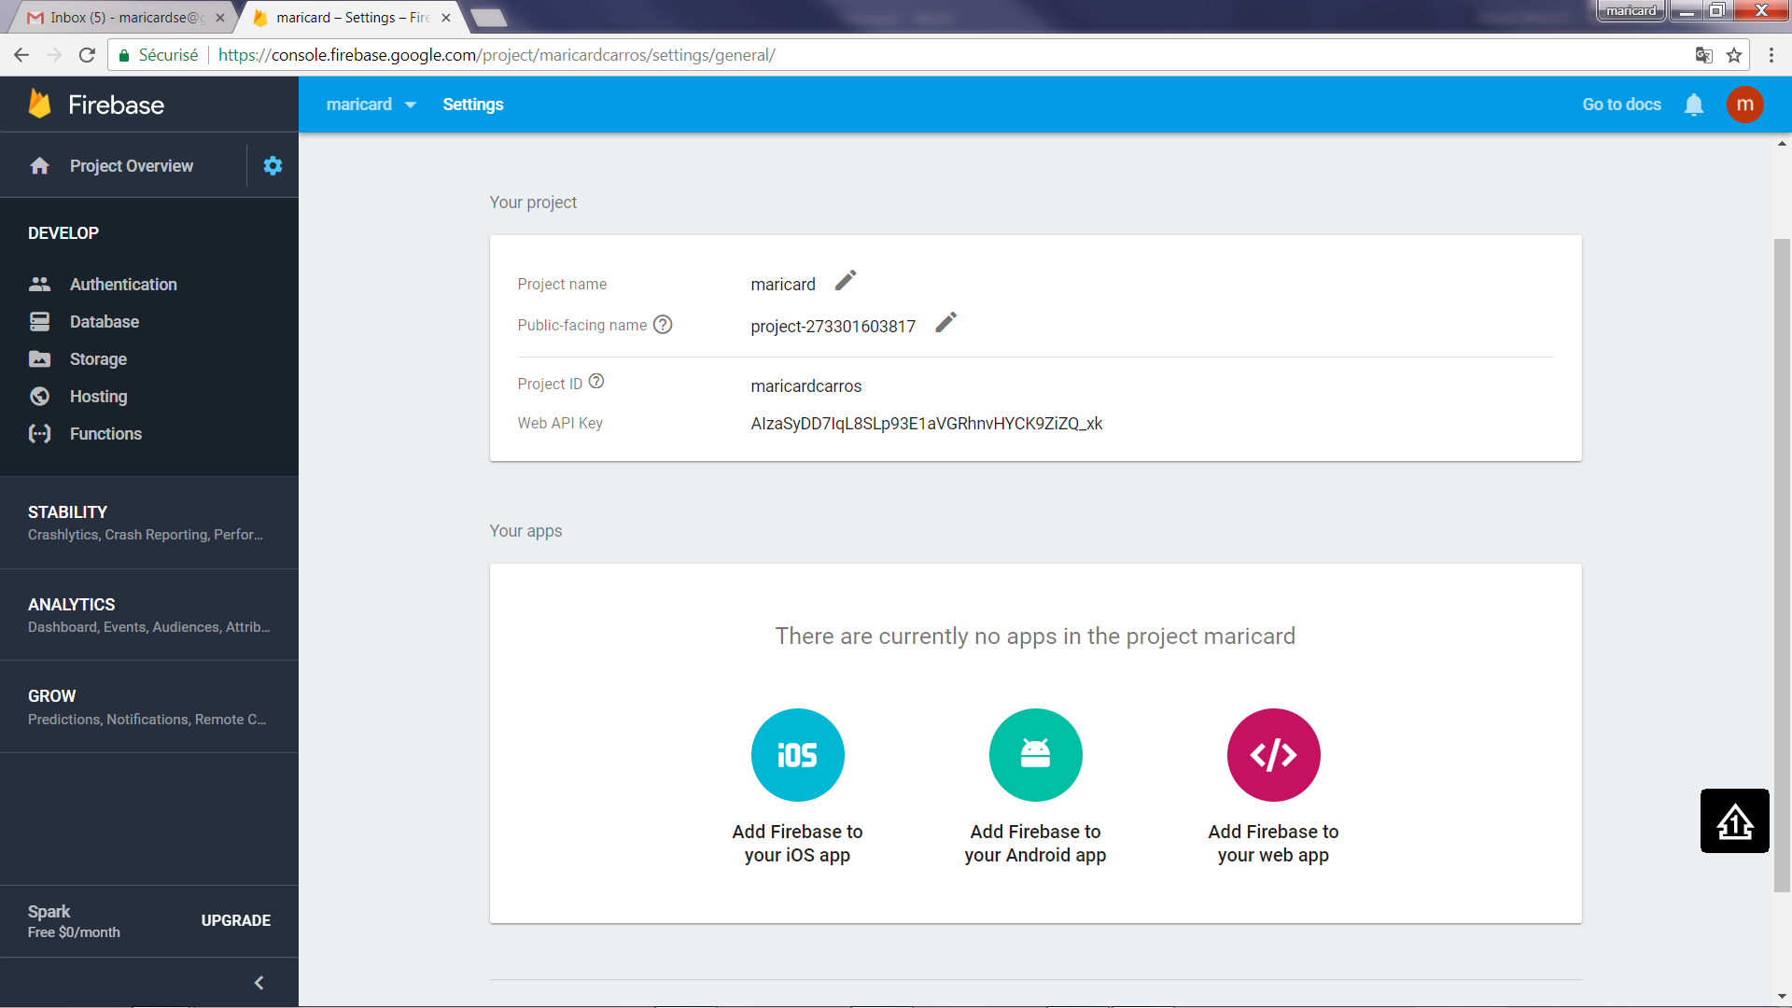

# Create a github project

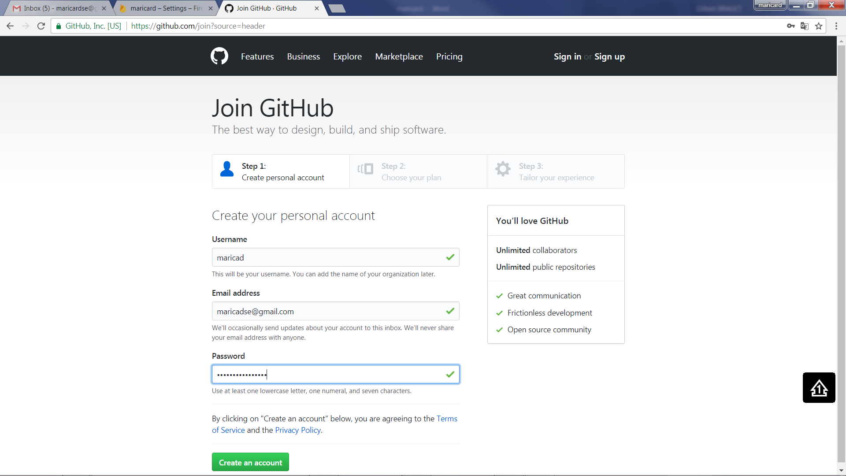

Pswd: maricard06.carros

# Fork businessgraphs

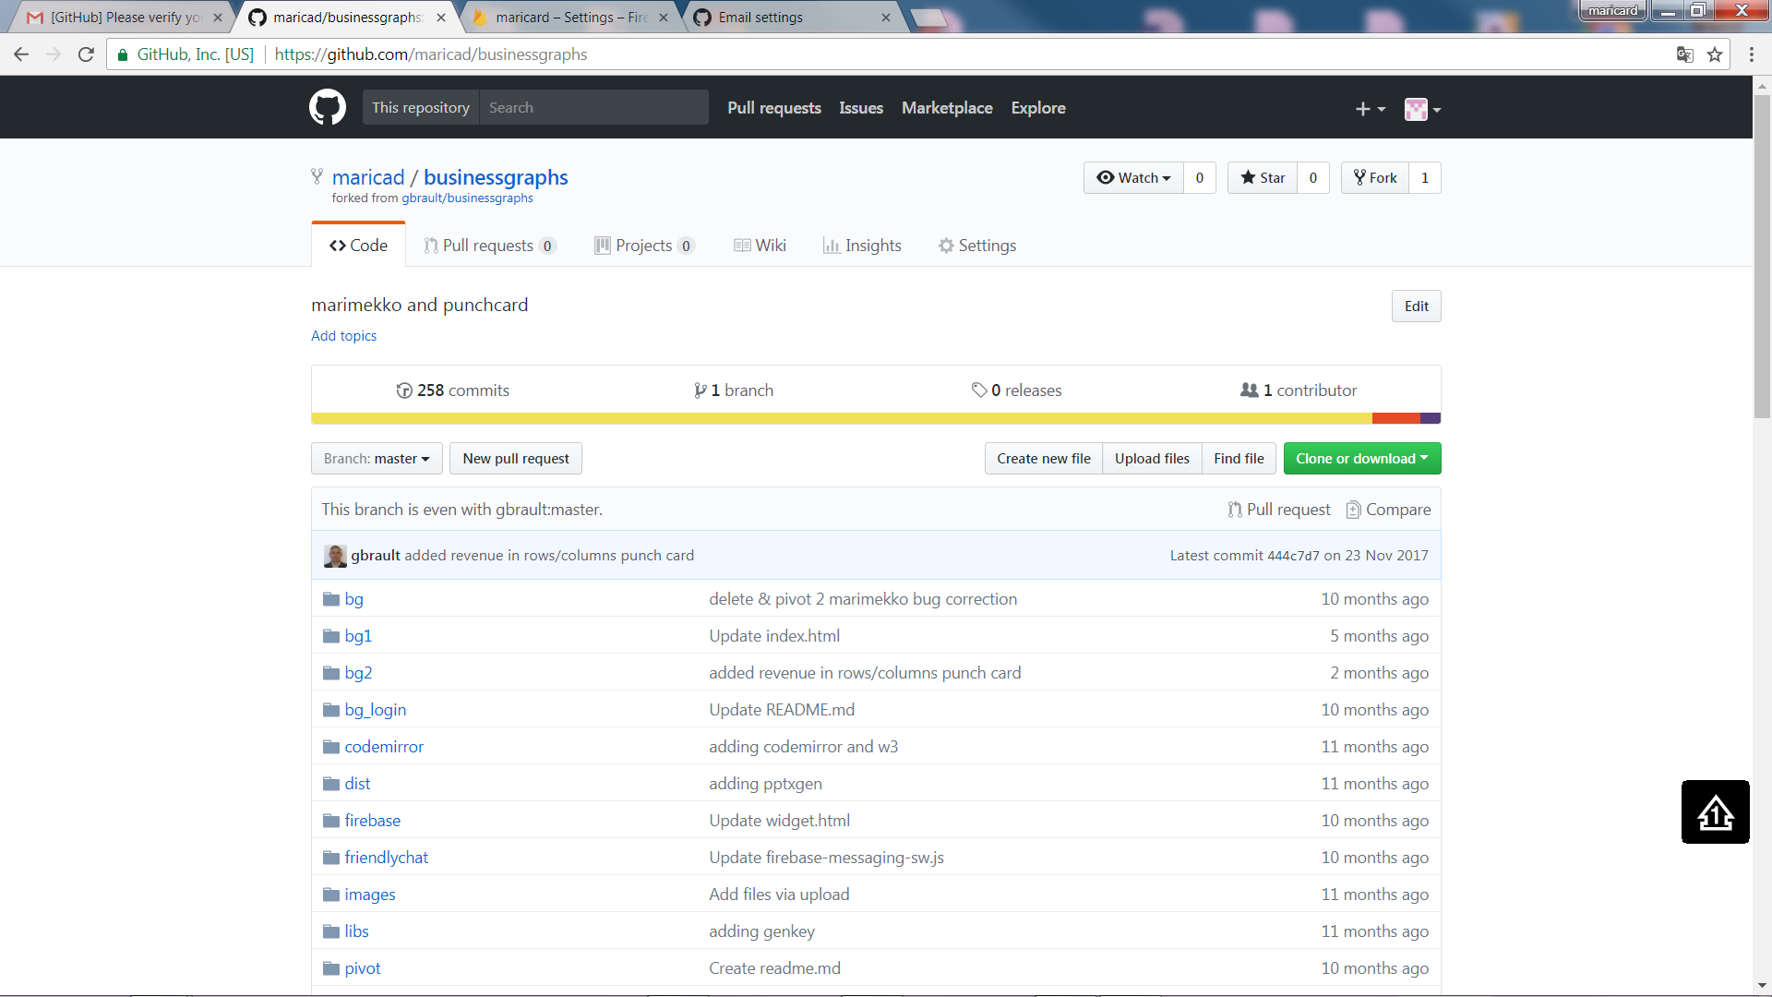

# Update firebase referral

Couple of files: need to improve that

# Update domain (testing add rawgit)

