AUDITOR, Maricar L.

2ECE-D

**DATA WRANGLING**

**Problem 1**

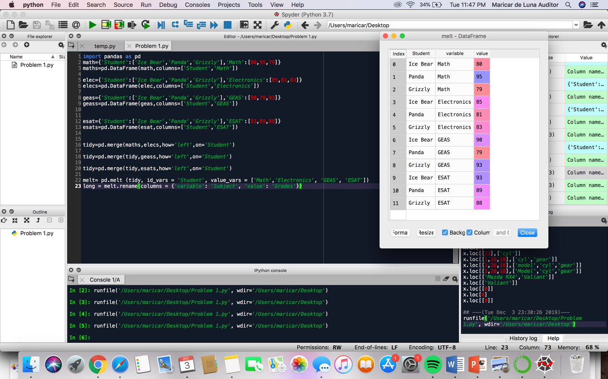

**Problem 2**

