Generating SDRs in TestHound
- Log In:
  - Access your account on Test Hound.
- Navigate to Performance Tracker:
  - Select Performance Tracker from the main menu.
  - 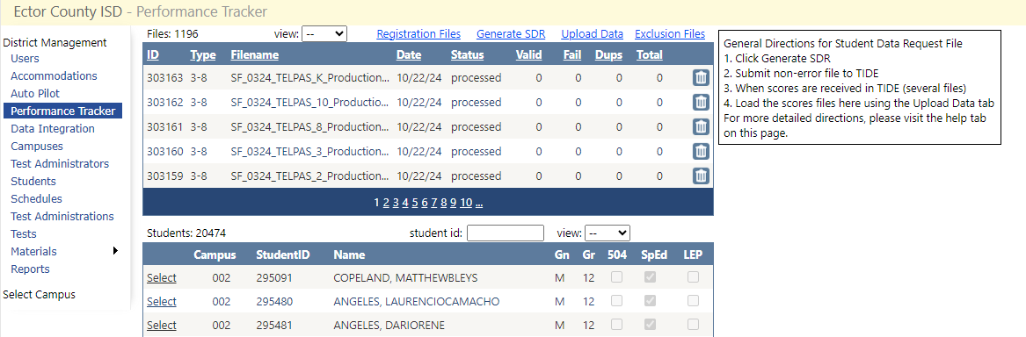
- Generate SDRs:
  - Choose Generate SDRs from the available options.
- Select Student Options:
  - Check the Flagged Students option.
  - Select the boxes for students in grades 3 through 12.
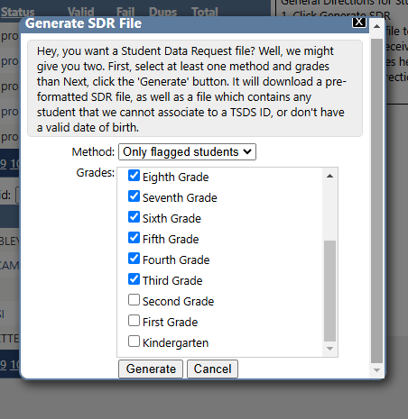
- Generate and Download:
  - Click Generate to create the SDR file.
  - Once the file is ready, download it in .csv format to your computer.

Populating the SDRs

Step 1: Log In
- Log in to TexasAssessment.gov.

Step 2: Access Student Data Request
- Navigate to the Student Information section.
- Select Student Data Request from the menu. – SDR instructions
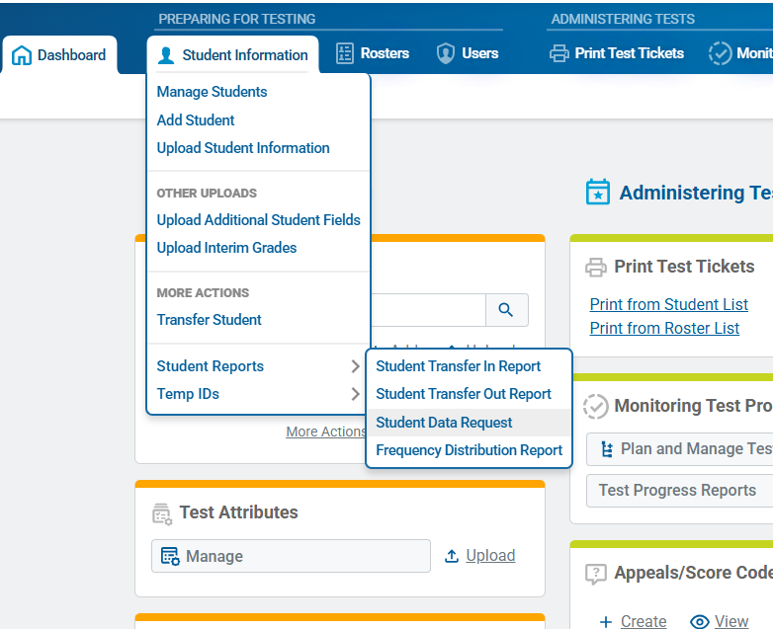

Step 3: Upload the File
- Upload the SDR file you generated earlier.

Step 4: Validate the File
- Once uploaded, the Validate page will display any issues with the file:
  - Errors: Rows with errors will be excluded from the upload, but the rest of the file will be processed.
  - Warnings: Rows with warnings will be included in the upload, but the field marked as invalid may affect data quality.
- Choose one of the following actions based on the validation results:
  - Continue with Upload: Proceed with the upload despite errors or warnings. The file will be processed, and a confirmation page will appear once completed.
  - Upload a Revised File: If you want to correct the errors or warnings:
    - Select Upload Revised File.
    - Make the necessary corrections to the file.
    - Re-upload the revised file for validation.
- Once validation is successful or you decide to proceed despite errors or warnings, select Continue with Upload. A confirmation page will indicate that your file has been successfully uploaded.
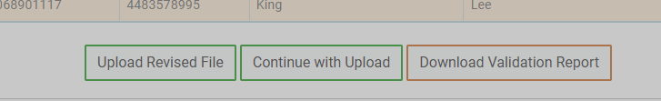

Step 5: Download the Processed File
- Navigate to the Secure File Center from the TIDE banner.
- Locate your file:
  - While processing, the file will appear in your inbox marked as In Progress.
  - Once processing is complete, the file will be available for download.
- (Optional) Use the keyword search or filters to locate your file more easily.
- Select the file name to download it. The file will be saved to your computer's default download location.
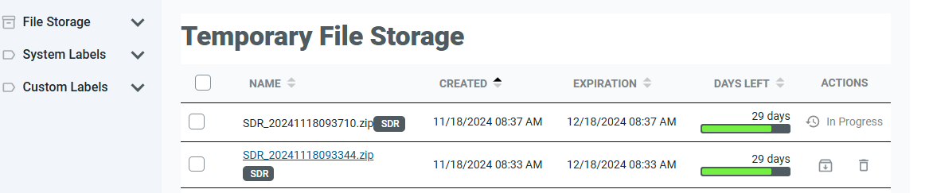

Uploading SDRs to Aware
- Rename the File:
  - Update the file name to include "SIRS" as part of the file name.
- Prepare the ZIP File (Optional):
  - If uploading multiple files, create a ZIP file containing all the SDR files.
  - Ensure the ZIP file name also includes "SIRS".
- Upload the File:
  - Log in to Aware.
  - Upload the file or ZIP file as you normally would.
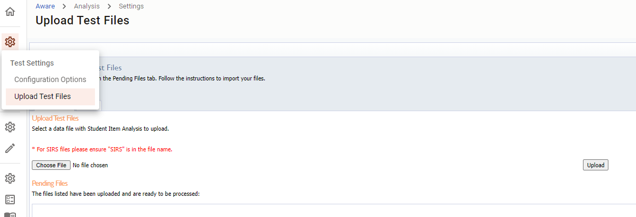

SDR File Sorter
The Python File Sorter consists of three Python scripts that must be located in the same directory. Follow these steps to use the sorter:
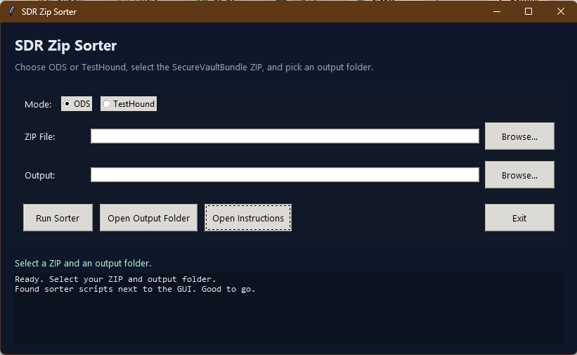
- Prepare the ZIP File:
  - Ensure you have downloaded the required ZIP file from TIDE.
- Launch the File Sorter:
  - Open the Python File Sorter GUI.
- Select a ZIP File:
  - Click Select ZIP File and choose the file you downloaded from TIDE.
- Choose an Output Folder:
  - Click Select Output Directory to specify where the sorted files will be saved.
- Choose Sorting Mode:
  - Select either:
    - Test Hound Sort: For files meant to be uploaded to Test Hound.
    - ODS Sort: For files categorized by STAAR, TELPAS, or other categories.
- Run the Sorter:
  - Click Run Sorter to begin the sorting process.
  - The files will be sorted into the specified output folder, with unsorted files placed in an Unsorted folder. A text file listing unsorted files will also be generated.

Uploading SDRs to Test Hound
- Log In:
  - Access your account on Test Hound.
- Navigate to Performance Tracker:
  - Select Performance Tracker from the main menu.
- Upload Data:
  - Click Upload Data to begin the upload process.
  - 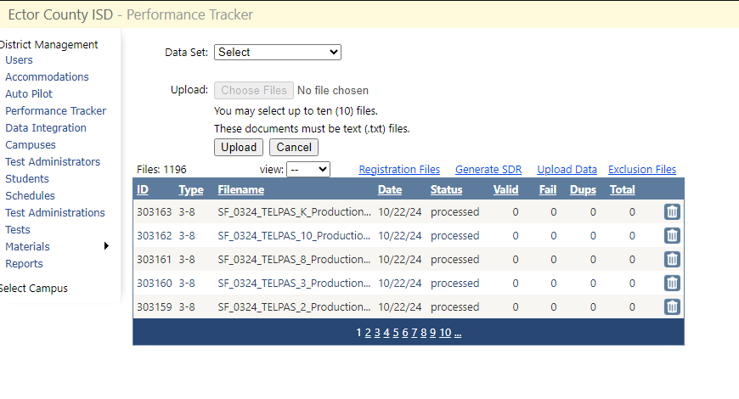
- Select File Type:
  - From the dropdown menu, choose the correct file type that matches the data and year of the SDR file you are uploading.
  - Double-check the file type and year to ensure accuracy.
  - 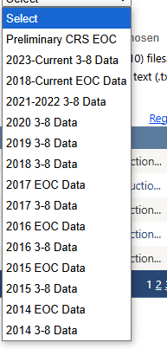
- Upload Files:
  - You can upload up to 10 files at a time.
  - Select the files and proceed with the upload process.

Uploading SDRs to ODS
- Categorize SDR Files:
  - Ensure that all SDR files are separated into the correct category type (e.g., STAAR EOC, TELPAS, TELPAS Alt).
  - Organize files based on the required ODS categories before proceeding.
- Upload Files:
  - Navigate to the File Upload Center in ODS.
  - Drag and drop the files into the appropriate upload area under the correct file type category.
  - 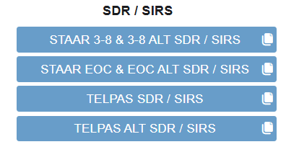
- Follow ODS Instructions:
  - Refer to the specific instructions provided by ODS for file naming conventions, upload limits, and any additional requirements.
- Confirm Upload:
  - Verify that all files have been uploaded successfully and are visible under the correct categories.

Follow the instructions provided from ODS:
