Read Now: Taking it Further Pyramids of Biomass Date:

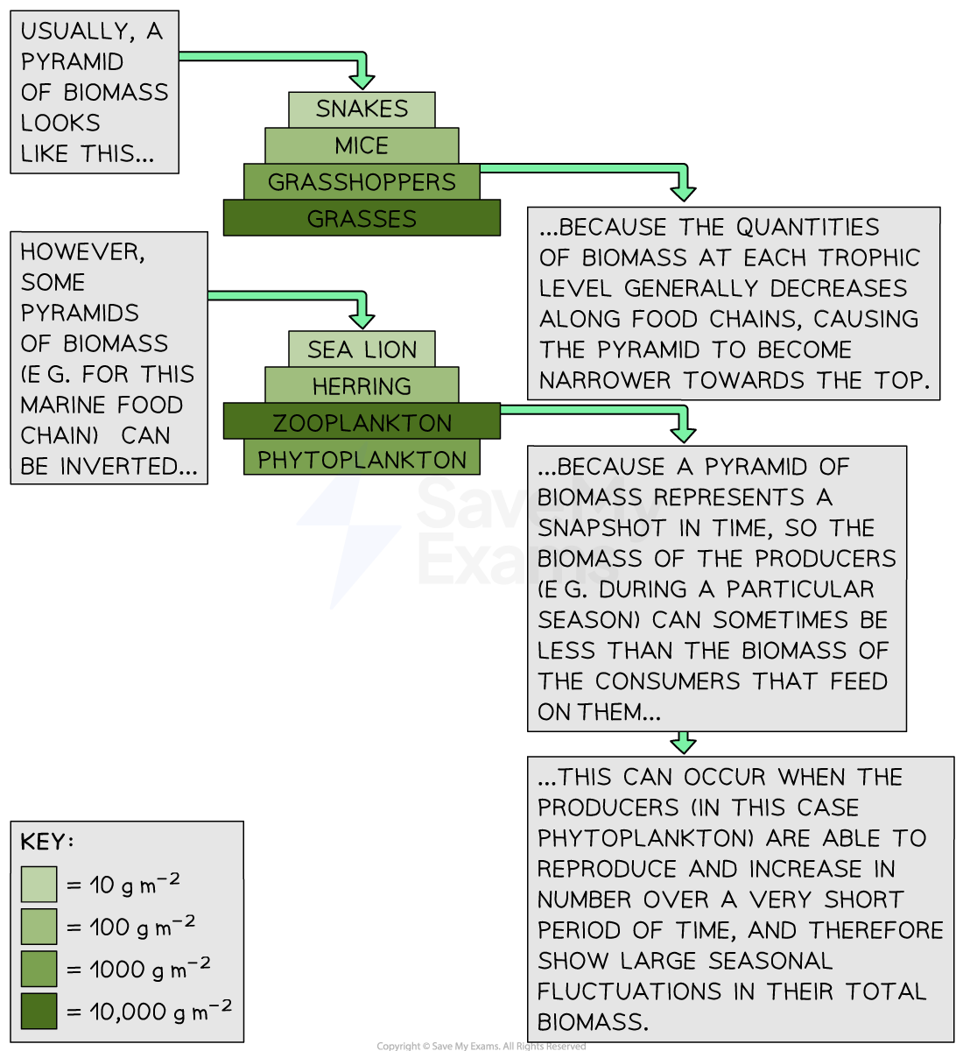

Biomass is the total mass of living things in an area. It shows how much energy is available in an ecosystem. We can visualize this using a pyramid of biomass. At the bottom, we have producers, like plants, which create energy from sunlight.
As we move up the pyramid, we find primary consumers, like herbivores. They eat plants and gain energy. Next are secondary consumers, like carnivores, which eat herbivores. Each level has less biomass than the one below. This is because energy is lost at each step, mainly as heat.
Understanding pyramids of biomass helps us see how energy moves through ecosystems. It shows us the importance of plants in providing energy for all other living things.
By working together, we can learn more about how to protect these ecosystems. Being kind to our environment ensures a healthy future.
Questions:
1. Define the term biomass. (1 mark)
2. What is at the bottom of a pyramid of biomass? (1 mark)
3. Name one group of organisms found in the middle of the pyramid. (1 mark)
4. Why is there less biomass at the top of the pyramid? (1 mark)
5. Explain how you can help protect ecosystems based on what you learned. (4 marks)

MARK SCHEME
1. Biomass is the total mass of living things in an area.
2. At the bottom of a pyramid of biomass are producers, like plants.
3. One group of organisms found in the middle is primary consumers, like herbivores.
4. There is less biomass at the top because energy is lost at each step.
5. You can help protect ecosystems by conserving energy, reducing waste, and planting trees.

