Read Now: Taking it Further Pyramids of Biomass Date:

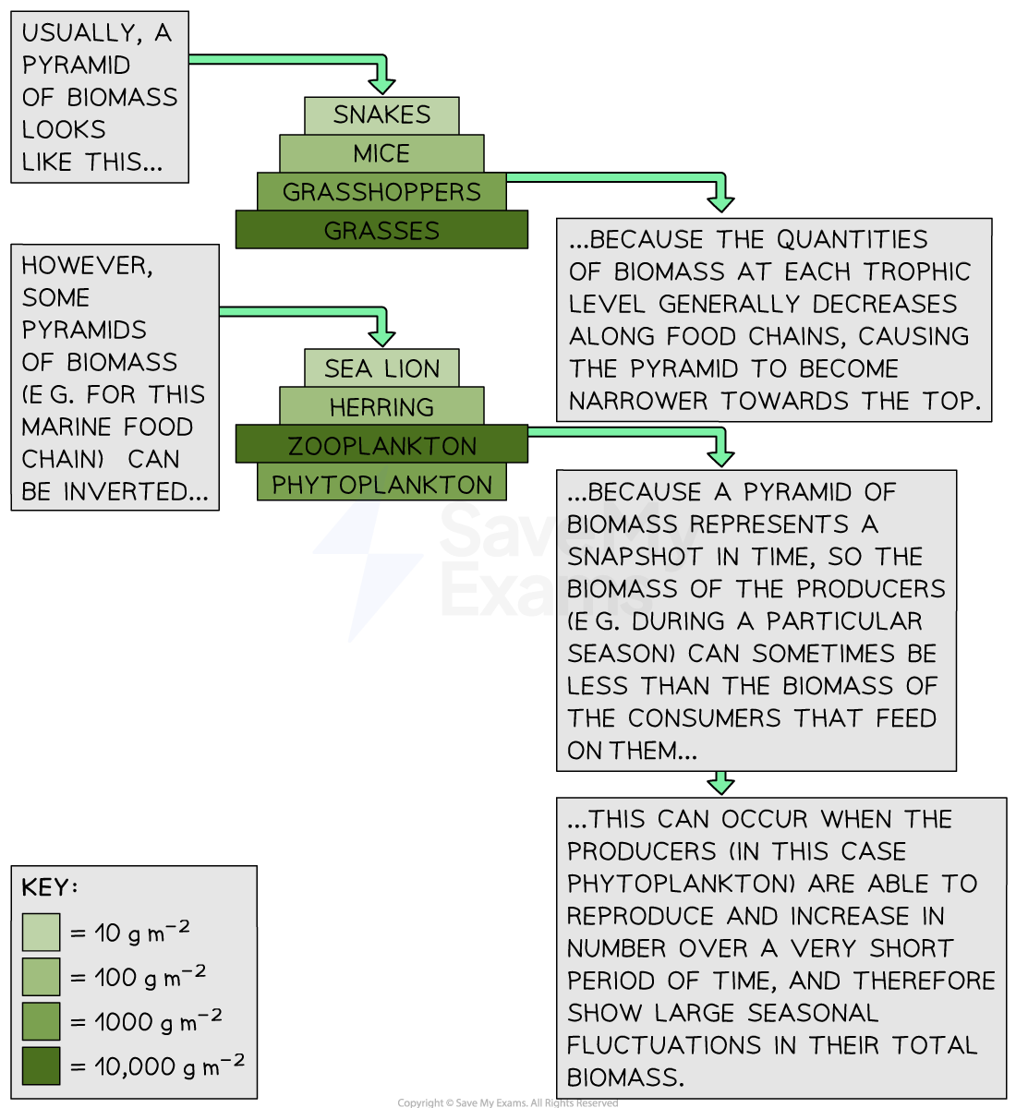

Biomass is the total mass of living things in an area. It includes plants, animals, and microorganisms. A pyramid of biomass shows how much biomass is at each level of a food chain. The bottom has the most biomass. This is usually plants, which are called producers. They make food using sunlight.
As you move up the pyramid, the biomass decreases. This is because energy is lost at each level. For example, herbivores eat plants, but they do not use all the energy. Predators eat herbivores, but they also lose energy.
Understanding pyramids of biomass helps us see how energy flows in ecosystems. It teaches us about the balance of nature. By knowing this, we can make better choices for the environment.
Questions:
1. What is biomass? A) Total mass of plants B) Total mass of living things C) Total mass of soil D) Total mass of water
2. The process of _____ occurs when energy is lost at each level.
3. State the role of producers in the pyramid of biomass.
4. Describe how energy flows in a food chain.
5. Explain the concept of a pyramid of biomass.
WHAT: What does a pyramid of biomass show?
WHY: Why is it important to understand energy flow?

MARK SCHEME
1. B
2. energy loss
3. Producers make food using sunlight.
4. Energy flows from producers to herbivores to predators.
5. WHAT: A pyramid of biomass shows the total mass at each level.
WHY: It is important to understand energy flow to protect ecosystems.

