Read Now: Electrolysis in Solutions Date:

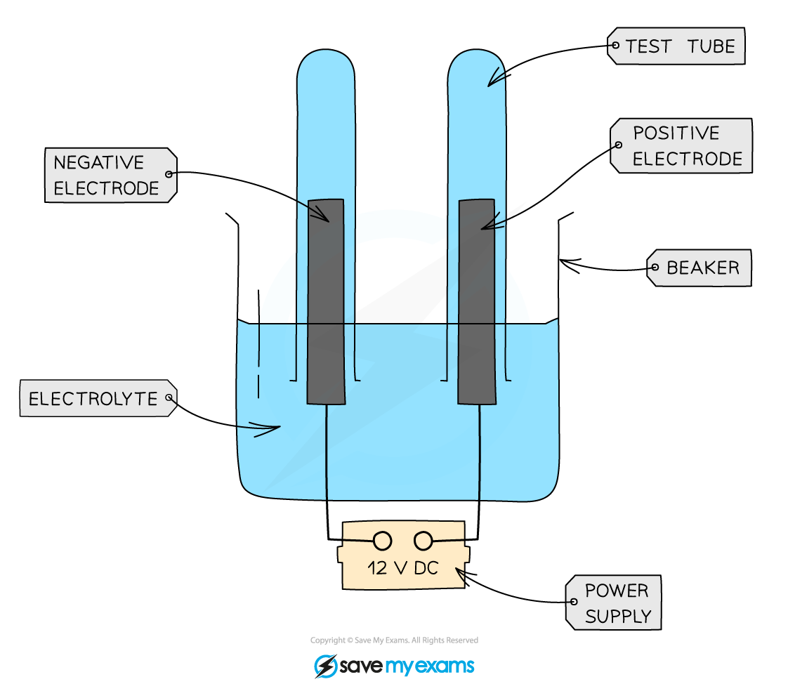

When a solid salt dissolves in water, it breaks into ions. These ions are charged particles. In a salt solution, we usually find positive cations and negative anions.
For example, if we dissolve table salt (sodium chloride) in water, it separates into sodium ions (Na⁺) and chloride ions (Cl⁻). This process allows electricity to flow through the solution.
In molten salts, the same idea applies. When a salt is heated until it melts, it still forms ions. For instance, in molten potassium bromide, you will find potassium ions (K⁺) and bromide ions (Br⁻).
During electrolysis, these ions move towards electrodes. The positive cations go to the negative electrode, while the negative anions move to the positive electrode. This movement allows for chemical reactions to take place.
Questions:
1. Define the term 'ion.' (1 mark)
2. State the cations and anions found in sodium chloride. (1 mark)
3. What happens to salt when it dissolves in water? (1 mark)
4. Name the ions in molten potassium bromide. (1 mark)
5. Describe what happens during electrolysis in a salt solution. (4 marks)

MARK SCHEME
1. An ion is a charged particle formed when a molecule gains or loses electrons.
2. The cations in sodium chloride are sodium ions (Na⁺) and the anions are chloride ions (Cl⁻).
3. When salt dissolves in water, it separates into ions.
4. The ions in molten potassium bromide are potassium ions (K⁺) and bromide ions (Br⁻).
5. During electrolysis, ions move to electrodes; cations go to the negative electrode and anions go to the positive electrode, causing chemical reactions.

DRILL QUESTIONS
1. What is the ionic equation for the reaction between zinc and sulfuric acid?
2. Explain why aluminium ore is dissolved in molten cryolite rather than being melted directly during the extraction of aluminium.
3. Define electrolysis and state two conditions that must be met for electrolysis to occur.

MARK SCHEME
1. Zn(s) + 2H+(aq) → Zn2+(aq) + H2(g)
2. Cryolite has a much lower melting point than aluminium oxide, making the process less expensive as it requires less energy to heat to the required temperature.
3. Electrolysis is the process by which ionic substances are decomposed into simpler substances when an electric current is passed through them. The compound must contain ions and the ions must be free to move (by melting or dissolving in water).

