Read Now: Taking it Further Corrosion and its Prevention Date:

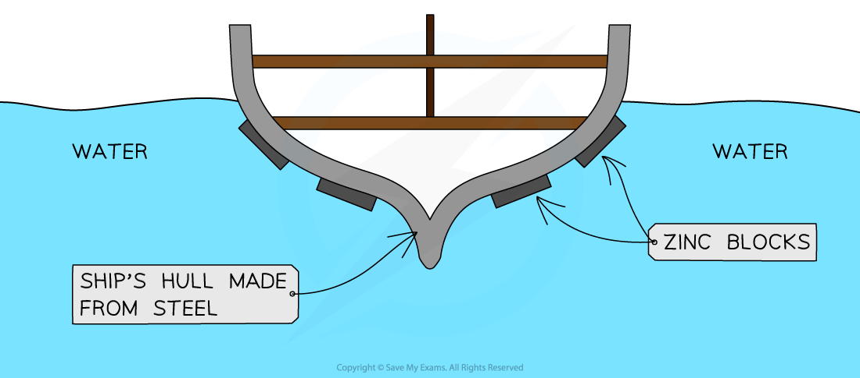

Corrosion is the process where metals break down. It happens when metals react with water, air, or chemicals. A common example is rust on iron. Rust forms when iron meets oxygen in the presence of water.
Corrosion can be harmful. It weakens structures like bridges and cars. This can lead to accidents and costly repairs. To stop corrosion, we can use different methods.
One way is to paint metal surfaces. This keeps out water and air. Another method is galvanization. This means covering the metal with a layer of zinc. Zinc protects the metal underneath by corroding first.
Using these methods helps keep our metal items safe and lasting longer. Preventing corrosion saves money and keeps our environment safe.
Questions:
1. Define corrosion. (1 mark)
2. What is a common example of corrosion? (1 mark)
3. What can corrosion weaken? (1 mark)
4. Name one method to prevent corrosion. (1 mark)
5. Why is preventing corrosion important for the environment? (4 marks)

MARK SCHEME
1. Corrosion is the process where metals break down.
2. A common example of corrosion is rust on iron.
3. Corrosion can weaken structures like bridges and cars.
4. One method to prevent corrosion is painting metal surfaces.
5. Preventing corrosion is important because it saves money and keeps structures safe.

DRILL QUESTIONS
1. What are the products formed when zinc reacts with sulfuric acid, and write the balanced chemical equation for this reaction?
2. Explain why aluminium is extracted using electrolysis rather than reduction with carbon.
3. During the electrolysis of copper sulfate solution using inert electrodes, what substance is produced at the anode and why?

MARK SCHEME
1. The products are zinc sulfate and hydrogen gas. The balanced equation is: Zn(s) + H₂SO₄(aq) → ZnSO₄(aq) + H₂(g)
2. Aluminium is more reactive than carbon, so it cannot be extracted by reduction with carbon and requires electrolysis.
3. Oxygen is produced at the anode because copper sulfate does not contain halide ions, so hydroxide ions from water are discharged instead.

