Read Now: Recycling Metals Date:

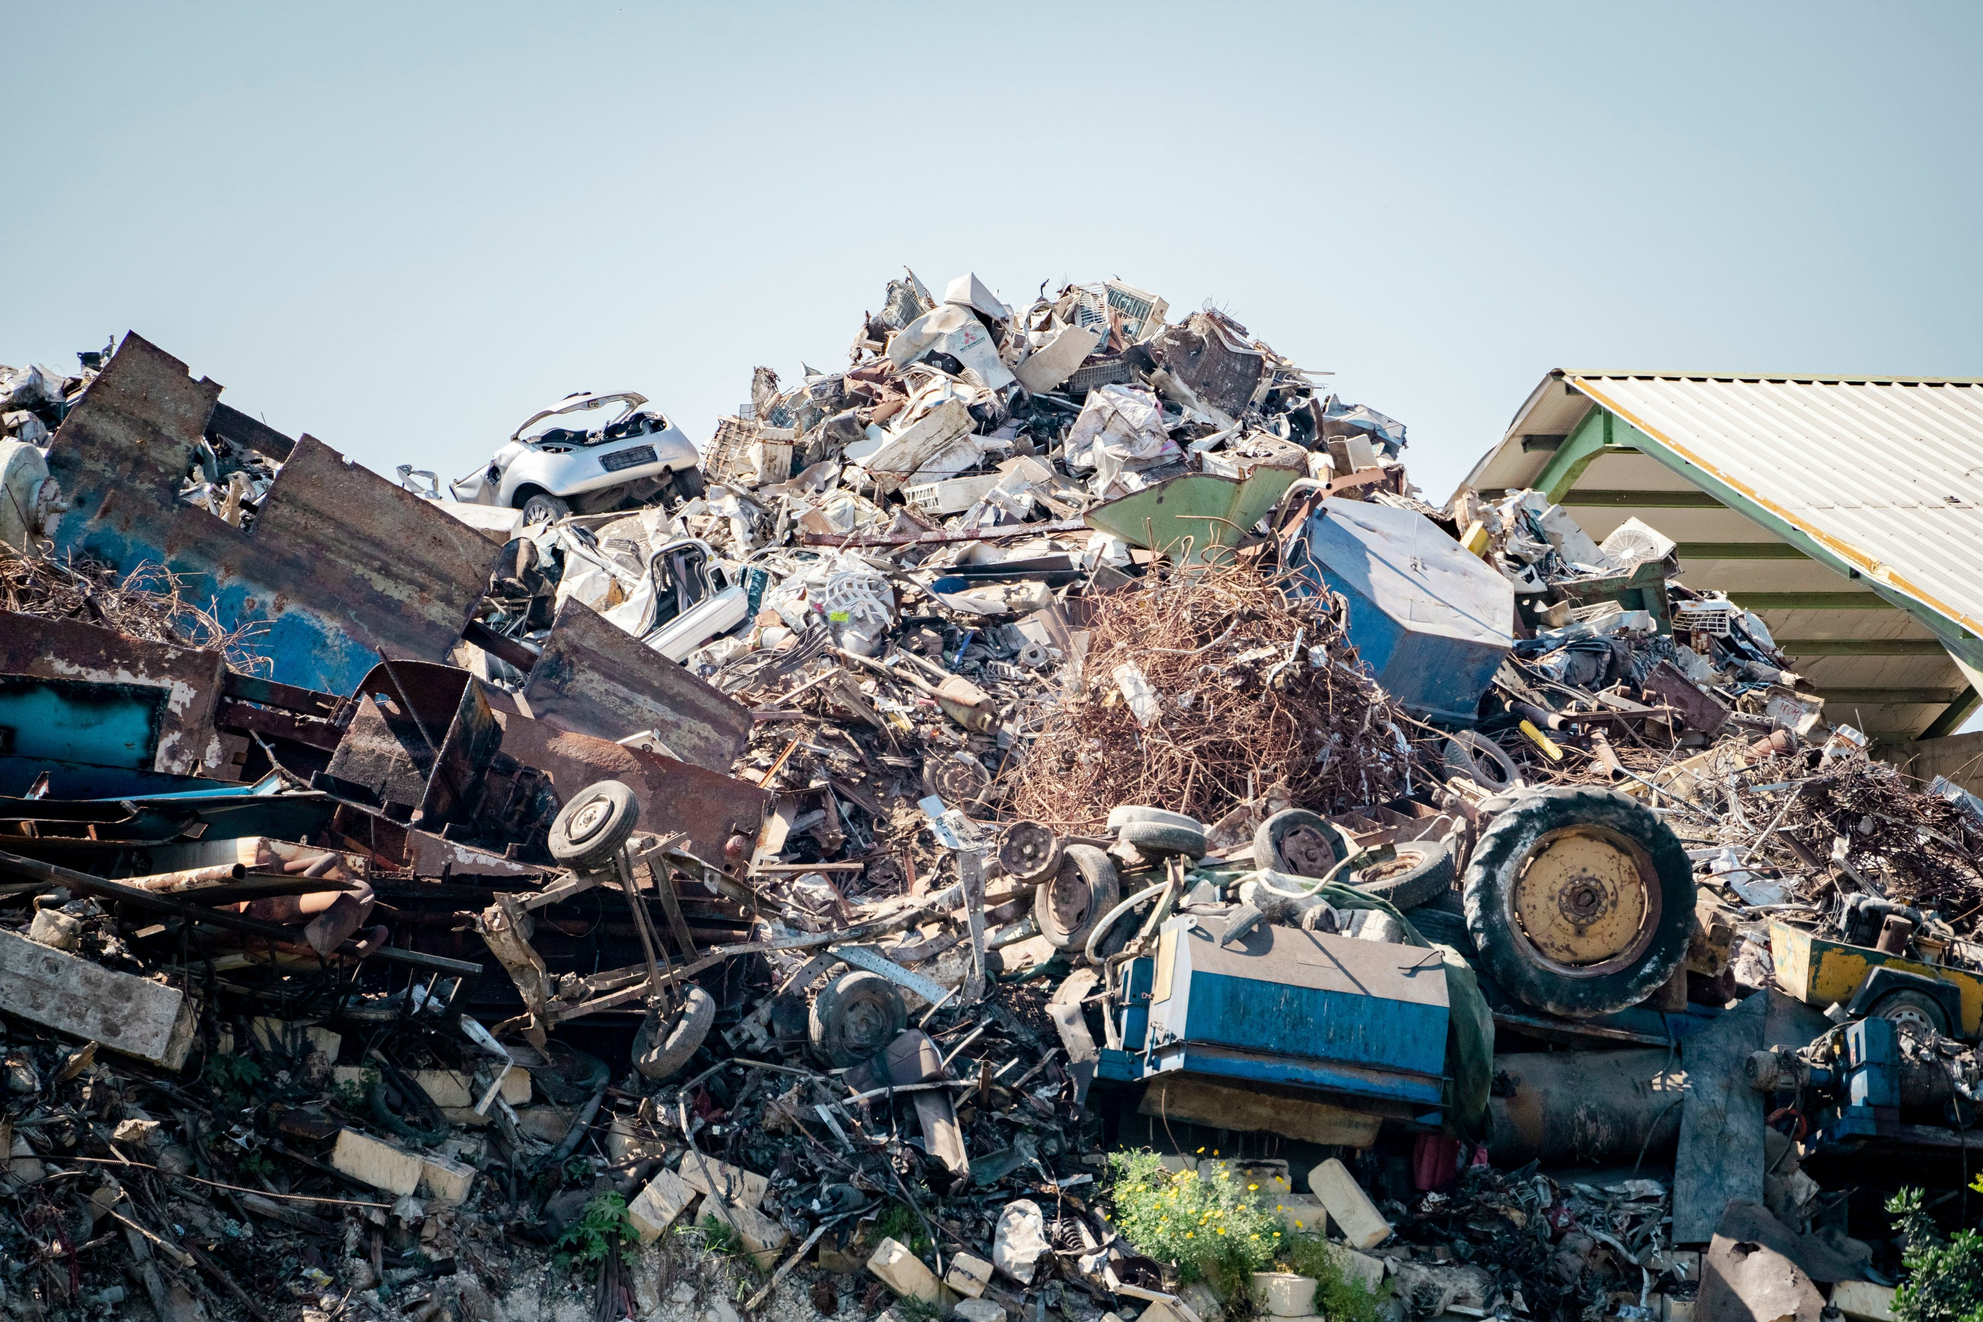

Metals are valuable materials. Recycling metals helps save energy and reduces waste. The recycling process starts with collecting used metal items, like cans and old cars. These items are then sorted and cleaned to remove non-metal parts.
Next, the metals are melted down in large furnaces. This process turns the solid metal into liquid. After melting, the liquid metal is poured into molds to create new shapes. For example, aluminum cans can become new cans again.
Recycling metals uses less energy than making new metals. It also helps to conserve natural resources. By recycling, we reduce pollution and protect the environment. Every small action counts, so recycling metal can make a big difference.
In summary, recycling metals is important for our planet. It saves energy, reduces waste, and helps create new products.
Questions:
1. Define the term 'recycling'. (1 mark)
2. State one benefit of recycling metals. (1 mark)
3. Describe the first step in the metal recycling process. (1 mark)
4. Name one item that can be recycled into new metal products. (1 mark)
5. If a community increases its metal recycling, what impact might this have on energy use? (4 marks)
MARK SCHEME:
1. Recycling is the process of collecting and processing used materials.
2. One benefit of recycling metals is that it saves energy.
3. The first step in the metal recycling process is collecting used metal items.
4. One item that can be recycled into new metal products is aluminum cans.
5. If a community increases its metal recycling, it may reduce energy use significantly by lowering the need for new metal production.

DRILL QUESTIONS
1. What are the two conditions that are both necessary for iron to rust?
2. Explain why aluminium is extracted by electrolysis rather than by reduction with carbon.
3. Write the ionic equation for the reaction between zinc and hydrochloric acid.

MARK SCHEME
1. Both oxygen and water are necessary for iron to rust.
2. Aluminium is more reactive than carbon, so it cannot be extracted by reduction with carbon (or aluminium reacts with carbon).
3. Zn(s) + 2H+(aq) → Zn2+(aq) + H2(g)

