Read Now: Feedback Lesson Date:

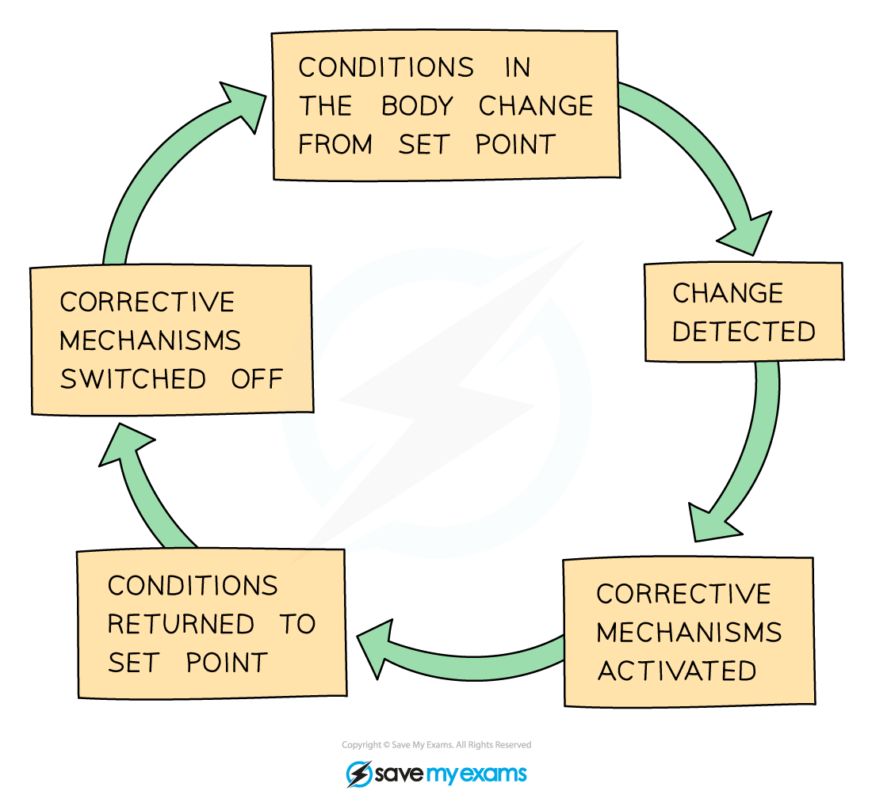

In class, we often learn new things. Sometimes, we may not understand everything. This is normal! A fix-it lesson helps us correct our mistakes. It is a chance to fill in gaps in our knowledge.
After a lesson, teachers use an exit ticket. This is a quick check. It shows what we understood and what we need to work on. If many students struggle with a topic, the teacher will focus on that. This way, everyone can improve.
Using everyday examples helps us see the big picture. Think of a puzzle. If one piece is missing, the picture isn't complete. Fix-it lessons help us find those missing pieces in our learning. By addressing gaps, we build a stronger foundation in chemistry.
Questions:
1. Define a key term.
2. Recall a fact about exit tickets.
3. What do fix-it lessons help us do?
4. Why are everyday examples useful?
5. Imagine you did poorly on a topic. How would a fix-it lesson help you?

MARK SCHEME
1. Fix-it lessons help us correct mistakes and improve understanding.
2. An exit ticket shows what students understood after a lesson.
3. Fix-it lessons help us fill in gaps in our knowledge.
4. Everyday examples make complex ideas easier to understand.
5. A fix-it lesson would review the topic, explain it clearly, and allow practice to improve understanding.

DRILL QUESTIONS
1. What are the two essential conditions required for iron to rust, and why is this knowledge useful for preventing corrosion?
2. Explain why aluminium is extracted by electrolysis rather than by reduction with carbon, and state one reason why cryolite is mixed with aluminium oxide during this process.
3. Write the ionic equation for the reaction between zinc and hydrochloric acid, and identify which species is oxidised in this reaction.

MARK SCHEME
1. Both oxygen and water are necessary for iron to rust. This knowledge allows us to prevent rusting by creating barriers (painting, greasing) or removing these conditions.
2. Aluminium is too reactive to be extracted by reduction with carbon (or aluminium reacts with carbon). Cryolite has a much lower melting point than aluminium oxide, reducing energy costs.
3. Zn(s) + 2H⁺(aq) → Zn²⁺(aq) + H₂(g). Zinc is oxidised (loses electrons to form Zn²⁺ ions).

