Read Now: Extracting Less Reactive Metals Date:

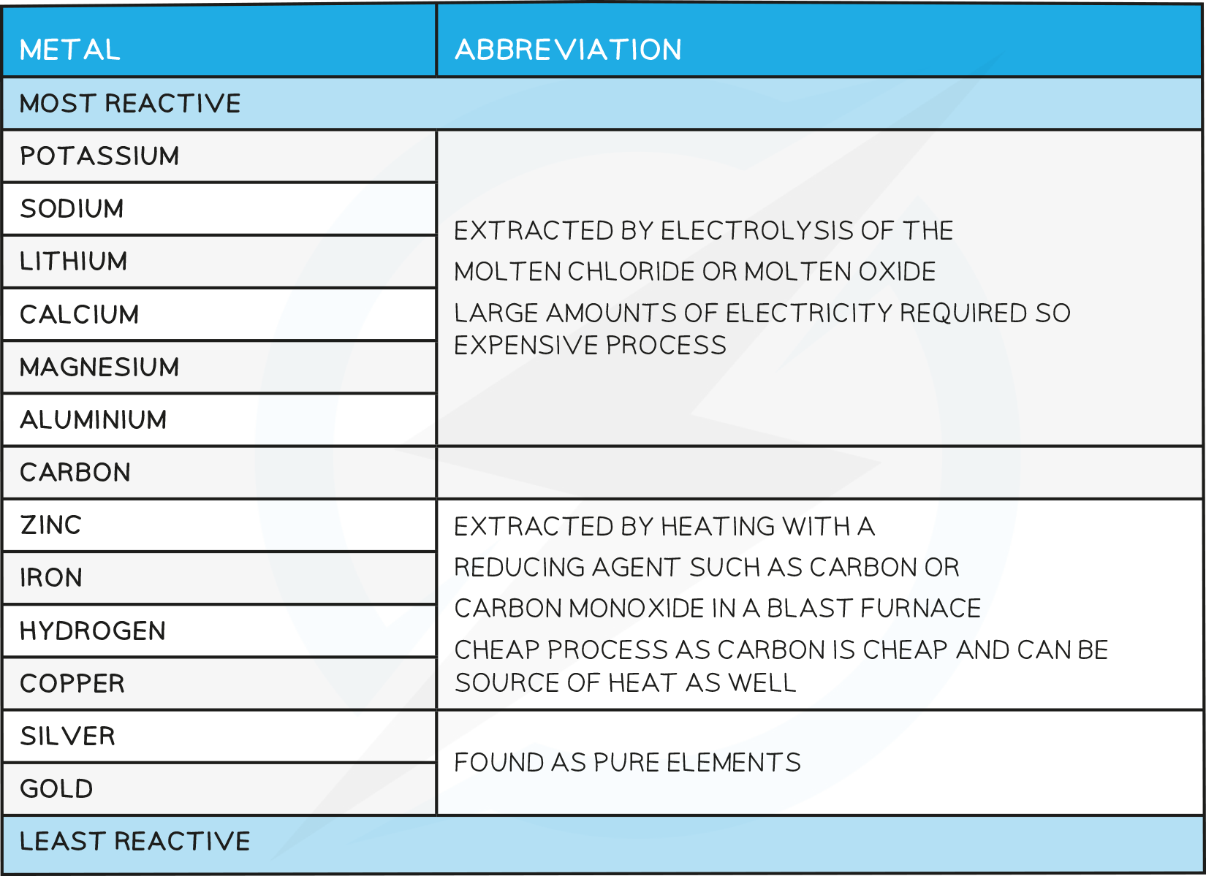

Metals are found in the Earth, often mixed with other elements. To get pure metals, we need to extract them. Less reactive metals, like copper and gold, are easier to extract than more reactive ones, such as aluminum.
For less reactive metals, we can use simple methods. One common way is heating the metal ore with carbon. Carbon pulls out the metal, leaving behind other materials. This method works well for metals that do not react with carbon.
Another method involves using acid. When we add acid to metal ores, it can dissolve the metal. This makes it easier to collect the pure metal later.
Understanding these methods helps us see how we can obtain metals for everyday use, like in electronics and jewelry.
Questions:
1. Define a key term.
2. Recall a fact.
3. Recall another fact.
4. Recall another fact.
5. How would you extract copper from its ore?

MARK SCHEME
1. Extract: To obtain a metal from its ore.
2. Less reactive metals are easier to extract than reactive ones.
3. Heating metal ore with carbon helps to extract less reactive metals.
4. Acid can dissolve metal ores to collect pure metals.
5. To extract copper, heat its ore with carbon or use acid to dissolve it.

DRILL QUESTIONS
1. What are the products formed when zinc reacts with hydrochloric acid?
2. Explain why the reaction between magnesium and oxygen is classified as an oxidation reaction.
3. Define what is meant by a reactivity series of metals.

MARK SCHEME
1. Zinc chloride (salt) and hydrogen gas are produced.
2. It is an oxidation reaction because the magnesium gains oxygen to form magnesium oxide.
3. A reactivity series is a list of metals arranged in order from most reactive (at the top) to least reactive (at the bottom).

