Read Now: Prior Knowledge Review Ions, Ionic Bonding and Deducing Ionic Formulae Date:

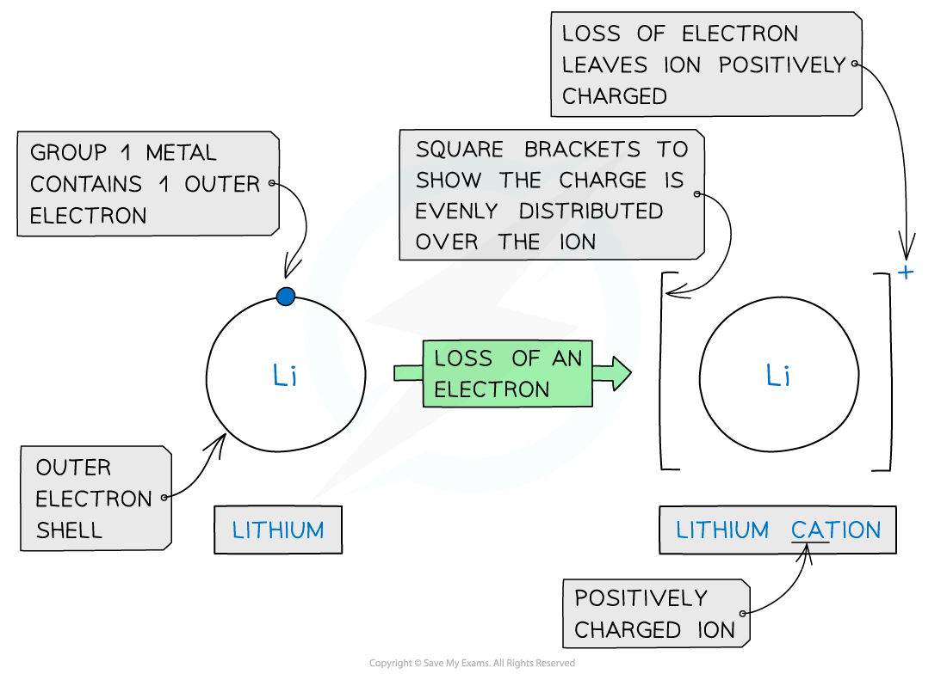

Ions are charged atoms or molecules. They form when atoms gain or lose electrons. When an atom loses an electron, it becomes a positive ion or cation. When an atom gains an electron, it becomes a negative ion or anion.
Ionic bonding happens between cations and anions. These oppositely charged ions attract each other. This attraction forms strong bonds, creating ionic compounds. A common example is table salt, made of sodium (Na+) and chloride (Cl-).
To write an ionic formula, we need to consider the charges. For sodium chloride, sodium has a charge of +1 and chloride has a charge of -1. One of each ion combines to balance the charges. Thus, the formula is NaCl.
Understanding how ions form helps us grasp ionic bonding and how to write ionic formulas.
Questions:
1. Define a key term.
2. Recall a fact.
3. Recall another fact.
4. Recall another fact.
5. Apply knowledge/solve a problem.

MARK SCHEME
1. Ion: A charged atom or molecule.
2. Ions form when atoms gain or lose electrons.
3. Cations are positive ions formed by losing electrons.
4. Anions are negative ions formed by gaining electrons.
5. Write the formula for magnesium chloride. Magnesium has a +2 charge and chloride has a -1 charge. You need two chloride ions to balance one magnesium ion. The formula is MgCl2.

DRILL QUESTIONS
1. What gas is produced when metals react with acids?
2. Explain why gold is found in the Earth as the metal itself rather than as a compound.
3. Define what happens during reduction in terms of oxygen.

MARK SCHEME
1. Hydrogen gas is produced when metals react with acids.
2. Gold is found as the metal itself because it is unreactive and does not easily take part in chemical reactions.
3. Reduction involves the loss of oxygen from a substance.

