Read Now: (HT) Ionic Equations and Displacement Reactions Date:

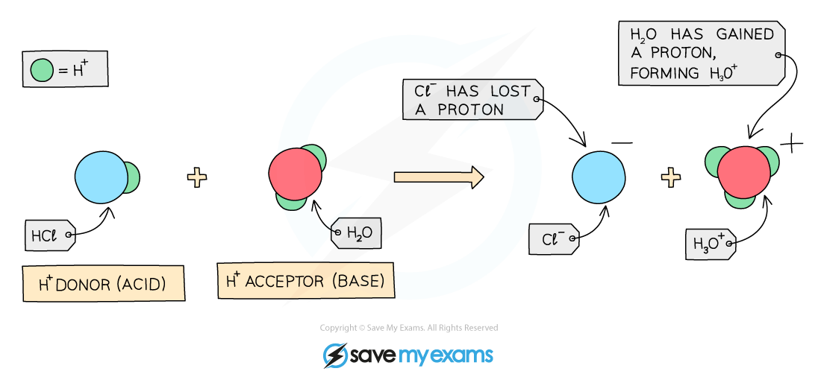

In chemistry, ions are charged atoms or molecules. They can be positive or negative. A displacement reaction occurs when one ion replaces another in a compound. This can be shown with ionic equations, which focus on the ions involved.
To write an ionic equation, start with the balanced chemical equation. Next, break down all soluble salts into their ions. For example, in the reaction between sodium chloride (NaCl) and silver nitrate (AgNO₃), the equation is NaCl + AgNO₃ → AgCl + NaNO₃. The ionic equation shows Na⁺ + Cl⁻ + Ag⁺ + NO₃⁻ → AgCl + Na⁺ + NO₃⁻. Here, Ag⁺ replaces Na⁺, forming a solid silver chloride (AgCl).
Remember, only the ions that change are shown in the final ionic equation. This simplified view helps us understand how displacement reactions happen.
Questions:
1. Define the term 'ion.' (1 mark)
2. What is a displacement reaction? (1 mark)
3. Name one component of an ionic equation. (1 mark)
4. What does it mean to break down soluble salts into ions? (1 mark)
5. Write the ionic equation for the reaction between NaCl and AgNO₃. (4 marks)
MARK SCHEME:
1. An ion is a charged atom or molecule.
2. A displacement reaction occurs when one ion replaces another in a compound.
3. One component of an ionic equation is an ion.
4. It means to separate the soluble salts into their ions.
5. The ionic equation is Na⁺ + Cl⁻ + Ag⁺ + NO₃⁻ → AgCl + Na⁺ + NO₃⁻.

DRILL QUESTIONS
1. What is the charge on an ion formed when a Group 2 metal atom reacts with a non-metal?
2. Explain why zinc can be extracted from zinc oxide using carbon, but sodium cannot be extracted from sodium oxide using carbon.
3. Define what happens during a reduction reaction in terms of oxygen.

MARK SCHEME
1. The ion has a charge of +2 (because Group 2 metals lose 2 electrons to achieve a noble gas electronic structure).
2. Zinc is less reactive than carbon so carbon can displace it from its oxide, but sodium is more reactive than carbon so carbon cannot displace it.
3. Reduction is the loss of oxygen from a compound.

