Read Now: (HT) Writing Half Equations Date:

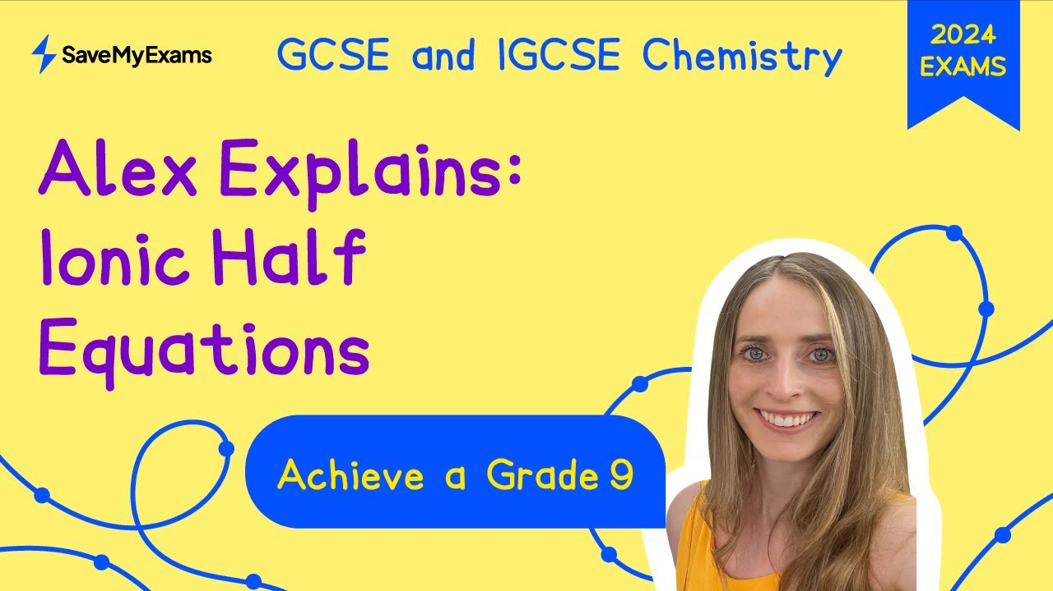

In chemistry, we can split an ionic equation into two parts. These parts are called half equations. Each half equation shows what happens to either the reactants or the products.
One half equation shows oxidation, where an atom loses electrons. For example, when iron rusts, it loses electrons. The other half equation shows reduction, where an atom gains electrons. In the case of rusting, oxygen gains electrons.
To write a half equation, start with the correct ion. Then, add or remove electrons. Make sure to balance the charges. This process helps us understand how chemical reactions work in detail.
By splitting the equation, we can see the changes happening in each part. This makes it easier to study redox reactions and understand how energy is transferred.
Questions:
1. Define a key term.
2. Recall a fact about half equations.
3. What does oxidation involve in half equations?
4. What does reduction involve in half equations?
5. Write a half equation for the oxidation of magnesium.
MARK SCHEME:
1. A half equation shows what happens to reactants or products.
2. A half equation can show oxidation or reduction.
3. Oxidation involves an atom losing electrons.
4. Reduction involves an atom gaining electrons.
5. The half equation for the oxidation of magnesium is: Mg → Mg²⁺ + 2e⁻.

DRILL QUESTIONS
1. What happens to electrons when a metal atom reacts with a non-metal atom, and what types of ions are formed?
2. Why can zinc displace copper from copper sulfate solution, but copper cannot displace zinc from zinc sulfate solution?
3. Define oxidation and reduction in terms of electron transfer.

MARK SCHEME
1. Electrons in the outer shell of the metal atom are transferred to the non-metal atom. Metal atoms lose electrons to become positively charged ions, and non-metal atoms gain electrons to become negatively charged ions.
2. Zinc is more reactive than copper, so it can displace the less reactive copper from its compound. Copper is less reactive than zinc, so it cannot displace the more reactive zinc.
3. Oxidation is the loss of electrons and reduction is the gain of electrons.

