Read Now: (HT) Ionic Equations for the Reactions of Acids and Metals Date:

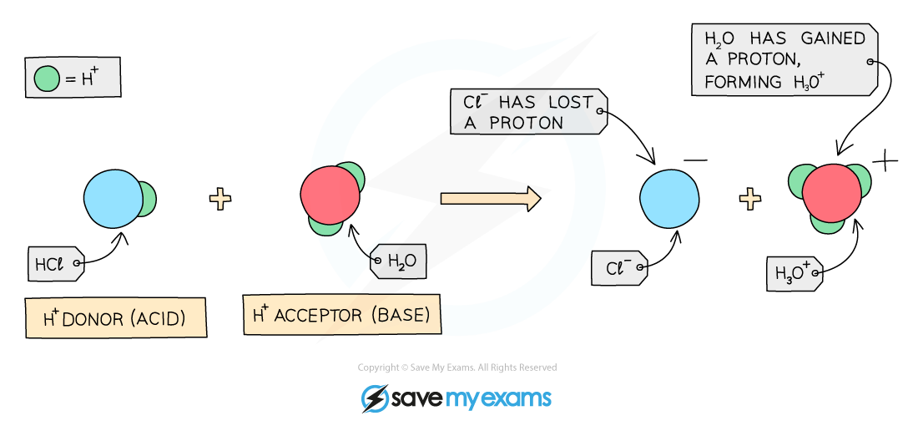

Acids react with metals to produce hydrogen gas and a salt. This reaction shows how metals can be ionized in the presence of acids. For example, when zinc reacts with hydrochloric acid, it forms zinc chloride and hydrogen gas.
The reaction can be written as a chemical equation:
Zinc + Hydrochloric Acid → Zinc Chloride + Hydrogen.
In ionic equations, we focus on the ions. The zinc ions and hydrogen ions are important in understanding how the reaction happens.
In simple terms, the metal loses electrons to become a positive ion. The hydrogen ions from the acid gain these electrons to form hydrogen gas. This is why we see bubbles during the reaction.
Knowing how to write these equations helps us understand chemical reactions better.
Questions:
1. Define a key term.
2. Recall a fact about the products of acid and metal reactions.
3. Recall another fact about the reactants in these reactions.
4. Recall another fact about what happens to metals in these reactions.
5. If you have 2 grams of zinc reacting with hydrochloric acid, what would you expect to observe?

MARK SCHEME
1. Ionic is a type of chemical that involves charged ions.
2. Acids react with metals to produce hydrogen gas and a salt.
3. Zinc is an example of a metal that reacts with acids.
4. Metals lose electrons to form positive ions in reactions.
5. You would observe bubbles of hydrogen gas being released.

DRILL QUESTIONS
1. What happens to electrons when a metal atom from Group 2 reacts with a non-metal atom from Group 7?
2. Explain why zinc can displace copper from copper sulfate solution, but copper cannot displace zinc from zinc sulfate solution.
3. Define oxidation and reduction in terms of electron transfer.

MARK SCHEME
1. The Group 2 metal atom loses 2 electrons to become a 2+ ion, and the Group 7 non-metal atom gains 1 electron to become a 1- ion.
2. Zinc is more reactive than copper, so it can displace the less reactive copper from its compound. Copper is less reactive than zinc, so it cannot displace the more reactive zinc.
3. Oxidation is the loss of electrons and reduction is the gain of electrons.

