Read Now: Introduction to Electrolysis Date:

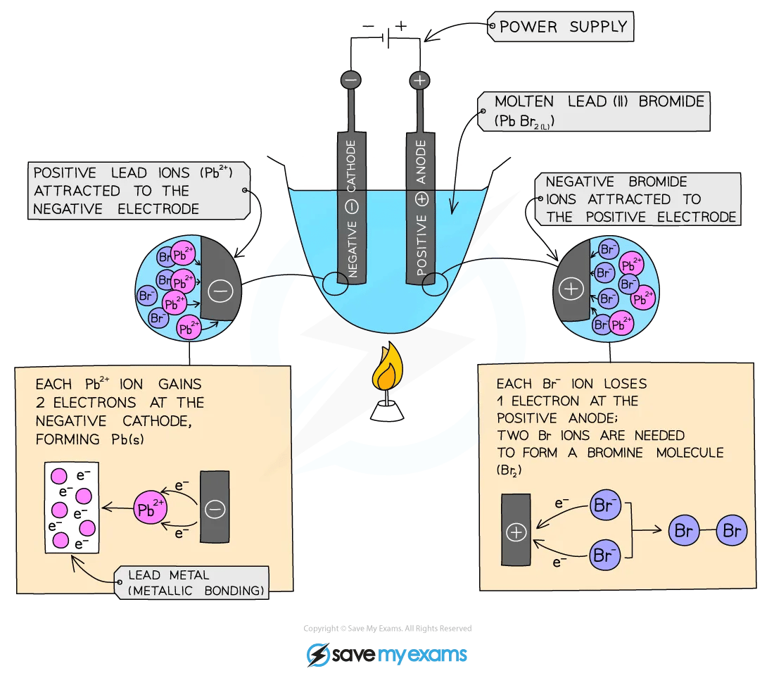

Electricity can break down substances in a process called electrolysis. In this process, an electric current flows through a liquid or solution. This liquid must conduct electricity, which means it has ions that can move.
During electrolysis, the ions move to different parts of the liquid. Positive ions go to the negative electrode, called the cathode. Negative ions move to the positive electrode, called the anode. This movement causes the substances to break apart and form new materials.
A common example of electrolysis is splitting water into hydrogen and oxygen. When electricity is passed through water, it separates into these two gases. Electrolysis is also used in industries to extract metals from ores.
Understanding electrolysis helps us see how electricity can change materials and create new things.
Questions:
1. Define electrolysis.
2. What must a liquid have to conduct electricity?
3. Where do positive ions move during electrolysis?
4. Give an example of a substance that can be split by electrolysis.
5. If you want to separate sodium chloride (table salt) using electrolysis, what would you need to do? What products would you expect to see?
MARK SCHEME:
1. Electrolysis is the process of breaking down substances using electricity.
2. A liquid must have ions to conduct electricity.
3. Positive ions move to the negative electrode, called the cathode.
4. Water can be split into hydrogen and oxygen by electrolysis.
5. You would need a solution of sodium chloride and apply electricity. You would expect to see hydrogen gas at the cathode and chlorine gas at the anode.

DRILL QUESTIONS
1. What are the two half equations for the reaction between zinc and hydrochloric acid?
2. Explain why gold can be found in the Earth as the metal itself, while iron must be extracted from compounds.
3. Define oxidation and reduction in terms of electrons.

MARK SCHEME
1. Zn → Zn²⁺ + 2e⁻ (oxidation) and 2H⁺(aq) + 2e⁻ → H₂(g) (reduction)
2. Gold is unreactive/less reactive than carbon so it doesn't readily form compounds, while iron is more reactive and forms compounds that require extraction.
3. Oxidation is the loss of electrons and reduction is the gain of electrons.

