Read Now: Extracting Metals by Electrolysis Date:

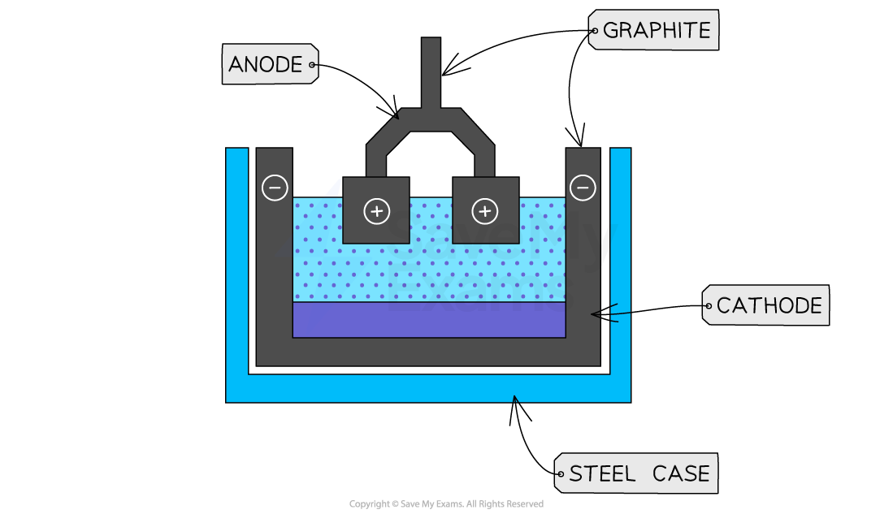

Electrolysis is a method to extract metals from their ores. An ore is a rock containing enough metal to be useful. In electrolysis, we use electricity to break down compounds into their basic parts.
The process starts by placing the ore in a solution. This solution contains ions, which can move freely. When electricity is passed through, the ions move towards the electrodes. The positive ions go to the cathode (negative electrode) and gain electrons. This turns them into neutral metal atoms. The negative ions move to the anode (positive electrode) and lose electrons.
For example, to extract aluminum, we use aluminum oxide. This process separates aluminum from oxygen. Electrolysis is important for metals that are high on the reactivity series, like aluminum and sodium.
In summary, electrolysis is a powerful way to get pure metals from their ores using electricity.
Questions
1. Define the term 'ore'. (1 mark)
2. How do positive ions behave in electrolysis? (1 mark)
3. What happens at the cathode during electrolysis? (1 mark)
4. Name a metal that is extracted using electrolysis. (1 mark)
5. Explain why electrolysis is used for aluminum extraction. (4 marks)
MARK SCHEME
1. An ore is a rock containing enough metal to be useful.
2. Positive ions move towards the cathode (negative electrode).
3. At the cathode, positive ions gain electrons to become neutral atoms.
4. Aluminum is a metal that is extracted using electrolysis.
5. Electrolysis is used for aluminum because it is high on the reactivity series, making it difficult to extract by other methods.

DRILL QUESTIONS
1. What happens to ions when an electric current is passed through an electrolyte during electrolysis?
2. Why can gold be found naturally in the Earth as the metal itself, while most other metals are found as compounds?
3. Write the ionic equation for the reaction between iron and hydrochloric acid.

MARK SCHEME
1. Positively charged ions move to the cathode (negative electrode) where they are reduced by gaining electrons, and negatively charged ions move to the anode (positive electrode) where they are oxidised by losing electrons.
2. Gold is unreactive/less reactive than other metals, so it does not readily take part in chemical reactions with other substances.
3. Fe(s) + 2H+(aq) → Fe2+(aq) + H2(g)

