Read Now: Electrolysis of Molten Ionic Compounds Date:

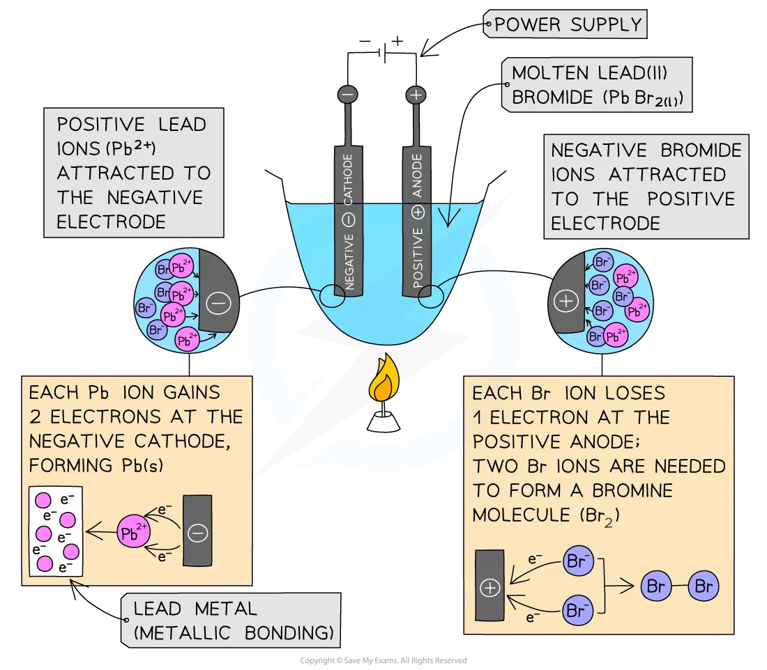

During electrolysis, we break down ionic compounds using electricity. When an ionic compound is melted, it becomes a liquid. This liquid contains ions that can move freely.
In this process, we use two electrodes: the anode (positive) and the cathode (negative). Positively charged cations move to the cathode. Here, they gain electrons and become neutral atoms. Negatively charged anions move to the anode. They lose electrons and form neutral atoms as well.
For example, when we melt sodium chloride (table salt) and perform electrolysis, sodium ions go to the cathode. They become sodium metal. Chloride ions go to the anode to form chlorine gas. This shows how ions change into elements during electrolysis.
In summary, electrolysis of molten ionic compounds allows us to create pure elements from their compounds.
Questions:
1. Define the term ‘electrolysis’. (1 mark)
2. State what happens to cations during electrolysis. (1 mark)
3. Name an example of an ionic compound used in electrolysis. (1 mark)
4. Describe what happens at the anode during electrolysis. (1 mark)
5. If potassium bromide is melted and electrolyzed, what elements are formed? (4 marks)
MARK SCHEME:
1. Electrolysis is the process of breaking down ionic compounds using electricity.
2. Cations gain electrons at the cathode and become neutral atoms.
3. An example of an ionic compound is sodium chloride.
4. At the anode, anions lose electrons and form neutral atoms.
5. Electrolysis of potassium bromide forms potassium metal and bromine gas.

DRILL QUESTIONS
1. What happens to electrons when a metal atom reacts with a non-metal atom to form an ionic compound?
2. Why is cryolite mixed with aluminium oxide during the electrolysis extraction of aluminium?
3. Write the half equation for the oxidation of zinc when it reacts with hydrochloric acid.

MARK SCHEME
1. Electrons in the outer shell of the metal atom are transferred to the non-metal atom. The metal loses electrons to become a positive ion and the non-metal gains electrons to become a negative ion.
2. Cryolite has a much lower melting point than aluminium oxide, which reduces the energy costs required to melt the mixture.
3. Zn → Zn²⁺ + 2e⁻

