Read Now: Taking it Further Alkenes Date:

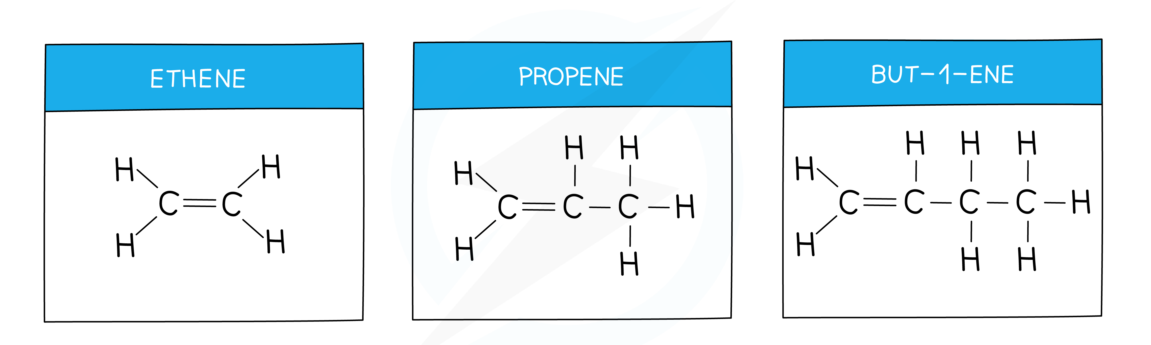

Alkenes are a group of hydrocarbons that contain a carbon-carbon double bond. This double bond makes alkenes more reactive than alkanes. Common examples of alkenes include ethylene and propylene.
Alkenes can undergo a process called addition reaction. In this reaction, the double bond breaks and new atoms are added. For example, when ethylene reacts with bromine, it forms dibromoethane. This is an important reaction in making various chemicals and plastics.
Alkenes are also used in the production of alcohols. For instance, when alkenes react with water in the presence of an acid, they form alcohols. This process is known as hydration.
Understanding alkenes helps in many industries, from manufacturing to food processing. Their versatility makes them essential in daily life.
Questions:
1. Define the term 'alkene'.
2. State one example of an alkene.
3. What type of reaction do alkenes undergo?
4. Describe what happens in an addition reaction.
5. If ethylene reacts with water, what product is formed? Explain the process briefly.

MARK SCHEME
1. An alkene is a hydrocarbon with a carbon-carbon double bond.
2. One example of an alkene is ethylene.
3. Alkenes undergo an addition reaction.
4. In an addition reaction, the double bond breaks and new atoms are added.
5. Ethylene reacts with water to form alcohol. This is done through hydration.

