Read Now: Taking it Further Alkenes Date:

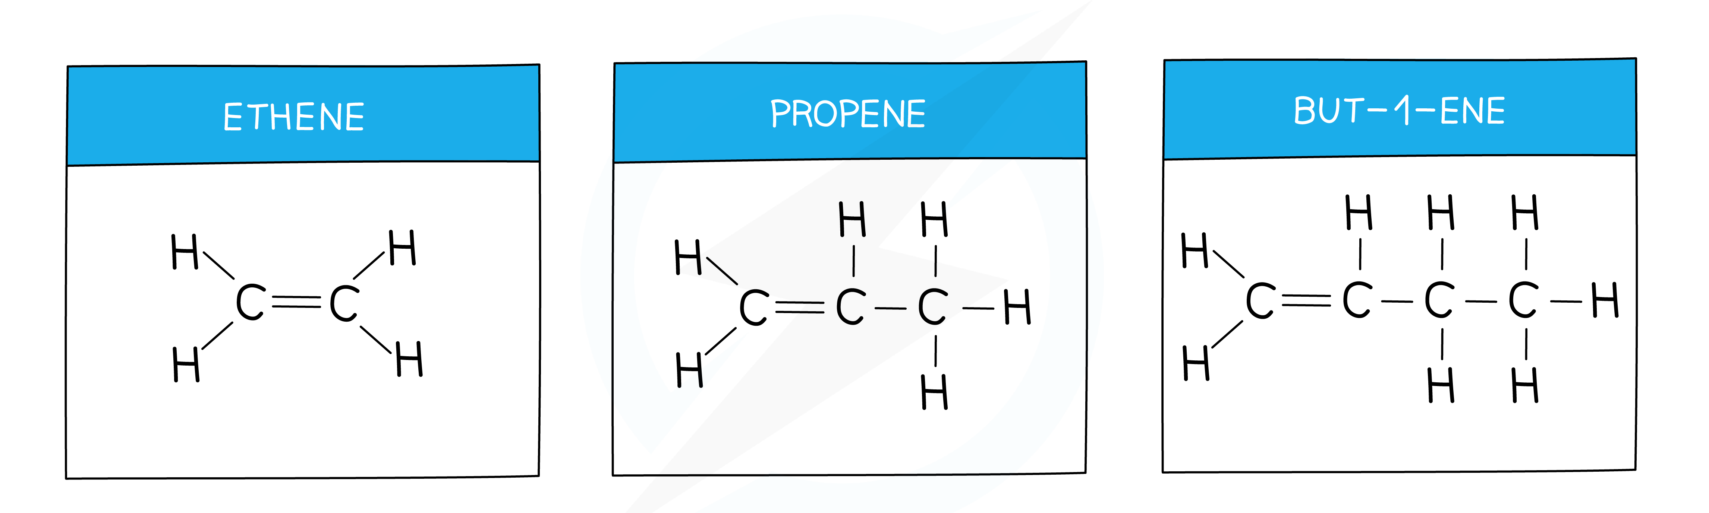

Alkenes are a group of hydrocarbons with at least one double bond between carbon atoms. This double bond makes them more reactive than alkanes, which only have single bonds. A common example of an alkene is ethylene, found in fruits. Alkenes can undergo a process called addition reaction, where new atoms attach to the carbon atoms. This makes them useful in making plastics and other products. Understanding alkenes helps us see how we use chemistry in everyday life.
Questions:
1. What is an alkene? A) A type of metal B) A group of hydrocarbons C) A single bond D) A gas
2. The process of _____ occurs when new atoms attach to alkenes.
3. State one use of alkenes.
4. Describe what happens during an addition reaction.
5. Explain what an alkene is.
WHAT: Alkenes are hydrocarbons with a double bond.
WHY: The double bond makes them more reactive than alkanes.

MARK SCHEME
1. B
2. addition reaction
3. Alkenes are used to make plastics.
4. During an addition reaction, new atoms bond with the alkene.
5. WHAT: Alkenes are hydrocarbons with a double bond. WHY: The double bond makes them more reactive than alkanes.

