Read Now: Eukaryotic and Prokaryotic Cells Date:

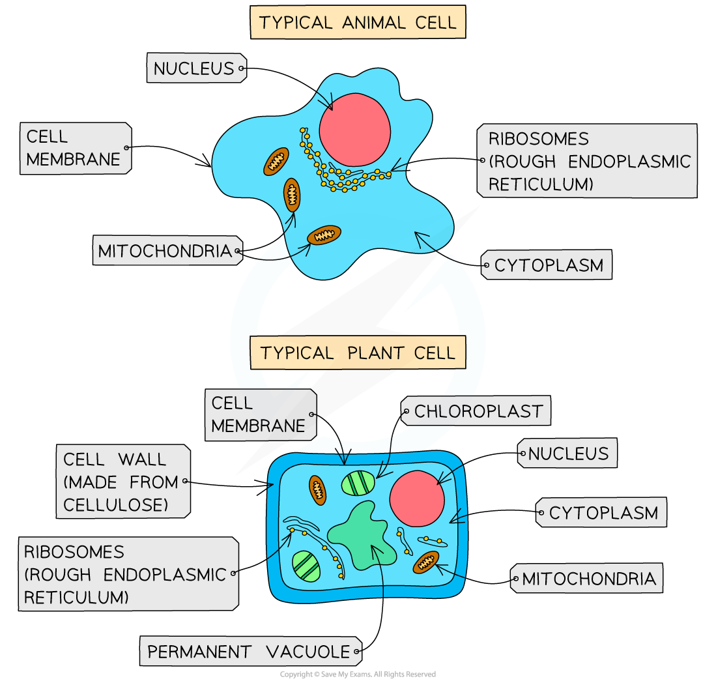

Cells are the building blocks of life. There are two main types: eukaryotic and prokaryotic cells.
Eukaryotic cells are larger and more complex. They have a nucleus, which holds genetic material. Examples include human cells and plant cells.
Prokaryotic cells are smaller and simpler. They do not have a nucleus. Their genetic material floats in the cell. Bacteria are common examples of prokaryotic cells.
In summary, eukaryotic cells are complex with a nucleus, while prokaryotic cells are simple without one.
Questions:
1. What are the two main types of cells? (look at line 1)
2. Name one example of a eukaryotic cell. (look at line 5)
3. What is a key feature of prokaryotic cells? (look at line 6)
4. Define eukaryotic cells. (look at lines 2-3)
5. Why do prokaryotic cells not have a nucleus? (look at lines 6-7)

MARK SCHEME
1. Eukaryotic and prokaryotic cells.
2. Human cells or plant cells.
3. They do not have a nucleus.
4. Larger and more complex cells with a nucleus.
5. Their genetic material floats in the cell.

