Read Now: Biodiversity Date:

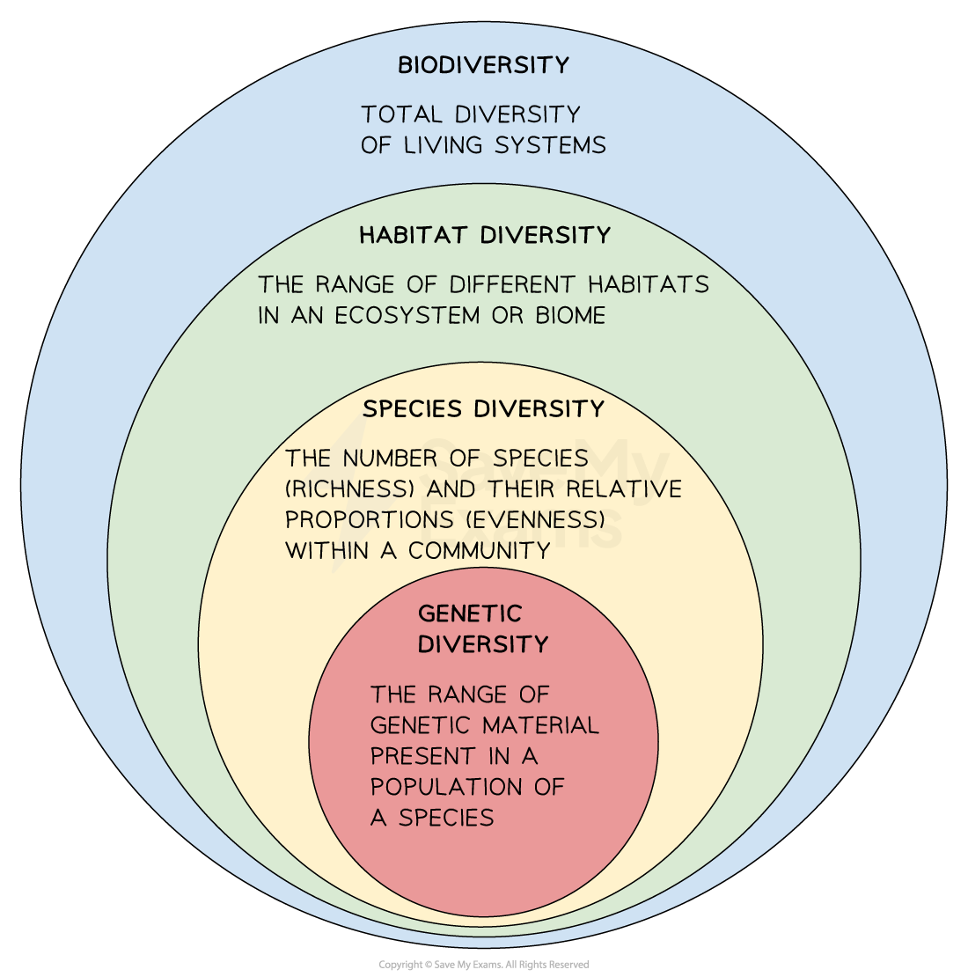

High biodiversity means many different plants and animals live together. This variety helps an ecosystem stay healthy and strong. For example, a forest with many tree types supports different animals. If one tree type dies, others can still survive. This keeps the ecosystem stable. High biodiversity also means better food sources and habitats for animals. In contrast, low biodiversity makes ecosystems weak. They may struggle to adapt to changes, like climate change or diseases. A stable ecosystem can recover from problems more easily. Protecting biodiversity is important for our planet's health.
Questions:
1. What is biodiversity? (look at line 1)
2. How does high biodiversity help ecosystems? (look at lines 2-3)
3. Give one example of high biodiversity. (look at line 4)
4. Why is it important to protect biodiversity? (look at line 6)

MARK SCHEME
1. Biodiversity is many different plants and animals living together.
2. High biodiversity helps ecosystems stay healthy and strong.
3. An example of high biodiversity is a forest with many tree types.
4. It is important to protect biodiversity because it keeps ecosystems stable.

