Read Now: How Humans Affect Biodiversity Date:

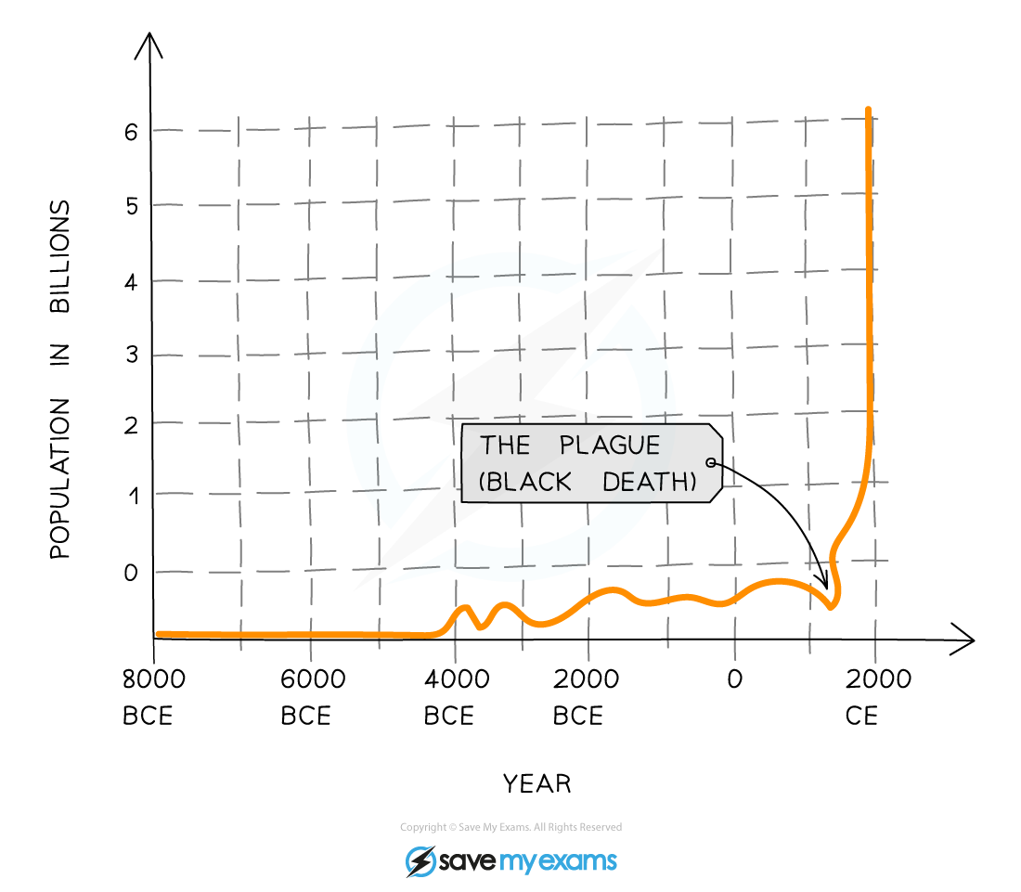

The human population is growing very fast. More people need more resources like food, water, and energy. This means we take more from nature. We cut down forests for farming and housing. This harms biodiversity, which is the variety of plants and animals in an area. More resources also create more waste. Waste can pollute land, water, and air. Pollution affects animals and plants, making them sick or even causing extinction. We must find ways to use resources wisely. This can help protect our planet's biodiversity for the future.
Questions:
1. What is biodiversity? (look at line 1)
2. How does the human population growth affect forest areas? (look at lines 3-4)
3. State one impact of waste on the environment. (look at lines 5-5)
4. Define the term 'pollution'. (look at line 5)
5. Why do we need to protect biodiversity? (look at line 6)

MARK SCHEME
1. Biodiversity is the variety of plants and animals in an area.
2. The human population growth affects forest areas by causing deforestation for farming and housing.
3. One impact of waste on the environment is that it can pollute land, water, and air.
4. Pollution is the introduction of harmful materials into the environment.
5. We need to protect biodiversity to keep our planet healthy for the future.

