Read Now: How Humans can Preserve Biodiversity Date:

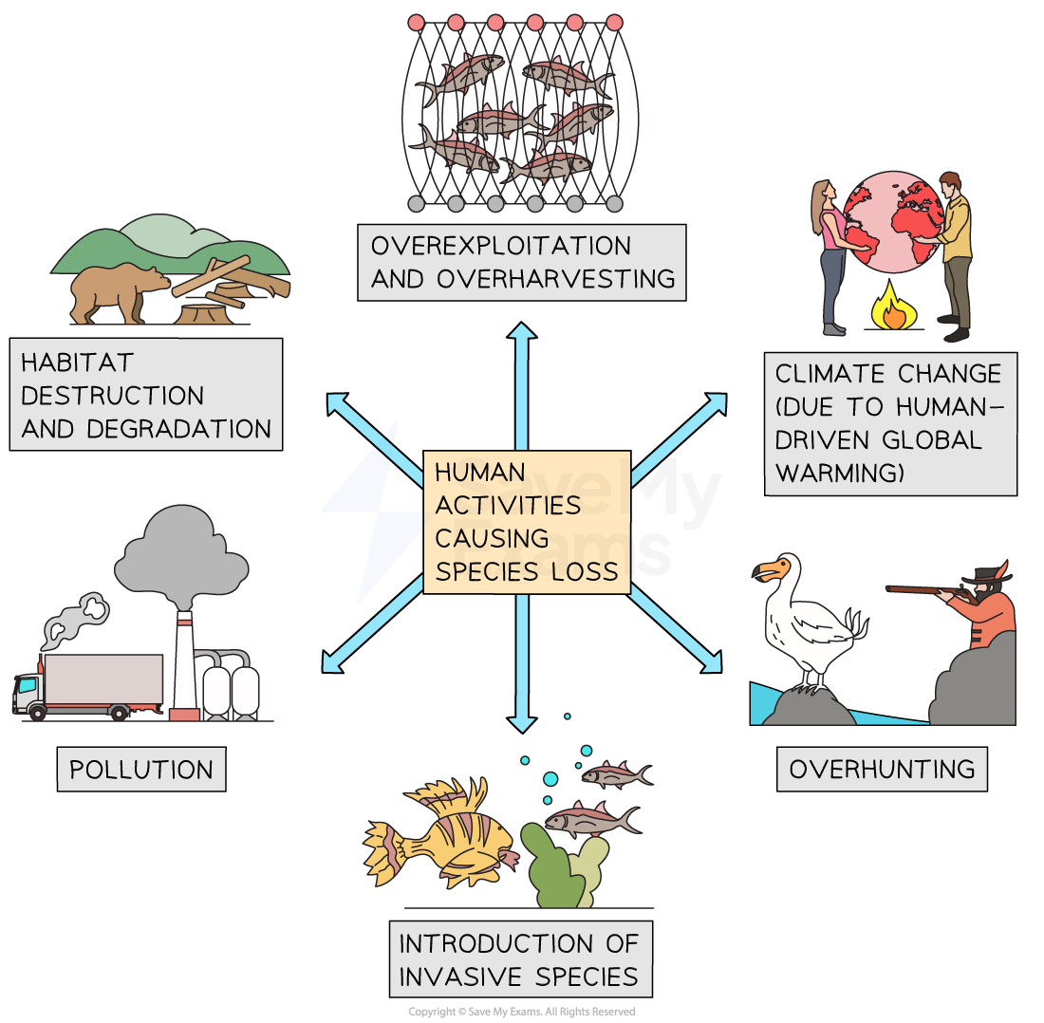

The human population is growing fast. More people means more demand for resources. This includes food, water, and space. To help preserve biodiversity, we can take several steps.
First, we should reduce waste. Recycling helps keep materials in use. Second, planting trees can restore habitats. Third, we can support local farms. This reduces the need for transporting food long distances. Lastly, protecting natural areas keeps ecosystems healthy. Each action helps maintain biodiversity, which is important for our planet's health.
Questions:
1. What is biodiversity? A) Variety of life B) A type of tree C) A water source D) A farming method
2. The process of _____ occurs when we reuse materials.
3. State one way to reduce waste.
4. Describe how planting trees helps the environment.
5. Explain recycling.
WHAT: Recycling keeps materials in use.
WHY: This reduces waste and helps the planet.

MARK SCHEME
1. A
2. recycling
3. By recycling or composting.
4. Planting trees helps by restoring habitats for wildlife.
5. WHAT: Recycling keeps materials in use. WHY: This reduces waste and helps the planet.

