Read Now: The Effect of Pollution on Biodiversity Date:

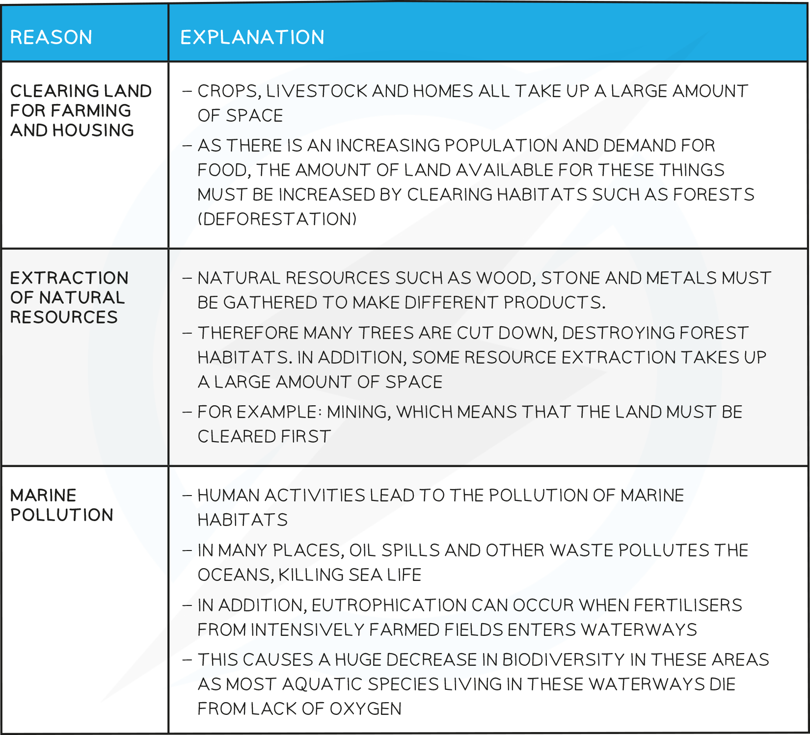

Pollution is harmful to nature. It can reduce biodiversity, which means fewer types of living things. As the human population grows to about 7.7 billion, we create more waste. This waste can pollute the air, water, and land.
For example, plastic in oceans harms fish and other sea life. Chemicals from factories can poison rivers, killing plants and animals. When habitats are destroyed, many species may disappear. This loss affects the balance of ecosystems. Healthy ecosystems are important for clean air and water. They also provide food and other resources for humans.
Questions:
1. What is biodiversity? (look at line 1)
2. How does pollution affect ecosystems? (look at lines 6-7)
3. Name one example of pollution harming sea life. (look at line 5)
4. State one reason why healthy ecosystems are important. (look at line 8)
5. Why does a growing human population increase pollution? (look at line 3)

MARK SCHEME
1. Biodiversity means fewer types of living things. (line 1)
2. Pollution affects ecosystems by harming plants and animals. (lines 6-7)
3. One example is plastic in oceans harming fish. (line 5)
4. Healthy ecosystems provide clean air and water. (line 8)
5. A growing human population increases pollution by creating more waste. (line 3)

