Read Now: Global Warming Date:

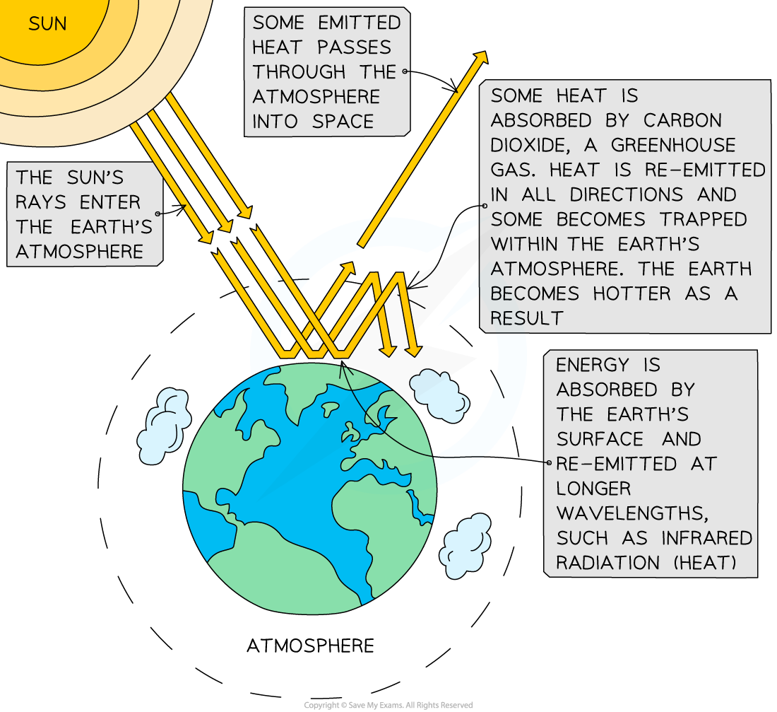

The Earth’s temperature is rising. This is called global warming. It happens because of greenhouse gases. These gases, like carbon dioxide, trap heat from the sun.
Carbon dioxide comes from burning fossil fuels. Fossil fuels are found in cars and factories. Deforestation, or cutting down trees, also adds to this problem. Trees help remove carbon dioxide from the air.
When the Earth gets too warm, ice melts. This raises sea levels. Extreme weather events, like storms and heatwaves, may become more common.
We need to reduce greenhouse gas emissions to protect our planet.
Questions:
1. What is global warming? (look at line 1)
2. Name a greenhouse gas. (look at line 3)
3. How does deforestation contribute to global warming? (look at lines 5-6)
4. What happens when the Earth gets too warm? (look at line 8)
5. Why do we need to reduce greenhouse gas emissions? (look at line 9)
MARK SCHEME:
1. Global warming is the Earth's temperature rising.
2. A greenhouse gas is carbon dioxide.
3. Deforestation adds to global warming by removing trees that absorb carbon dioxide.
4. When the Earth gets too warm, ice melts and sea levels rise.
5. We need to reduce greenhouse gas emissions to protect our planet.

