Read Now: Taking it Further Pyramids of Biomass Date:

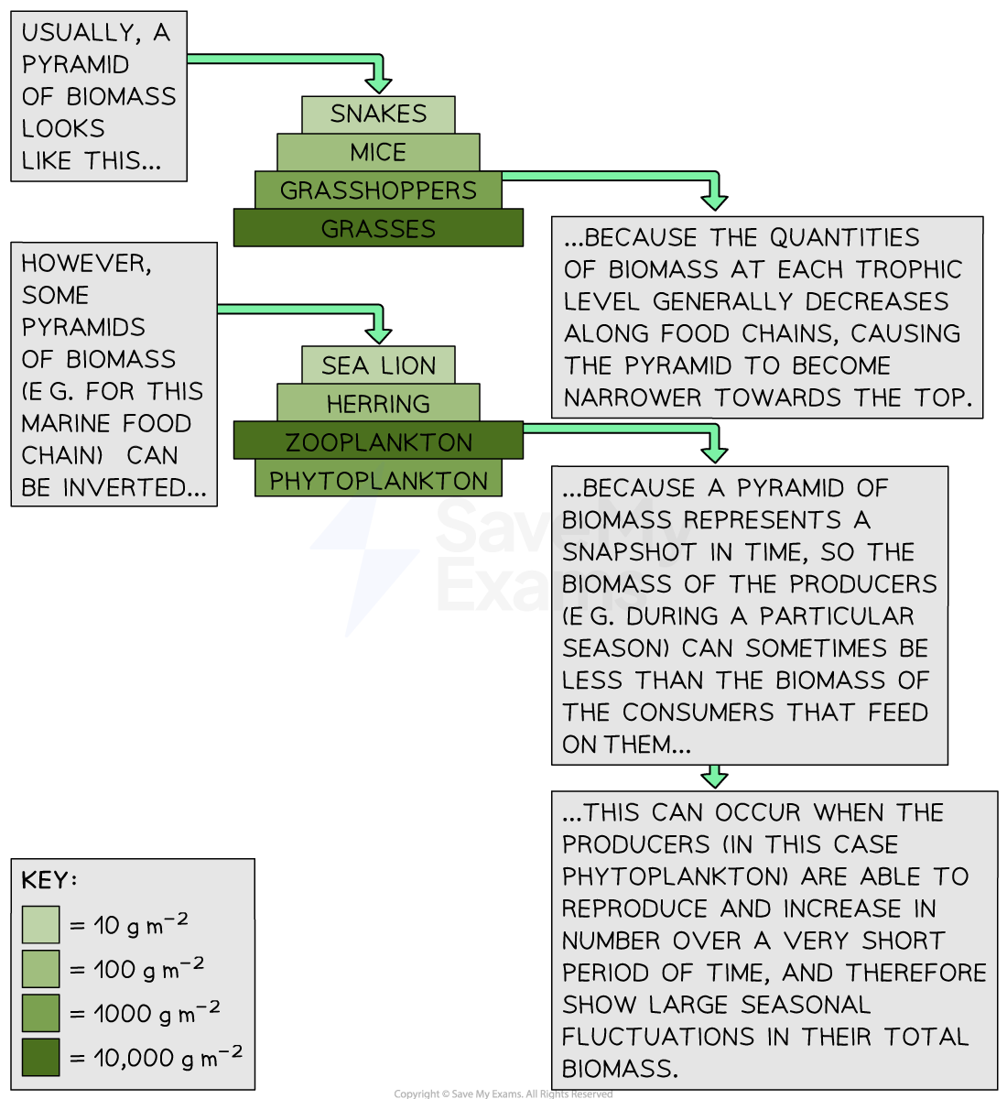

Biomass shows how living things make energy. It starts with plants. They use sunlight to grow. This is called photosynthesis. When animals eat plants, they get energy too. The energy moves up the food chain. At the bottom, we have producers like plants. Next are primary consumers like rabbits. Then come secondary consumers like foxes. Each step shows less biomass. The top has fewer animals. This shows how energy is lost. Understanding this helps us take care of our planet.
Questions:
1. What is biomass? A) Energy from the sun B) Living things C) Water in plants D) Soil nutrients
2. The process of _____ occurs when plants make energy.
3. State one type of consumer in a food chain.
4. Describe what happens to energy as it moves up the food chain.
5. Explain why there is less biomass at the top of the food chain.
WHAT: What happens to energy as it moves up?
WHY: Why does this energy loss happen?

MARK SCHEME
1. B
2. photosynthesis
3. Primary consumer
4. Energy decreases as it moves up the food chain.
5. There is less biomass at the top.
WHAT: Energy is lost at each step.
WHY: This happens because not all energy is passed on.

