Read Now: Taking it Further Farming and Biotechnology Date:

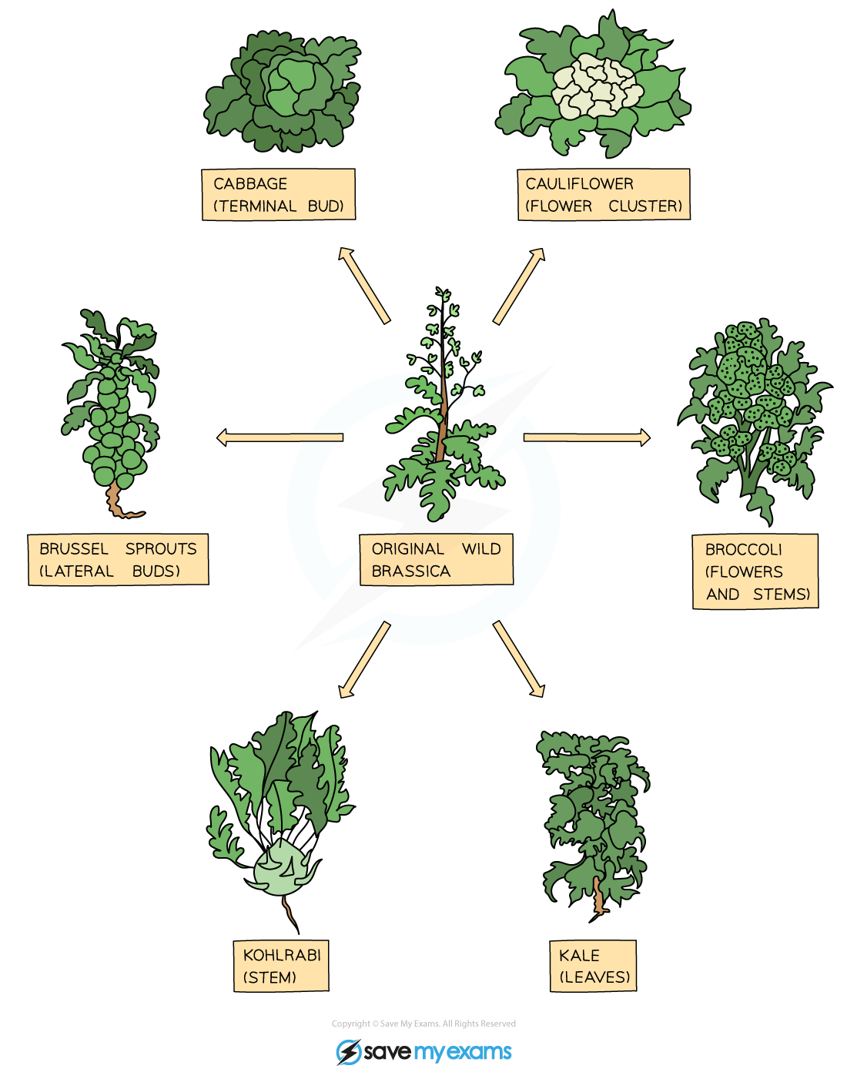

Farming can be improved by using intensive farming methods. These methods help increase the efficiency of biomass transfers. Biomass is the total mass of living things, like animals and plants. In farming, we want to use less energy, so more goes into the food we eat.
For example, raising chickens in a small space can help. They eat less food and grow faster. This means more meat is produced with less energy wasted. Other methods include better food and careful care. These changes help farmers produce more food for everyone.
Questions:
1. What is biomass? (look at line 2)
2. How does intensive farming improve efficiency? (look at line 1)
3. Describe one example of intensive farming. (look at line 4)
4. Why do farmers want to use less energy in production? (look at line 5)

MARK SCHEME
1. Biomass is the total mass of living things, like animals and plants.
2. Intensive farming improves efficiency by reducing energy waste in food production.
3. One example of intensive farming is raising chickens in a small space.
4. Farmers want to use less energy to produce more food for everyone.

