Read Now: Taking it Further Food Security Date:

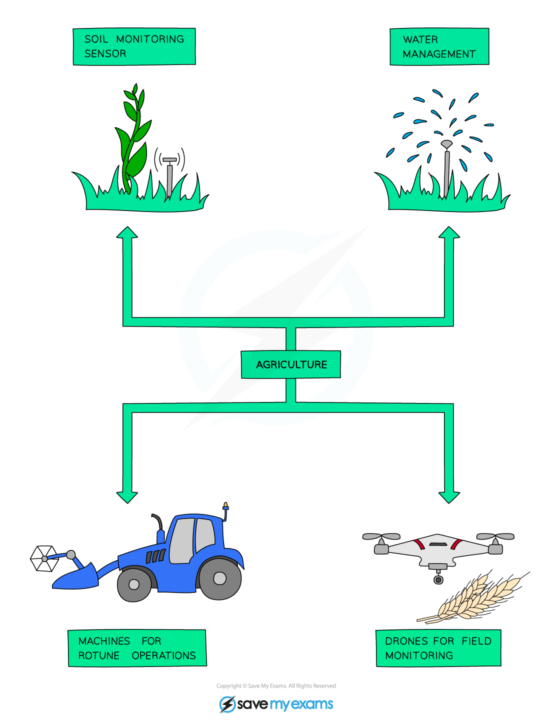

Many biological factors can threaten food security. Food security means having enough safe and nutritious food for everyone. One factor is pests, like insects that eat crops. These pests can destroy plants, leading to less food. Another factor is diseases that affect plants and animals. For example, a disease can make cows sick, reducing milk and meat supply. Climate change also affects food production. Extreme weather can destroy crops or reduce yields. Farmers need to use better methods to grow food. This includes using pesticides to control pests and planting disease-resistant crops. By addressing these issues, we can help improve food security for the future.
Questions:
1. What is food security? (look at line 1)
2. Name one factor that threatens food security. (look at line 2)
3. How do pests affect food production? (look at line 4)
4. What can farmers do to improve food security? (look at line 7)
5. Why does climate change impact food production? (look at line 5)

MARK SCHEME
1. Food security means having enough safe and nutritious food for everyone. (line 1)
2. One factor that threatens food security is pests. (line 2)
3. Pests can destroy plants, leading to less food. (line 4)
4. Farmers can use pesticides to control pests and plant disease-resistant crops. (line 7)
5. Climate change impacts food production by causing extreme weather that can destroy crops. (line 5)

