Read Now: Relative Formula Mass Date:

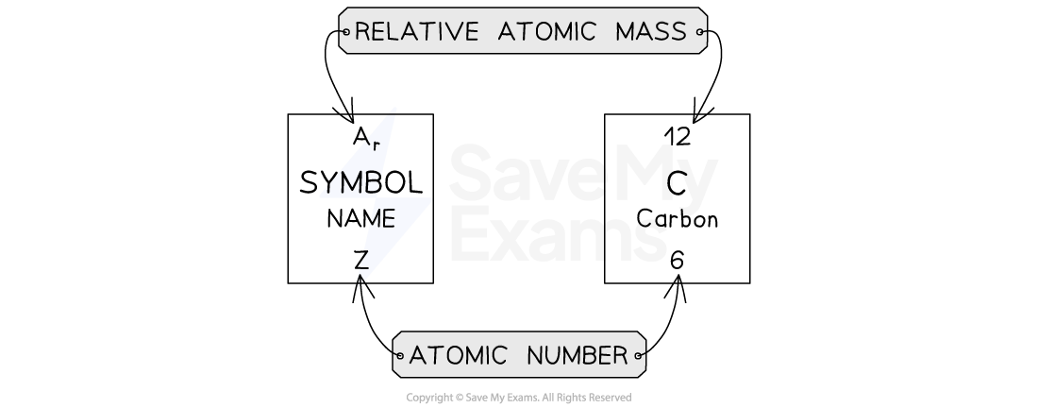

In chemistry, relative formula mass (RFM) shows how heavy a molecule is. To find the RFM, add the masses of all atoms in a formula. For example, in water (H₂O), there are 2 hydrogen (H) atoms and 1 oxygen (O) atom. Each hydrogen atom has a mass of 1. The oxygen atom has a mass of 16. So, the RFM of water is 2 (from H) + 16 (from O) = 18.
Understanding RFM helps us know how much of a substance we need. This knowledge is important in experiments.
Aim high, work together, be kind, and lead the way in learning chemistry!
Questions:
1. What is relative formula mass? (look at line 1)
2. How do you calculate relative formula mass? (look at lines 2-3)
3. State the RFM of water. (look at line 5)
4. Name the elements in water. (look at line 4)
5. Why is knowing RFM important in experiments? (look at line 6)

MARK SCHEME
1. Relative formula mass shows how heavy a molecule is.
2. Add the masses of all atoms in a formula.
3. The RFM of water is 18.
4. The elements in water are hydrogen and oxygen.
5. Knowing RFM helps us know how much of a substance we need.

