Read Now: (HT) Ionic Equations and Displacement Reactions Date:

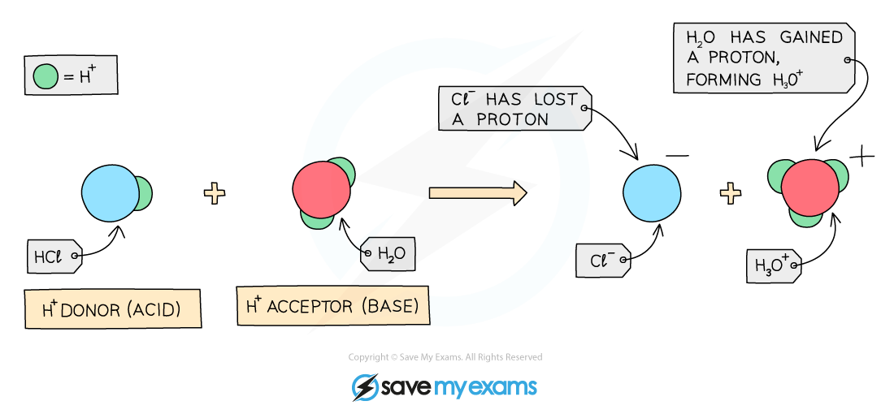

Oxidation is the loss of electrons. Reduction is the gain of electrons. Together, oxidation-reduction refers to reactions where one substance loses electrons (oxidation) and another gains electrons (reduction) at the same time.
In chemistry, we can use ionic equations to show what happens in these reactions. In a displacement reaction, a more reactive element can take the place of a less reactive one. For example, if we mix two halogens, the more reactive one will displace the other. This is important in understanding how different substances interact in reactions.
By studying these concepts, we are working scientifically and developing our understanding of how materials behave in the world.
Questions:
1. What is oxidation? A) Gain of electrons B) Loss of electrons C) A type of reaction D) A chemical bond
2. The process of _____ occurs when a substance gains electrons.
3. State what reduction is.
4. Describe what happens in a displacement reaction.
5. Explain oxidation-reduction.
WHAT: What happens to electrons during oxidation-reduction?
WHY: Why is this process important in chemical reactions?

MARK SCHEME
1. B
2. Reduction
3. Reduction is the gain of electrons.
4. In a displacement reaction, a more reactive element replaces a less reactive one.
5. Oxidation-reduction means that one substance loses electrons while another gains them. This is important because it helps us understand how substances can change in chemical reactions.

