Read Now: Taking it Further Carboxylic Acids Date:

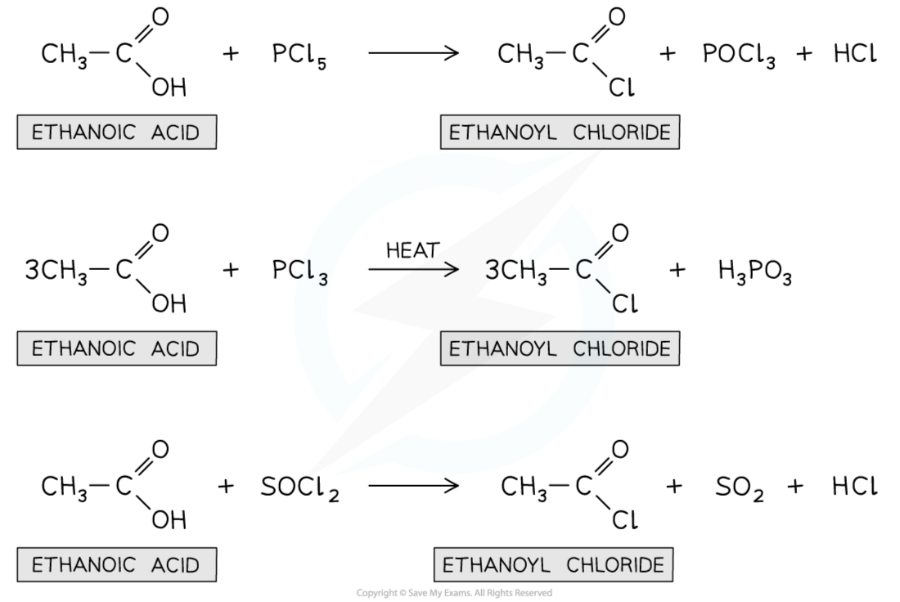

Carboxylic acids are a group of organic compounds. They contain a carboxyl group, which is made of a carbon atom, two oxygen atoms, and one hydrogen atom. This group gives them unique properties. For example, vinegar is a common carboxylic acid. It contains acetic acid. Carboxylic acids can also be found in fruits, like citric acid in lemons. They can react with alcohols to form esters, which are used in flavorings and perfumes. Carboxylic acids can be weak acids. This means they do not fully ionize in water. Understanding these acids helps us learn about everyday substances.
Questions:
1. What is a carboxylic acid? A) A type of base B) An organic compound C) A metal D) A salt
2. The process of _____ occurs when carboxylic acids react with alcohols.
3. State one example of a carboxylic acid.
4. Describe what a carboxyl group is.
5. Explain why carboxylic acids are considered weak acids.
WHAT: They do not fully ionize in water.
WHY: This means they release fewer hydrogen ions.

MARK SCHEME
1. B
2. esterification
3. Vinegar or acetic acid
4. A carboxyl group is a carbon atom linked to oxygen atoms and hydrogen.
5. WHAT: They do not fully ionize in water. WHY: This means they release fewer hydrogen ions.

