Read Now: Taking it Further Esters Date:

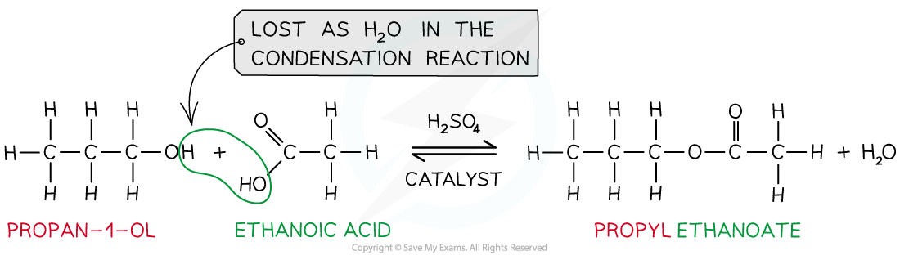

Esters are special molecules formed from alcohols and carboxylic acids. They have a fruity smell and are found in many foods. For example, the smell of bananas comes from an ester called isoamyl acetate.
To make an ester, mix an alcohol with a carboxylic acid. Then, heat the mixture with a chemical catalyst. This process is called esterification. Esters are used in food flavorings, perfumes, and even in plastics. They are important because they add nice smells and tastes to our everyday products.
Questions:
1. What is an ester? A) A type of atom B) A special molecule C) A chemical reaction D) A type of acid
2. The process of _____ occurs when an alcohol and a carboxylic acid mix.
3. State one use of esters.
4. Describe how to make an ester.
5. Explain esterification.
WHAT: Esterification is the process of mixing an alcohol and a carboxylic acid.
WHY: This process creates esters, which have fruity smells and flavors.

MARK SCHEME
1. B
2. esterification
3. Esters are used in food flavorings or perfumes.
4. To make an ester, mix an alcohol with a carboxylic acid and heat it.
5. WHAT: Esterification is the process of mixing an alcohol and a carboxylic acid. WHY: This process creates esters, which have fruity smells and flavors.

