Read Now: Polymers Date:

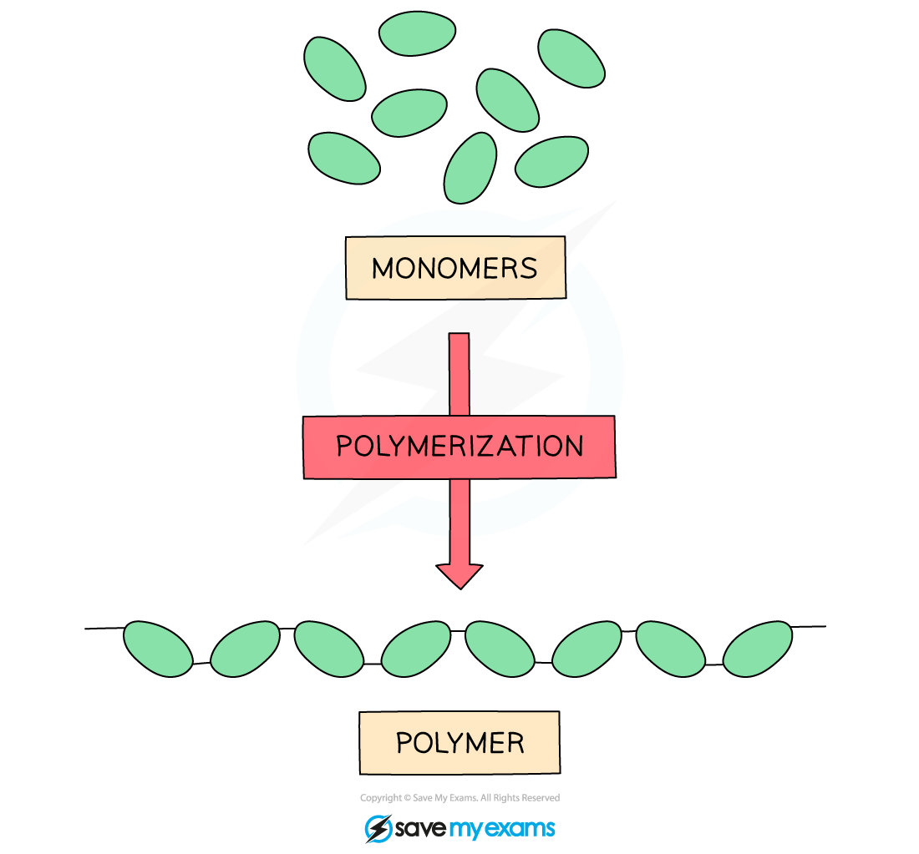

A polymer is a large chain of repeating units called monomers. These monomers are small molecules that join together. Think of a polymer like a long necklace made of beads. Each bead represents a monomer. Common examples of polymers are plastics, rubber, and DNA. They are used in everyday items like water bottles, toys, and clothing. The process of making polymers is called polymerization. During this process, monomers link together to form the long chains. Polymers have unique properties, like being flexible or strong, depending on their monomers and structure.
Questions:
1. What is a polymer? A) A small molecule B) A large chain of monomers C) A type of metal D) A gas
2. The process of _____ occurs when monomers link together.
3. State what the repeating units of a polymer are called.
4. Describe a common example of a polymer.
5. Explain polymerization.
WHAT: What happens during polymerization?
WHY: Why is this process important?

MARK SCHEME
1. B
2. polymerization
3. Monomers
4. A common example of a polymer is plastic.
5. WHAT: During polymerization, monomers link together to form long chains. WHY: This process is important because it creates materials with unique properties used in many products.

