Read Now: Taking it Further Addition Polymerisation Date:

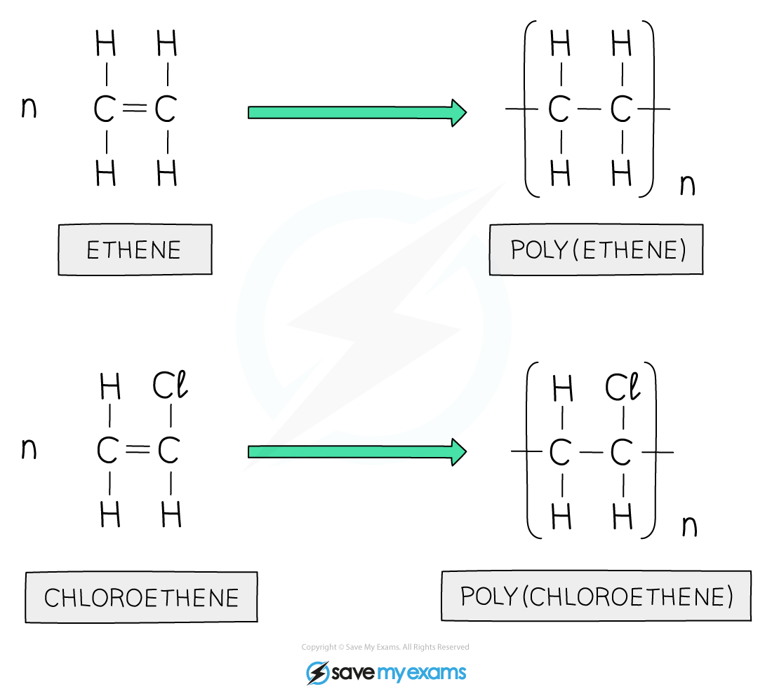

Addition polymerisation is a process that creates long chains called polymers. It happens when small molecules, called monomers, join together. For example, making plastic from ethene gas involves this process.
During polymerisation, the bonds in the monomers break. New bonds form between the monomers, creating a polymer. This is why you can find many everyday items, like plastic bags, made from polymers. Polymers are strong and flexible, making them useful.
In summary, addition polymerisation is important for making many materials we use every day.
Questions:
1. What is addition polymerisation? A) A type of reaction B) A cooking method C) A cleaning process D) A type of metal
2. The process of _____ occurs when small molecules join together.
3. State what a monomer is.
4. Describe how a polymer is formed from monomers.
5. Explain addition polymerisation. WHAT: What happens to monomers during this process? WHY: Why is this process important?

MARK SCHEME
1. A
2. polymerisation
3. A monomer is a small molecule that can form a polymer.
4. A polymer is formed when monomers join together through chemical bonds.
5. WHAT: The monomers bond together to form long chains. WHY: This process is important because it creates materials like plastics that are used daily.

