Read Now: Taking it Further Condensation Polymerisation Date:

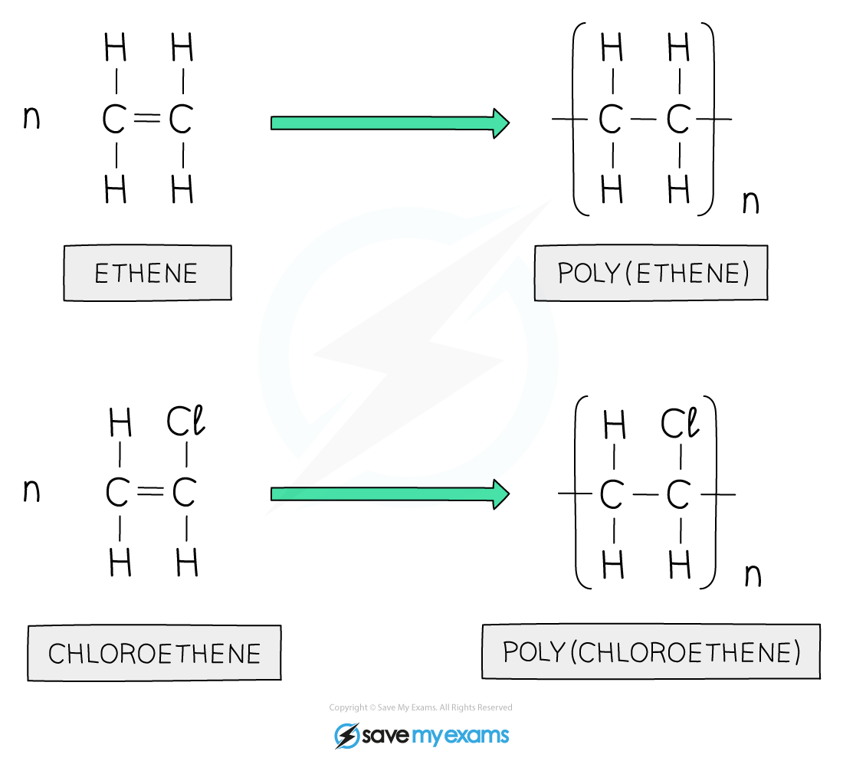

Condensation polymerisation is a process where small molecules join together. This forms a larger molecule called a polymer. During this process, a small molecule, like water, is released.
For example, when making nylon, two different monomers react. One is an acid and the other is an amine. They combine and lose water. This creates a long chain of repeating units, or a polymer.
Condensation polymerisation is important for making many everyday items, like plastics and fibers. It helps create strong materials that we use in clothing, bottles, and containers.
Questions:
1. What is condensation polymerisation? A) A type of chemical reaction B) A process for making metals C) A way to create heat D) A method of cooking
2. The process of _____ occurs when small molecules join to form a polymer.
3. State one example of a polymer made by condensation polymerisation.
4. Describe what happens during condensation polymerisation.
5. Explain condensation polymerisation. WHAT: What is formed during the process? WHY: Why is water released?

MARK SCHEME
1. A
2. condensation polymerisation
3. Nylon
4. Small molecules join and release water to form a polymer.
5. WHAT: A polymer is formed during the process. WHY: Water is released because the molecules bond together.

