Read Now: Taking it Further Naturally Occurring Polymers Date:

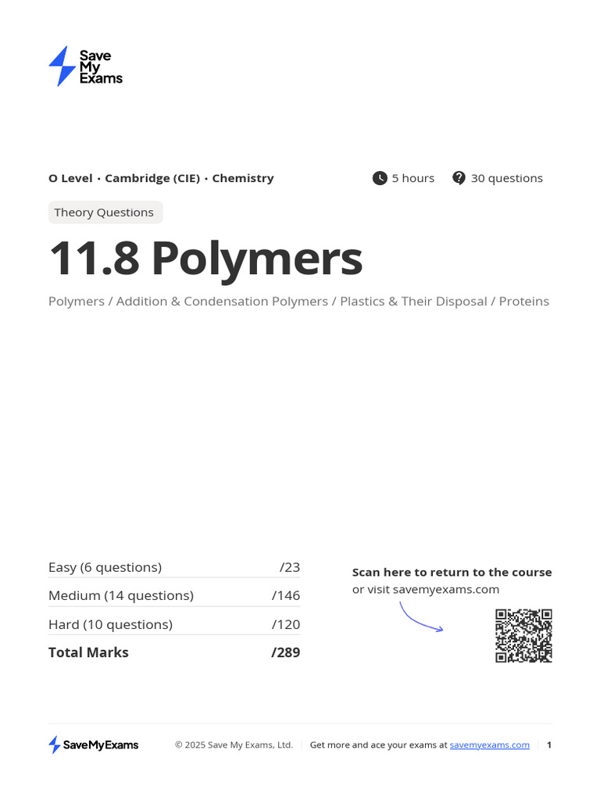

Natural polymers are large molecules made from smaller units called monomers. Many polymers come from natural sources. For example, cellulose is a polymer found in plants. It helps plants keep their structure. Another example is proteins. They are made of amino acids and are vital for life. Natural rubber is also a polymer. It comes from rubber trees and is used for tires. These polymers play key roles in our everyday lives, such as in food, clothing, and medicine. Understanding natural polymers helps us appreciate the materials around us.
Questions:
1. What is a polymer? A) A small molecule B) A large molecule C) A type of atom D) A gas
2. The process of _____ occurs when plants create cellulose.
3. State one example of a natural polymer.
4. Describe the role of proteins in living things.
5. Explain why natural polymers are important.
WHAT: Natural polymers provide structure and function in various materials.
WHY: They are essential for life and are used in many everyday products.

MARK SCHEME
1. B
2. photosynthesis
3. Cellulose
4. Proteins are vital for growth and repair in living things.
5. WHAT: Natural polymers provide structure and function in various materials. WHY: They are essential for life and are used in many everyday products.

