Read Now: Crude Oil and Hydrocarbons Date:

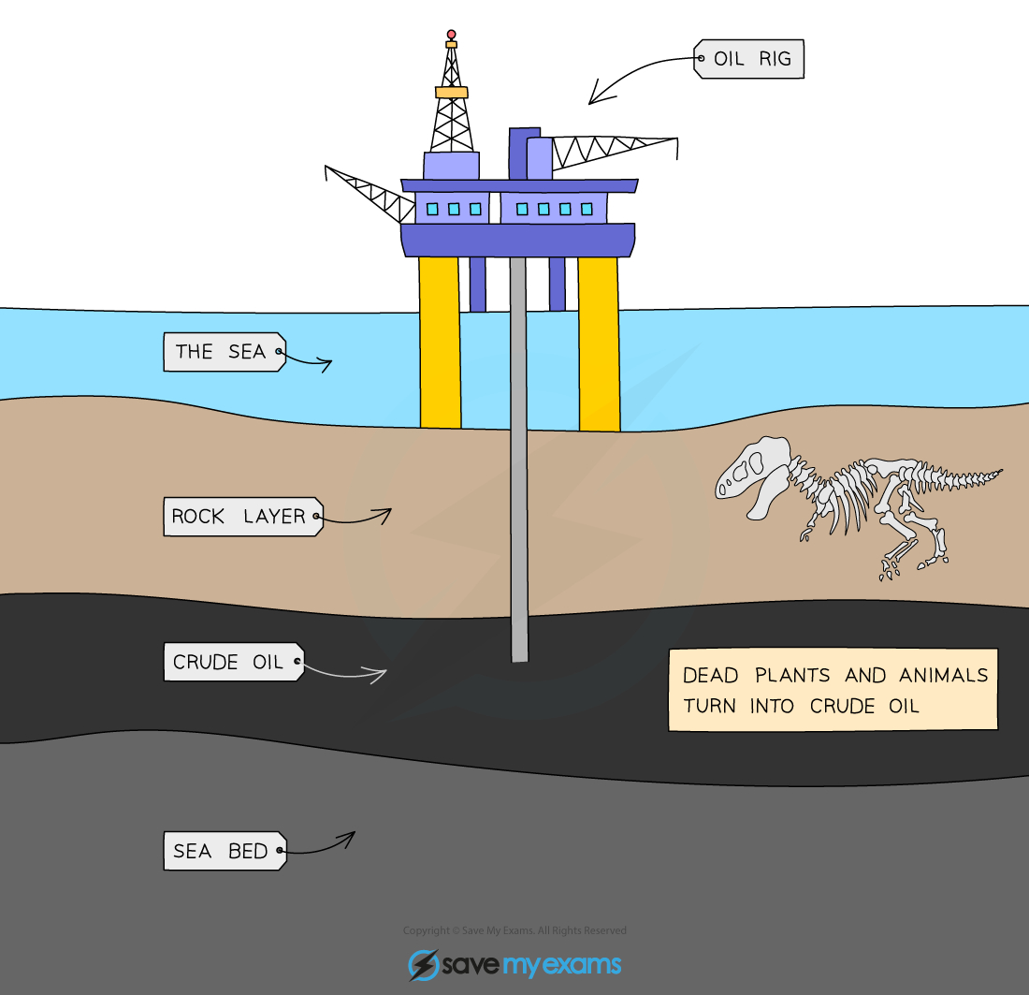

Crude oil is a thick, black liquid found underground. It is made of many different hydrocarbons. Hydrocarbons are compounds made of hydrogen and carbon atoms. When crude oil is heated, it can be separated into useful products. This process is called fractional distillation.
In fractional distillation, crude oil is boiled, and different gases rise. Each gas cools at different temperatures and forms liquids. Common products include petrol, diesel, and lubricating oils. These products are used in cars, heating, and making plastics.
Understanding crude oil helps us see its importance in everyday life.
Questions:
1. What is crude oil? A) A solid B) A gas C) A thick liquid D) A metal
2. The process of _____ occurs when crude oil is separated.
3. State what hydrocarbons are made of.
4. Describe fractional distillation in one sentence.
5. Explain fractional distillation.
WHAT: What happens to crude oil during the process?
WHY: Why do we need to separate crude oil?

MARK SCHEME
1. C
2. fractional distillation
3. Hydrogen and carbon.
4. Fractional distillation is heating crude oil to separate it.
5. WHAT: Crude oil is heated and turned into different gases.
WHY: We need to separate crude oil to obtain useful products.

