Read Now: Fractional Distillation Date:

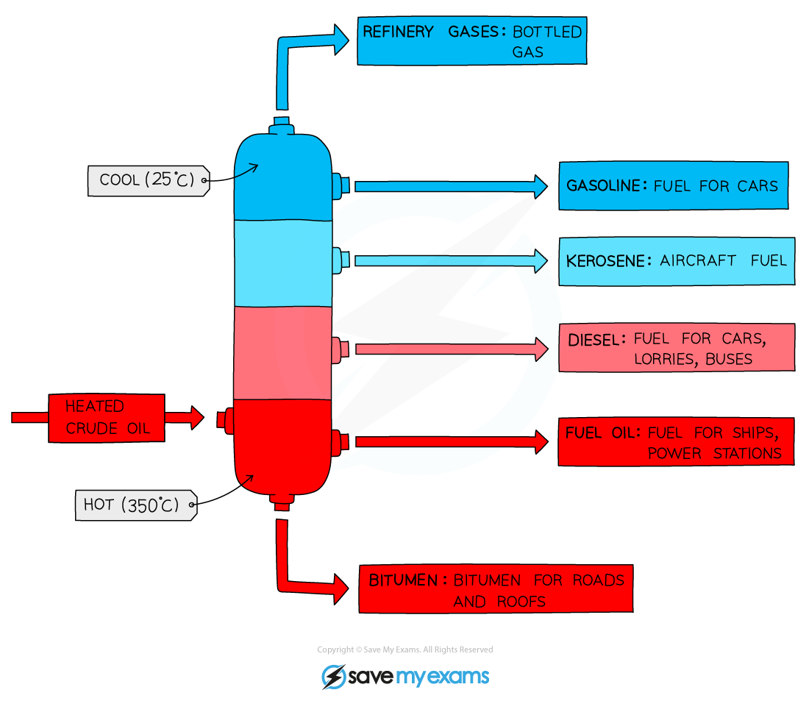

Fractional distillation is a method used to separate liquids with different boiling points. Imagine making perfume. It starts with a mixture of oils and alcohol. The mixture is heated in a fractionating column. As it heats, different parts turn into vapour at different temperatures. The vapour rises and cools at the top of the column. It then condenses back into a liquid. This liquid is collected separately. For example, when making gasoline from crude oil, fractional distillation separates many useful products. Each product has a unique boiling point. This process helps us get pure substances from mixtures easily.
Questions:
1. What is fractional distillation? A) Mixing liquids B) Heating solids C) Separating liquids D) Cooling gases
2. The process of _____ occurs when separating liquids by boiling points.
3. State what is collected after cooling in fractional distillation.
4. Describe how fractional distillation works.
5. Explain fractional distillation.
WHAT: How do different liquids separate during this process?
WHY: Why do they separate at different temperatures?

MARK SCHEME
1. C
2. distillation
3. Pure liquid
4. Fractional distillation heats a mixture and collects different parts.
5. WHAT: Different liquids separate based on their boiling points. WHY: They separate because each liquid has a unique boiling point.

