Read Now: Combustion of Hydrocarbons Date:

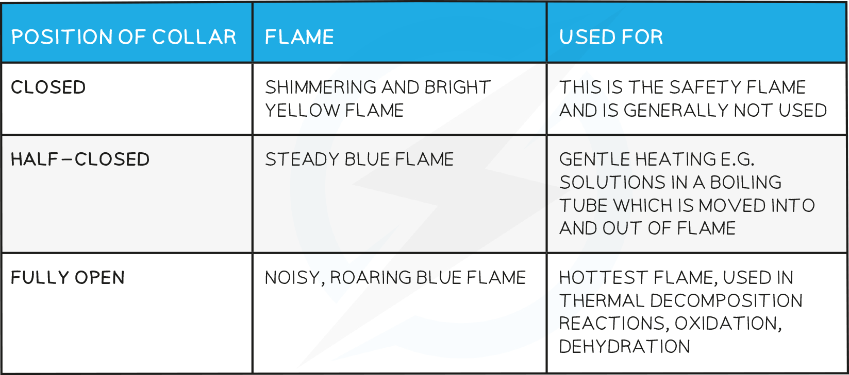

When hydrocarbons burn, they go through a process called combustion. This happens when hydrocarbons react with oxygen. The result is energy, carbon dioxide, and water vapor. For example, when you light a candle, the wax (a hydrocarbon) burns. This releases heat and light. If there is not enough oxygen, incomplete combustion occurs. This produces carbon monoxide, a harmful gas. In summary, hydrocarbons are essential fuels that power many things in our daily lives.
Questions:
1. What is combustion? A) A type of fuel B) A chemical reaction C) A solid material D) A liquid
2. The process of _____ occurs when hydrocarbons react with oxygen.
3. State the products of hydrocarbon combustion.
4. Describe what happens during combustion.
5. Explain incomplete combustion.
WHAT: What is produced when there is not enough oxygen?
WHY: Why is incomplete combustion dangerous?

MARK SCHEME
1. B
2. combustion
3. carbon dioxide and water vapor
4. Hydrocarbons react with oxygen to produce energy, carbon dioxide, and water.
5. Incomplete combustion produces carbon monoxide. It is dangerous because carbon monoxide is harmful to breathe.

