Read Now: Cracking Date:

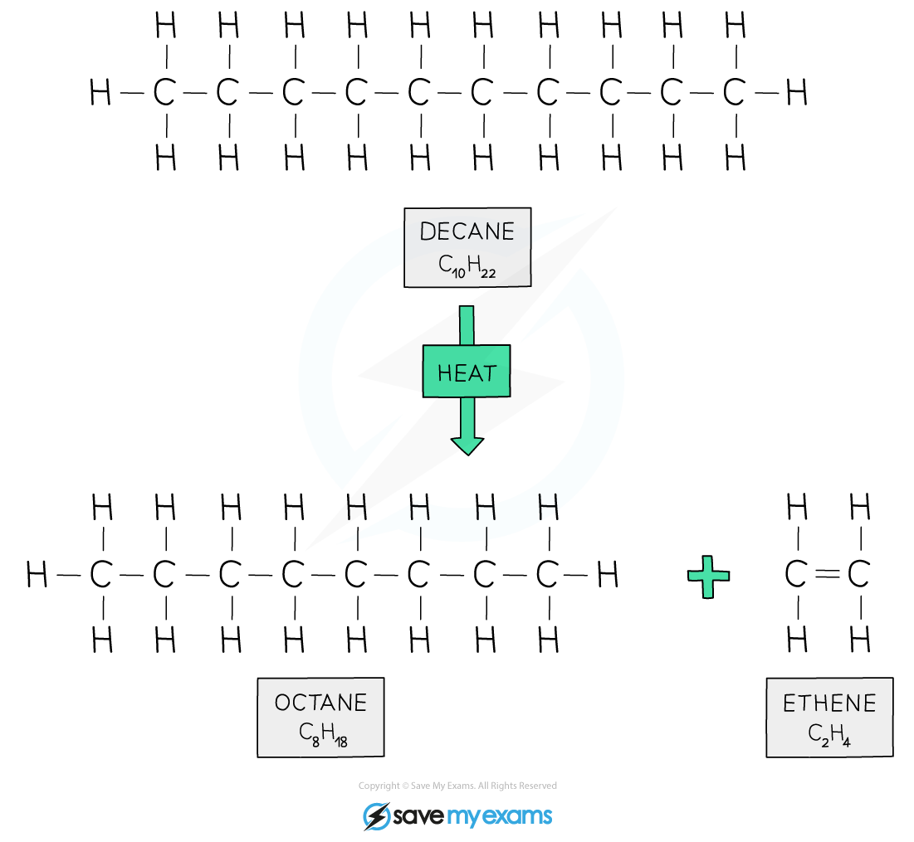

Many cars use petrol as fuel. Petrol is made of hydrocarbons, which are molecules containing hydrogen and carbon. A common hydrocarbon in petrol is octane (C8H18). There is a high demand for short-chain hydrocarbons for petrol engines. To meet this demand, we use a process called cracking.
Cracking breaks down larger hydrocarbons into shorter ones. This process also produces a type of hydrocarbon called an alkene. Alkenes are important because they help make many products, like plastics. Thus, cracking is essential for providing fuel and materials we use every day.
Questions:
1. What is cracking? A) A cooking method B) A type of fuel C) A chemical reaction D) A car part
2. The process of _____ occurs when larger hydrocarbons are broken down.
3. State one product produced from cracking.
4. Describe what cracking does to hydrocarbons.
5. Explain the process of cracking. WHAT: What happens during cracking? WHY: Why do we need to crack larger hydrocarbons?

MARK SCHEME
1. C
2. cracking
3. Short-chain hydrocarbons or alkenes
4. Cracking breaks larger hydrocarbons into shorter ones.
5. WHAT: Cracking breaks down larger hydrocarbons into shorter ones. WHY: We need to crack larger hydrocarbons to meet the demand for fuels and useful chemicals.

