Read Now: Taking it Further Alkenes Date:

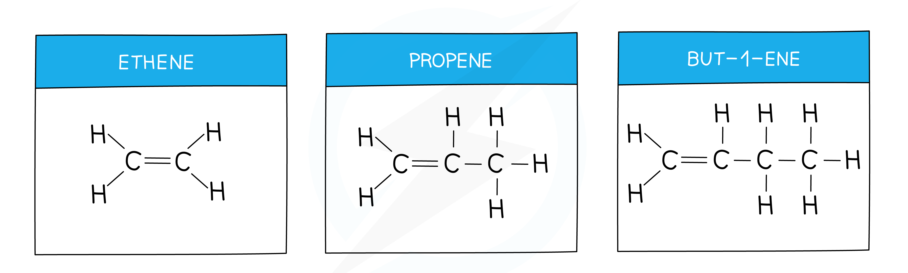

Alkenes are hydrocarbons that have at least one double bond between carbon atoms. They are unsaturated, meaning they can react more easily than saturated compounds. Common examples of alkenes include ethene, found in fruits, and propene, used in making plastics.
Alkenes react through a process called addition. During this reaction, atoms add across the double bond, breaking it. For example, when alkenes react with hydrogen, they form alkanes, which are saturated. They also react with bromine to create dibromoalkanes, adding bromine atoms.
Alkenes are important in making many everyday products, from fuels to plastics.
Questions:
1. Define the term 'alkene.'
2. Name a common example of an alkene.
3. What type of bond do alkenes have?
4. How do alkenes react with hydrogen?
5. If you have an alkene with 4 carbon atoms, what is it called? Describe its properties.

MARK SCHEME
1. An alkene is a hydrocarbon with at least one double bond.
2. A common example of an alkene is ethene.
3. Alkenes have at least one double bond between carbon atoms.
4. Alkenes react with hydrogen to form saturated alkanes.
5. An alkene with 4 carbon atoms is called butene. It is unsaturated and can react easily.

