Read Now: Taking it Further Alkenes Date:

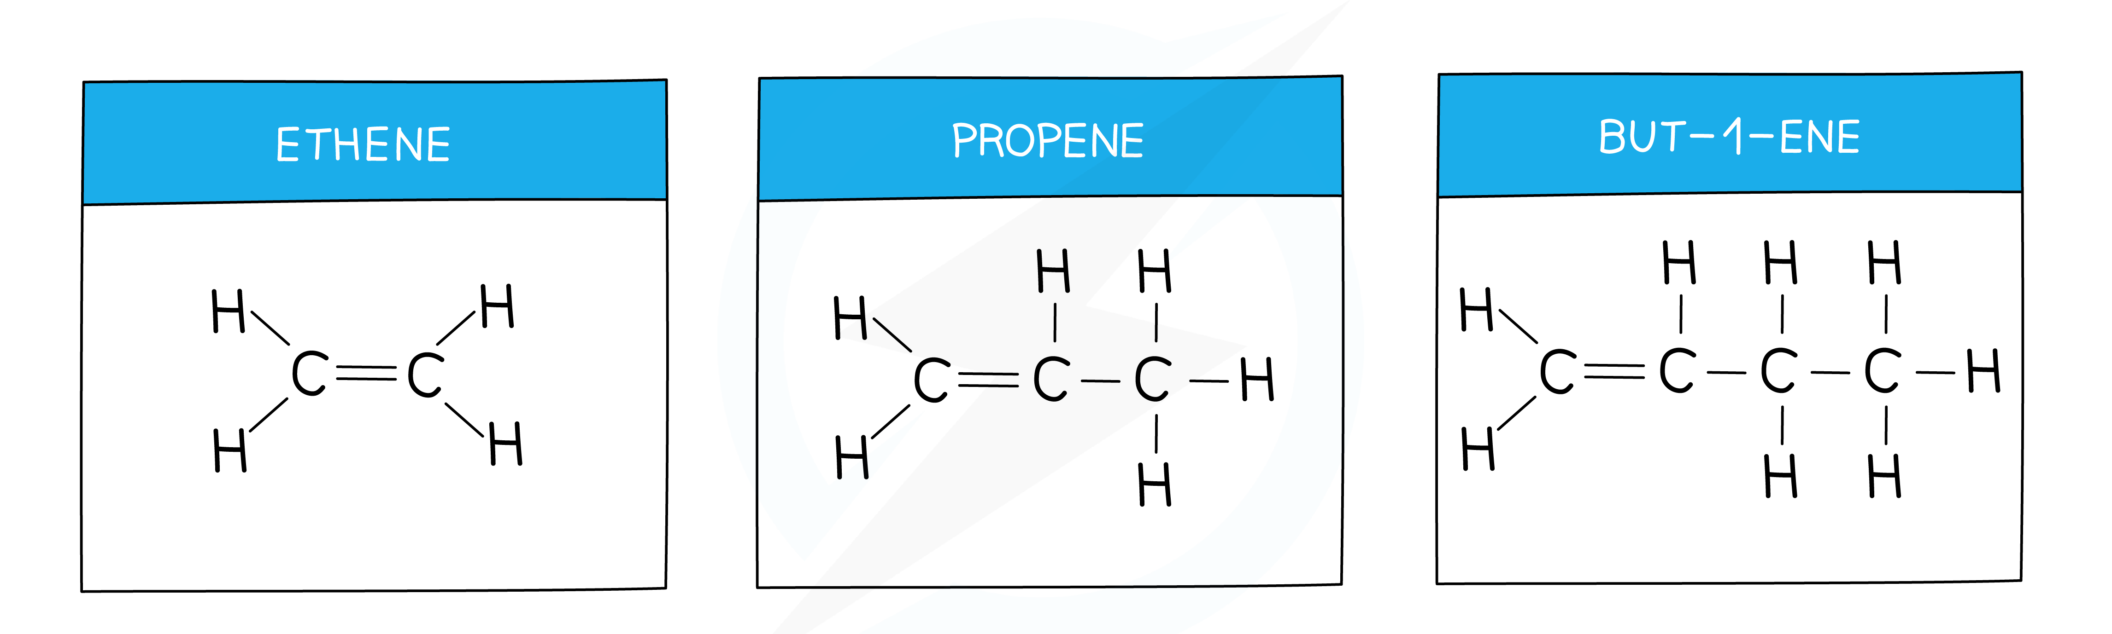

Alkenes are a group of hydrocarbons that contain at least one double bond between carbon atoms. They are unsaturated, meaning they can bond with more atoms. Common examples include ethylene, found in fruits, and propylene, used in plastics. Alkenes react easily because of their double bonds. This makes them important in making many everyday products. For example, ethylene is used to create plastic bags. To make alkenes, you can remove hydrogen from an alkane through a process called dehydrogenation. Understanding alkenes helps us know more about chemistry in daily life.
Questions:
1. What is an alkene? A) A saturated hydrocarbon B) A double-bonded hydrocarbon C) A single-bonded hydrocarbon D) A solid metal compound
2. The process of _____ occurs when hydrogen is removed from an alkane.
3. State one example of an alkene.
4. Describe the structure of alkenes.
5. Explain why alkenes are useful in making products.
WHAT: Alkenes have double bonds that allow for easy reactions.
WHY: This makes them suitable for creating various chemicals and materials.

MARK SCHEME
1. B
2. dehydrogenation
3. Ethylene
4. Alkenes have at least one double bond between carbon atoms.
5. Alkenes are useful because they react easily, allowing product creation.

