Read Now: Taking it Further Producing Ethanol by Fermentation Date:

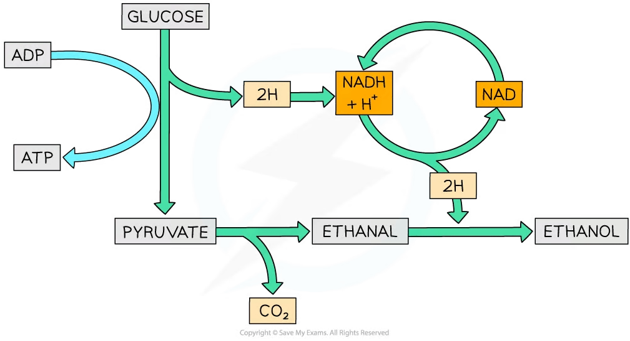

Ethanol can be produced by a process called fermentation. This happens when yeast breaks down sugars. The sugars can come from fruits, grains, or even sugarcane. During fermentation, carbon dioxide is released and ethanol is formed.
To make ethanol, follow these steps: first, prepare the sugar source. Next, add yeast to the mixture. Then, let it sit in a warm place for a few days. Finally, the ethanol can be collected after fermentation is complete.
Ethanol is often used in drinks and as a fuel. It is a renewable energy source because it comes from plants.
Questions:
1. What is fermentation? A) Cooking B) Mixing C) Breaking down sugars D) Freezing
2. The process of _____ occurs when yeast breaks down sugars.
3. State one source of sugar for fermentation.
4. Describe the fermentation process in one sentence.
5. Explain the role of yeast in fermentation.
WHAT: What does yeast do during fermentation?
WHY: Why is yeast important for producing ethanol?

MARK SCHEME
1. C
2. fermentation
3. Fruits, grains, or sugarcane.
4. Fermentation is when yeast breaks down sugars to produce ethanol.
5. WHAT: Yeast breaks down sugars to produce ethanol and carbon dioxide.
WHY: Yeast is essential because it enables the fermentation process, making ethanol possible.

