Read Now: Gradients Date: 11/12/2025

A gradient shows how steep a line is on a graph. The gradient tells us how much the y-axis value changes when the x-axis value increase.
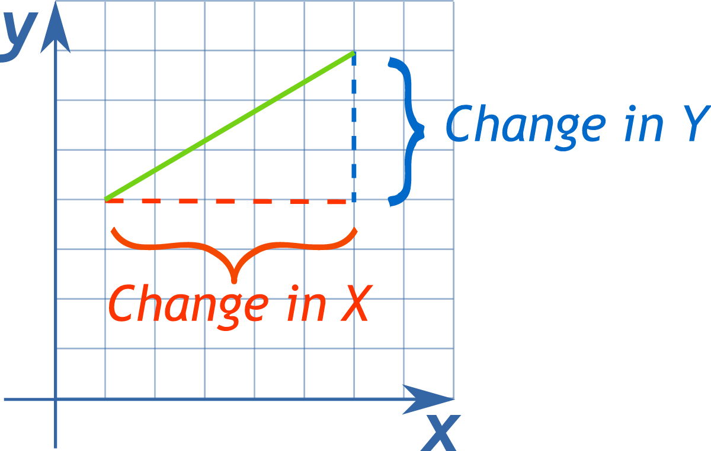
To calculate the gradient, you need to pick two points on the line. Draw a triangle under the line between these two points. The gradient equals the change in y by the change in x.

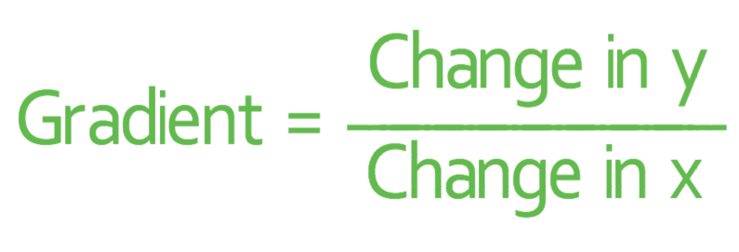

The gradient of a distance-time graph shows the speed. A steeper line means a faster speed.
The gradient of a velocity-time graph shows the acceleration. A steeper line means more acceleration.

Questions
1. What does a gradient show on a graph? (1 mark)
2. What do you need to pick to calculate a gradient? (1 mark)
3. What does the gradient of a distance-time graph show? (1 mark)
4. What does the gradient of a velocity-time graph show? (1 mark)
5. Why does a steeper line on a distance-time graph mean a faster speed? (2 marks)

MARK SCHEME
1. A gradient shows how steep a line is on a graph. (1 mark)
2. You need to pick two points on the line. (1 mark)
3. The gradient of a distance-time graph shows the speed. (1 mark)
4. The gradient of a velocity-time graph shows the acceleration. (1 mark)
5. A steeper line means the distance increases more quickly / the gradient is larger (1 mark), so the speed is faster (1 mark).

Graph 1
Below is a velocity–time graph described in words:
- From 0–4 s: velocity ________ steadily from __ m/s to ___ m/s.
- From 4–8 s: velocity stays __________ at 8 m/s.
- From 8–10 s: velocity ________ steadily from 8 m/s to 0 m/s.

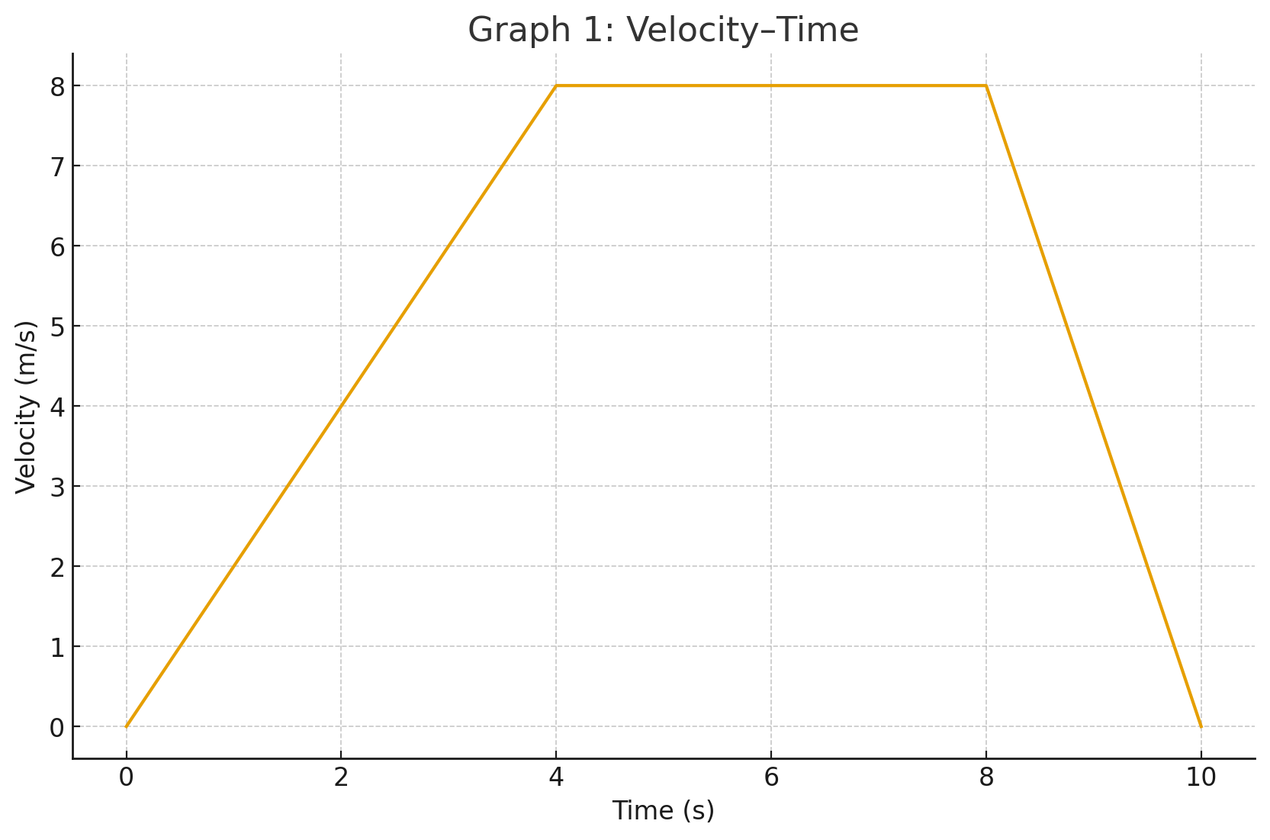

Questions:
- What is the gradient (acceleration) from 0–4 s?
- What is happening between 4–8 s?
- What is the velocity at 5 seconds?
- What is the acceleration from 8–10 s?

Graph 2
A cyclist’s motion is shown below:
- From 0–__ s: velocity increases from __ m/s to __ m/s.
- From – s: velocity increases from __ m/s to __ m/s.
- From – s: velocity remains constant at __ m/s.

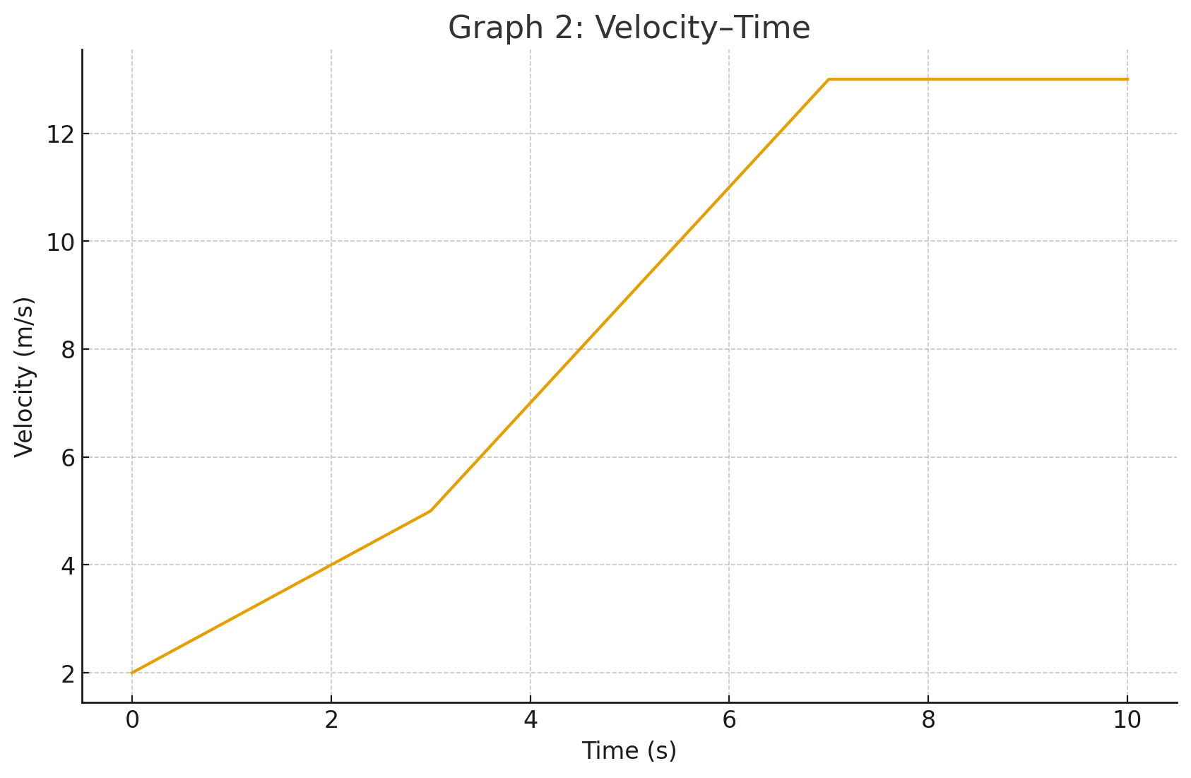

Questions:
- Calculate the gradient between 0–3 s.
- Calculate the gradient between 3–7 s.
- Is the cyclist accelerating at 8 seconds? Explain.
- What is the velocity at 6 seconds?

Graph 3
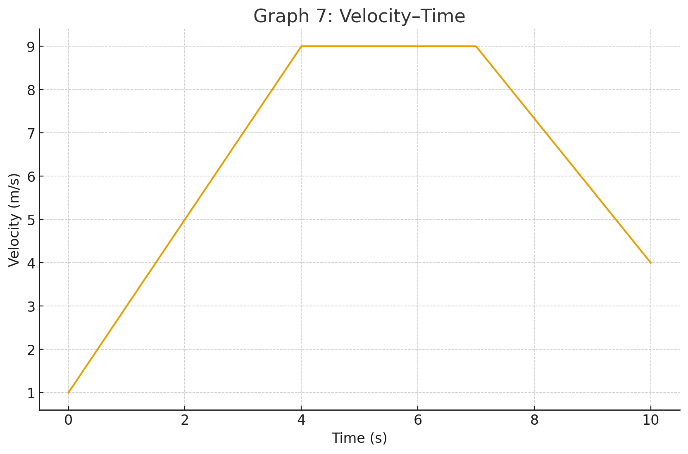

Questions:
- What is the gradient between 1–4 s?
- Is the car accelerating or decelerating between 7–10 s?
- What is the velocity at 2 seconds?
- What is happening between 4–7 s?

Graph 3 (extension)
A car travels with the following velocity changes:
- From 0–2 s: velocity increases from 0 m/s to 4 m/s.
- From 2–6 s: velocity decreases from 4 m/s to -2 m/s (the car is reversing slowly).
- From 6–10 s: velocity increases from -2 m/s to 6 m/s.

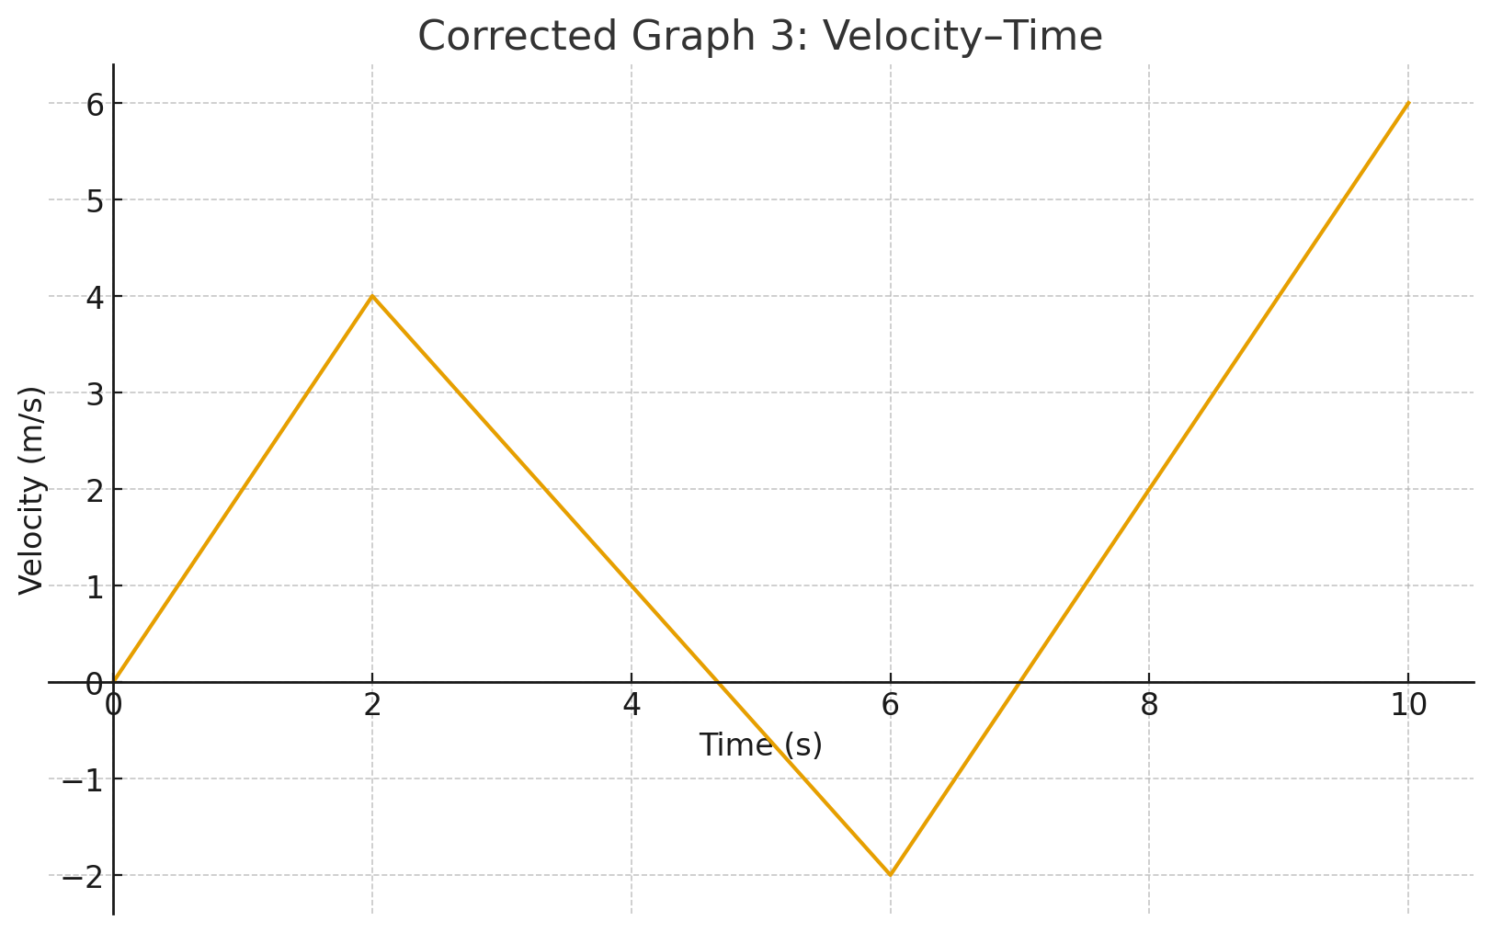

Questions:
- Find the acceleration from 0–2 s.
- What does a negative gradient mean between 2–6 s?
- What is the velocity at 3 seconds?
- Calculate the gradient from 6–10 s.

