Read Now: Biodiversity Date:

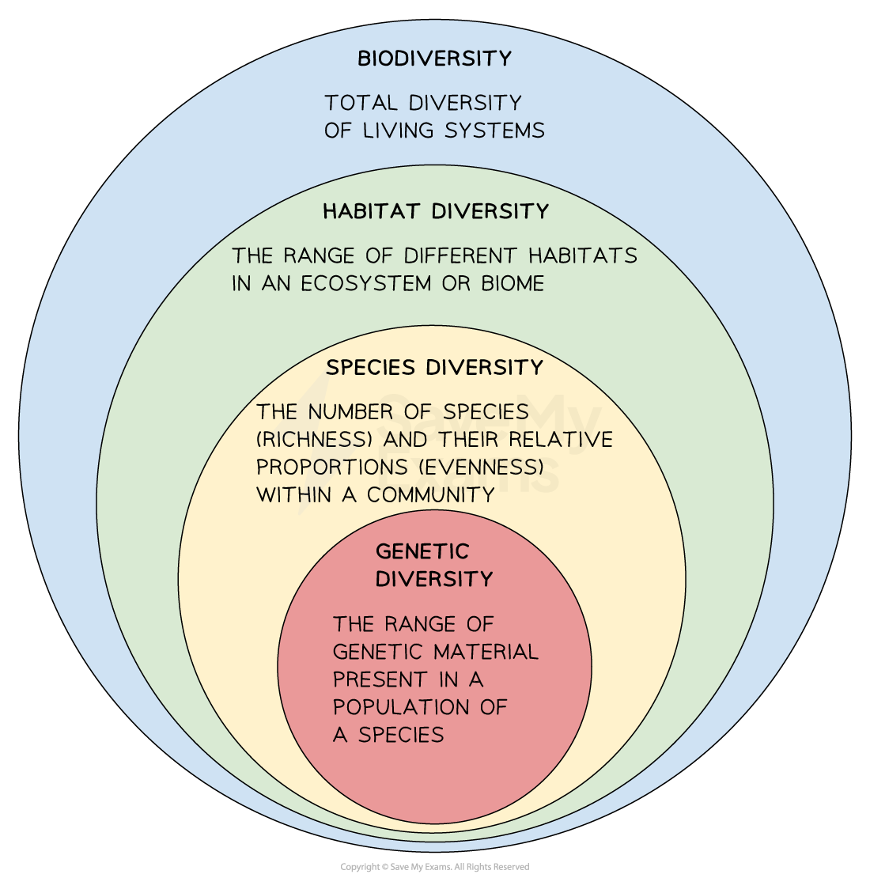

Biodiversity is the variety of different species in an ecosystem. It can be measured by using sampling techniques to count the abundance of different species. A quadrat is a piece of equipment (a frame) used to count the abundance of species. Random sampling is used to measure the abundance of a species in a particular habitat, using quadrats placed at random coordinates. Systematic sampling measures the effect of a factor on the distribution of a species, using a transect with quadrats placed at regular intervals. High biodiversity makes an ecosystem stable because each species is not dependent on just one other.
Pollution kills plants and animals, which can reduce biodiversity. Humans reduce the amount of land available for other animals and plants by building, quarrying, farming, and dumping waste.
Questions:
1. Define the term 'biodiversity'. (1 mark)
2. What is a quadrat used for? (1 mark)
3. How does pollution affect biodiversity? (1 mark)
4. Name two ways humans reduce land for animals and plants. (1 mark)
5. Explain why high biodiversity is important for an ecosystem. (4 marks)

MARK SCHEME
1. Biodiversity is the variety of different species in an ecosystem.
2. A quadrat is used to count the abundance of species.
3. Pollution kills plants and animals, which can reduce biodiversity.
4. Humans reduce land for animals and plants by building and farming.
5. High biodiversity makes an ecosystem stable because each species is not dependent on just one other.

