Read Now: Biodiversity Date:

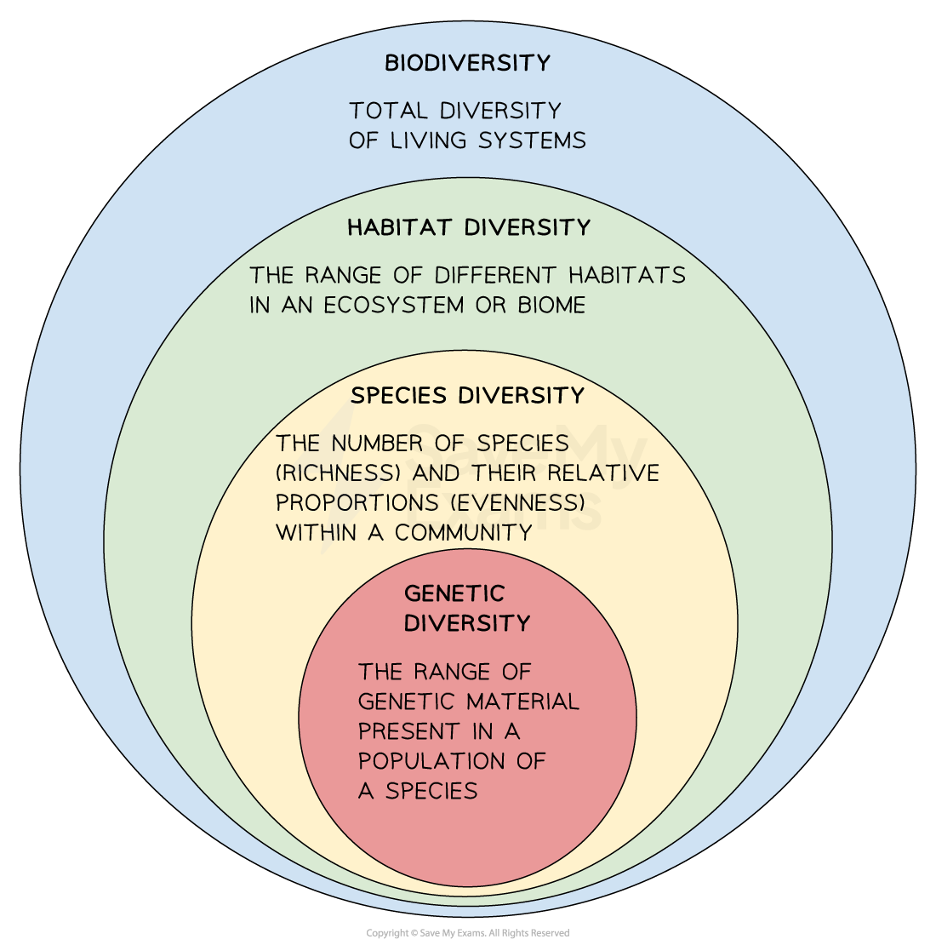

Biodiversity is the variety of different plant, animal, and microorganism species in an area. It includes the different species in a habitat, the number of each species, and their interactions within an ecosystem. Abundance refers to how many individuals of a species are present. Reducing biodiversity can happen when humans pollute land or destroy habitats like peat bogs. Peat bogs are important because they are homes to many species. Positive actions can help, such as breeding programs for endangered species and protecting rare habitats. These efforts aim to maintain or increase biodiversity and support healthy ecosystems.
Questions:
1. What is biodiversity? A) The number of animals B) The variety of species C) The size of habitats D) The amount of waste
2. The process of _____ occurs when species interact in an ecosystem.
3. State the definition of biodiversity.
4. Describe the impact of pollution on biodiversity.
5. Explain how breeding programs help biodiversity.
WHAT: Breeding programs increase the number of endangered species.
WHY: This helps to prevent extinction and supports ecosystem health.

MARK SCHEME
1. B
2. biodiversity
3. The variety of different plant, animal, and microorganism species in an area.
4. Pollution reduces biodiversity by harming plants and animals.
5. Breeding programs increase the number of endangered species because this helps to prevent extinction and supports ecosystem health.

