Read Now: How Humans can Preserve Biodiversity Date:

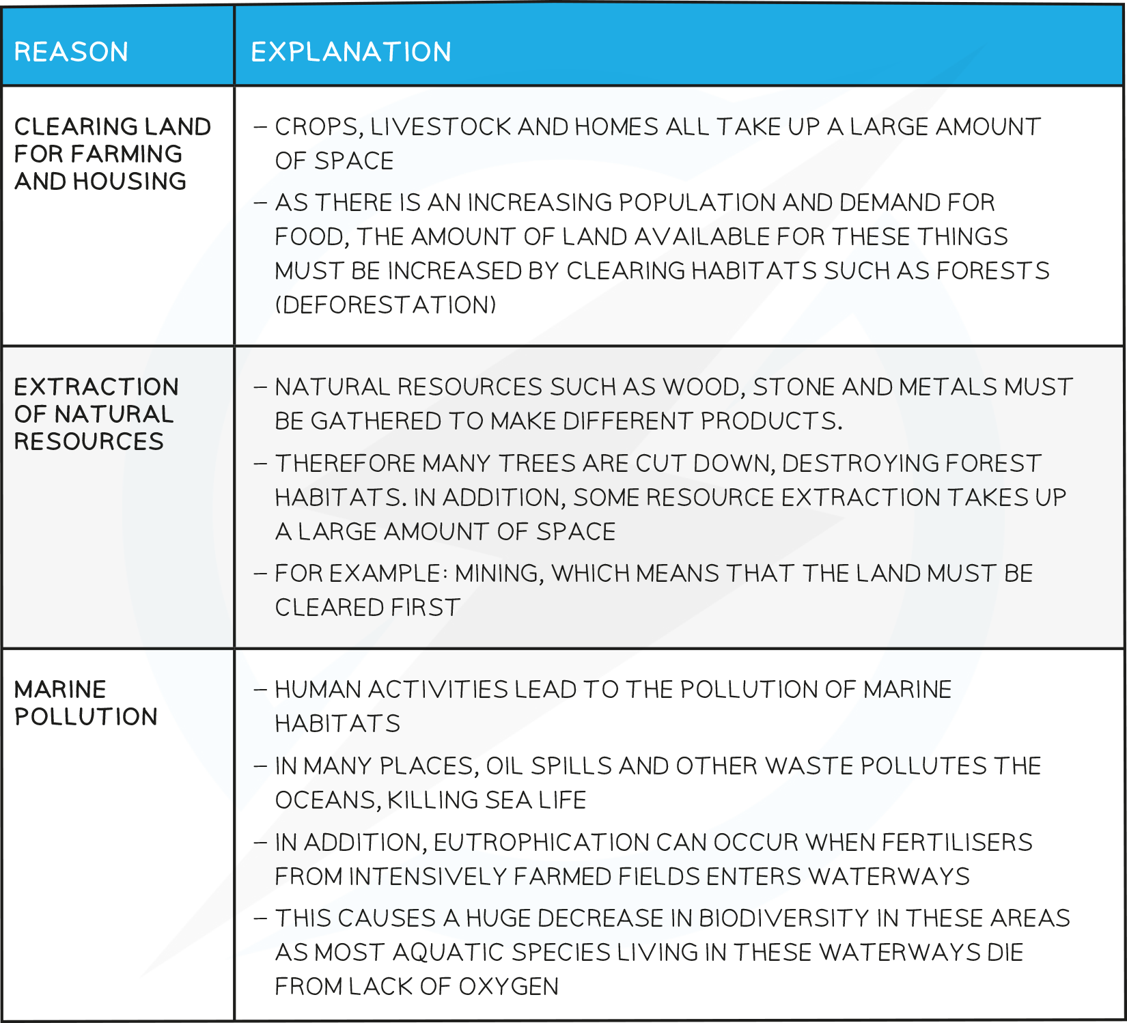

The growth of the population means that there are more people on Earth. This increase leads to a higher demand for resources, like food, water, and energy. As more waste is produced, pollution can occur in water, air, and on land. Pollution harms plants and animals, which reduces biodiversity.
To help protect biodiversity, humans can take positive actions. This includes creating breeding programmes for endangered species and protecting rare habitats. Governments can also reduce deforestation and carbon dioxide emissions. By recycling resources rather than dumping waste in landfill, we can help maintain the balance of nature and ensure that future generations can meet their own needs.
Questions:
1. What does the growth of the human population mean? (1 mark)
2. What are two types of pollution that can occur? (1 mark)
3. Name one action humans can take to help protect biodiversity. (1 mark)
4. What does the term biodiversity refer to? (1 mark)
5. Explain how reducing waste can help maintain biodiversity. (4 marks)
MARK SCHEME:
1. The growth of the human population means that there are more people on Earth.
2. Two types of pollution that can occur are in water and in air.
3. One action humans can take to help protect biodiversity is creating breeding programmes for endangered species.
4. The term biodiversity refers to the variety of different plant, animal, and microorganism species in an area.
5. Reducing waste can help maintain biodiversity by decreasing pollution, which harms plants and animals. It allows ecosystems to thrive and ensures that resources are available for future generations.

