Read Now: Taking it Further Pyramids of Biomass Date:

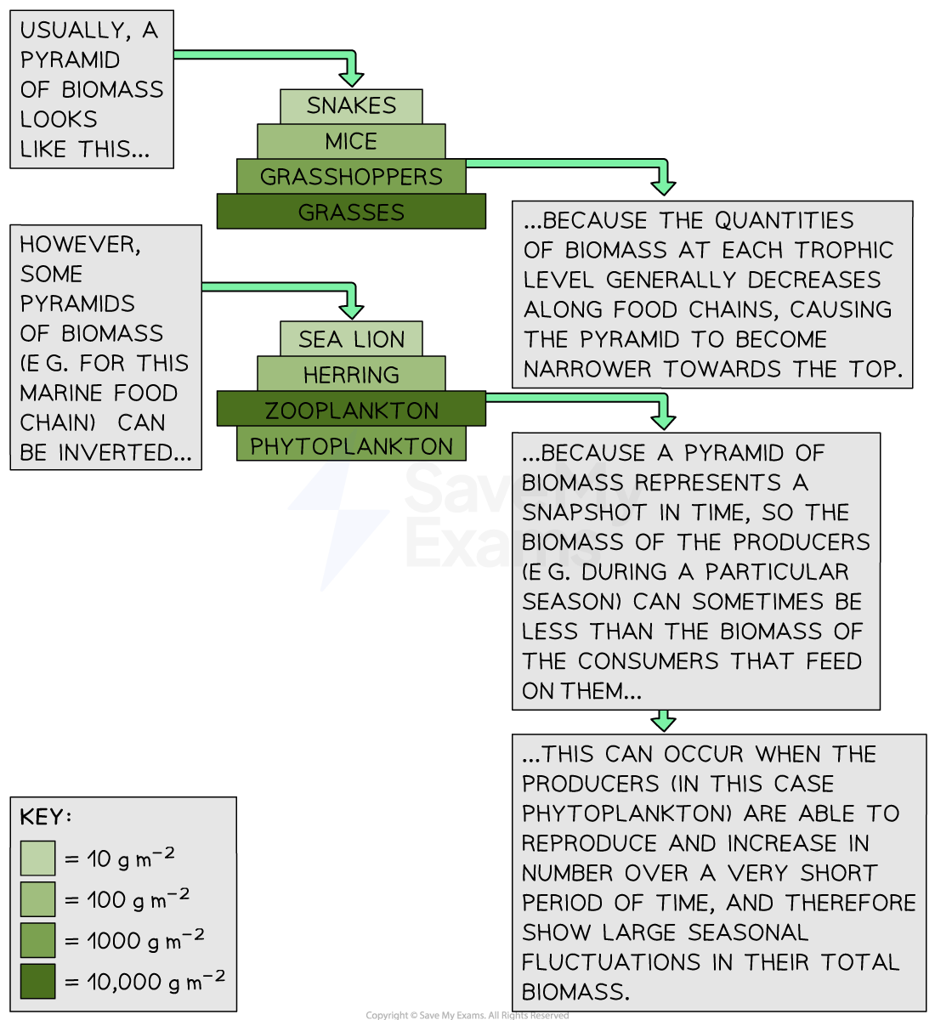

Biomass is the total mass of living organisms in a given area. In a pyramid of biomass, biomass is lost between trophic levels in a food chain. Producers (mostly plants and algae) transfer about 1% of the light energy they absorb for photosynthesis. Only approximately 10% of biomass from each trophic level is transferred to the level above. Biomass is lost through waste (faeces, urine, sweat, gas) and through life processes such as movement and thermoregulation.
Understanding pyramids of biomass helps us see how energy flows through ecosystems. As we aim high in our studies, we can work together to explore these concepts, while being kind to our environment and leading the way in ecological awareness.
Questions:
1. Define the term 'biomass'. (1 mark)
2. What percentage of biomass is transferred from one trophic level to the next? (1 mark)
3. How much light energy do producers transfer for photosynthesis? (1 mark)
4. Name two ways biomass is lost. (1 mark)
5. Explain why understanding pyramids of biomass is important for ecology. (4 marks)

MARK SCHEME
1. Biomass is the total mass of living organisms in a given area.
2. Approximately 10% of biomass is transferred from one trophic level to the next.
3. Producers transfer about 1% of the light energy they absorb for photosynthesis.
4. Biomass is lost through waste (faeces, urine, sweat, gas) and through life processes such as movement and thermoregulation.
5. Understanding pyramids of biomass is important for ecology because it illustrates how energy flows through ecosystems and helps us assess the health of environments and the efficiency of energy transfer.

